Nuclear Engineering and Nonproliferation (NEN)
Safeguards Science and Technology (NEN-1)

Title: | Software Test Plan for Source Tracker Software
Number: NEN1-PLAN-ST-TP |  |  | Revision: 4.0 | Page 1 of 161

Authority | Name | Title/Org | Signature | Date
Preparer | Heather Nordquist | Project Manager/  NEN-1
Preparer | Robert Parker | Software Engineer/  NEN-1
SQA Reviewer | Cecilia Rivenburgh | HPC-1
Software User (SU) | David Miko | NEN-1
Software Owner RLM (SO RLM) | Stacey Eaton | NEN-DO
Software User RLM/  Software Designer RLM  (SU RLM/  SD RLM) | Jon Bridgewater | NEN-1
Facility Design Authority Representative  (FDAR) | Larry Goen | ES-DO

history of revisions

Revision Number | Approval Date | Change Description
Revision 1.0 | 5/10/05 | Original Issue
Revision 1.1 | 2/10/05 | Modifications to plan after testing in May 2005
Revision 2.0 | 10/25/06 | Updated to include additional program enhancements and bug fixes for Source Tracker Rev. 11.14.06.
Revision 3.0 | 12/11/07 | Updated to conform to LANS Software Quality Assurance Standards. Addition of Support Program testing. Enhancement of MAR and CAT-IV.
Revision 3.1 | 1/29/08 | Final editing and format changes. Additional scope added to meet SRS items.
Revision 3.2 | 2/28/08 | N changed to STOFOD; reference DAR (definitions, acronyms, and references); standard history of revisions table; and added reference to the SSP in Section 2.1 (Regression Testing)
Revision 3.3 | 3/18/08 | Added Source Custodian N-1 to signature path
Revision 4.0 | 2/3/2016 | Major revision for version 2.0 of Source Tracker software.

Table of Contents
1. Overview 9
1.1. References 9
1.2. Definitions and Acronyms 9
2. Test Methodology 10
2.1. Regression Testing 10
2.2. Acceptance Testing 10
2.3. Testing Pre- and Post- Conditions 10
2.4. Sampling method 11
2.4.1. MAR Percentage Calculations 12
2.4.2. Criticality Calculations 13
2.5. Test types 14
3. Test Environment 15
3.1. Equipment Required to Execute the Test 15
3.2. Software Test Procedures Required to Execute the Test 15
3.3. Database 15
3.4. Document Conventions 15
4. Source Tracker Startup [Demonstration Test] 16
4.1. Startup 16
4.1.1. Purpose 16
4.1.2. Input 16
4.1.3. Output 16
4.1.4. Process Steps 16
5. Functional Requirements 21
5.1. Determine Test Sources/ Confirm Default Settings [Demonstration Test] 21
5.1.1. Purpose 21
5.1.2. Input 21
5.1.3. Output 21
5.1.4. Process Steps 21
5.2. Remove Source from Home Repository [Demonstration/Validation/Communication Test] 25
5.2.1. Purpose 25
5.2.2. Input 25
5.2.3. Output 25
5.2.4. Process Steps 25
5.3. Return Source to Home Repository [Demonstration/Validation/Communication Test] 33
5.3.1. Purpose 33
5.3.2. Input 33
5.3.3. Output 33
5.3.4. Process Steps 33
5.4. Re-Assign Source’s Current Owner or Location [Demonstration/Validation/Communication Test] 41
5.4.1. Purpose 41
5.4.2. Input 41
5.4.3. Output 41
5.4.4. Process Steps 41
5.5. Display List of Sources [Demonstration/Validation/ /Sampling/Boundary Condition Test] 47
5.5.1. Purpose 47
5.5.2. Input 47
5.5.3. Output 47
5.5.4. Process Steps 47
5.6. Confirm Inventory [Demonstration/Communication Test] 59
5.6.1. Purpose 59
5.6.2. Input 59
5.6.3. Output 59
5.6.4. Process Steps 59
5.7. Transfer a Source Permanently from one Location to Another [Demonstration/Communication Test] 66
5.7.1. Purpose 66
5.7.2. Input 66
5.7.3. Output 66
5.7.4. Process Steps 66
5.8. Edit Program Parameters [Demonstration/Failure Mode Test] 71
5.8.1. Purpose 71
5.8.2. Input 71
5.8.3. Output 71
5.8.4. Process Steps 71
5.9. Leak Test Selected Sources [Demonstration/Communication Test] 75
5.9.1. Purpose 75
5.9.2. Input 75
5.9.3. Output 75
5.9.4. Process Steps 75
5.10. Add/Remove/Modify Source [Demonstration/Validation/Communication/Boundary Condition Test] 82
5.10.1. Purpose 82
5.10.2. Input 82
5.10.3. Output 82
5.10.4. Process Steps 82
5.11. Add/Remove/Modify User [Demonstration/Validation Test] 95
5.11.1. Purpose 95
5.11.2. Input 95
5.11.3. Output 95
5.11.4. Process Steps 95
5.12. Time Out Timers [Demonstration/Code Verification Test] 101
5.12.1. Purpose 101
5.12.2. Input 101
5.12.3. Output 101
5.12.4. Process Steps 101
5.13. System Security Features [Demonstration/Security Test] 103
5.13.1. Purpose 103
5.13.2. Input 103
5.13.3. Output 103
5.13.4. Process Steps 103
5.14. Automatic Database Backups [Demonstration/Validation/Failure Mode Test] 105
5.14.1. Purpose 105
5.14.2. Input 105
5.14.3. Output 105
5.14.4. Process Steps 105
5.15. Email Notifications [Communication Test] 107
5.15.1. Purpose 107
5.15.2. Input 107
5.15.3. Output 107
5.15.4. Process Steps 107
5.16. MAR Calculation Validation [Demonstration/Validation Test] 109
5.16.1. Purpose 109
5.16.1. Input 109
5.16.2. Output 109
5.16.3. Process Steps 109
5.17. Criticality Calculation Validation [Demonstration/Validation Test] 117
5.17.1. Purpose 117
5.17.2. Input 117
5.17.3. Output 117
5.17.4. Process Steps 117
5.18. CAT IV Physical Security Calculation Validation [Demonstration/Validation Test] 124
5.18.1. Purpose 124
5.18.2. Input 124
5.18.3. Output 124
5.18.4. Process Steps 124
5.19. Fuel Rod Calculations Validation [Demonstration/Validation Test] 131
5.19.1. Purpose 131
5.19.2. Input 131
5.19.3. Output 131
5.19.4. Process Steps 131
5.20. Verify SourceTracker Calculations [Demonstration Test] 138
5.20.1. Purpose 138
5.20.2. Input 138
5.20.3. Output 138
5.20.4. MAR Calculation Verification 138
5.20.5. Criticality Verification 138
5.20.6. MAR Building Totals Verification 138
5.20.7. Criticality Building Totals Verification 138
5.20.8. Physical Security Totals Verification 139
5.20.9. Fuel Rod Counts Validation 139
5.21. Integration Test [Integration Test] 143
5.21.1. Purpose 143
5.21.2. Input 143
5.21.3. Output 143
5.21.4. Process Steps 143
5.22. Network Outage and other Failure Modes [Demonstration/Failure Mode Test] 147
5.22.1. Purpose 147
5.22.2. Input 147
5.22.3. Output 147
5.22.4. Process Steps 147
6. Source Tracker Disaster Recovery Test 149
6.1. Disaster recovery 149
6.2. System components required for complete system reconstruction 149
6.3. Source data retention and recovery 149
6.4. Disaster Recovery Test [Failure Mode Test] 150
6.4.1. Purpose 150
6.4.2. Input 150
6.4.3. Output 150
6.4.4. Process Steps 150
7. Appendix A 153
8. Appendix A2 155
9. Appendix A3 157
10. Appendix A4 159
11. Appendix B 160

List of Tables
Table 4.1 Tests for Source Tracker Startup 20
Table 5.1 Tests for Determine Test Sources and Confirm Default Settings 24
Table 5.2 Tests for Remove Source from Home Repository 31
Table 5.3 Tests for Return Source to Home Repository 39
Table 5.4 Tests for Reassign Source’s Current Owner or Location 45
Table 5.5 Tests for Displaying a List of Sources 57
Table 5.6 Tests for Confirm Inventory 64
Table 5.7 Tests for Transfer of a Source Permanently 69
Table 5.8 Tests for Edit Program Parameters 74
Table 5.9 Tests for Leak Test Selected Sources 80
Table 5.10 Tests for Add/Modify Source 92
Table 5.11 Tests for Add/Modify User 99
Table 5.12 Tests for Time Out Timers 102
Table 5.13 Tests for System Security Features 104
Table 5.14 Tests for Automatic Database Backups 106
Table 5.15 Tests for Email Notifications 108
Table 5.16 MAR Calculation Validation Test 115
Table 5.17 Criticality Calculation Validation Test 122
Table 5.18 CAT IV Acceptance Approval 129
Table 5.19 Fuel Rod Calculation Validiation 136
Table 5.20 Verify Source Tracker Calculations 141
Table 5.21 Integration Test 145
Table 5.22 Tests for Network Outage and other Failure Modes 148
Table 6.1 Tests for Disaster Recovery 151

Overview
This document is the test plan referenced in the Source Tracker Software Project Plan (NEN1-PLAN-ST-SPP). Testing documented here-in meet the requirements specified in the Source Tracker Software Requirements Specification (NEN1-ST-SRS). The Source Tracker Requirements Traceability Matrix (NEN1-ST-RTM) maps requirements in the SRS to test cases in this document. The main purpose of this plan is to verify by testing all of the functional tasks performed by Source Tracker, ensuring that calculations concerning MAR, CAT IV and criticality are correct and ensuring that the necessary support programs work as intended. Purpose of Test
The primary tests performed in this plan will verify:
- Removal, return, and reassigning of sources
- Custodian operations to perform inventory checks
- Edit program parameters
- Adding/modifying authorized users
- Adding/modifying/deleting sources in the Source Tracker central database
- Leak test checks
- Performing source inventories
- Calculating thresholds
- Browse Items
- Physical Security verification
- MAR verification
- Criticality verification
- Fuel rod count verification
- Verification of system alerts
- Verification of system reports
- System security features
- Integrated testing of production configuration
It is expected that testers will be personnel familiar with Source Tracker. It is anticipated that the tests will be conducted at Los Alamos by the Source Tracker custodian prior to the installation of the software on the existing Source Tracker systems.

References
References are found in the Source Tracker Definitions, Acronyms, and References document (NEN1-ST-DAR).

Definitions and Acronyms
Definitions and acronyms are found in the Source Tracker Definitions, Acronyms, and References document (NEN1-ST-DAR).

Test Methodology
The tests, including regression testing, described in this Test Plan will be performed according to the processes described in the Software Project Plan.

Regression Testing
Maintenance – In the future, software change requests (new functionality, enhancement) and software problem reports will be the subject of documented requests. These changes will be submitted and approved as described in the Source Tracker Corrective Action Procedure (NEN1-PROC-ST-CAP) and tracked via the Source Tracker SharePoint Report Submission Page (https://adtir.lanl.gov/programs/sourcetracker/SitePages/Source%20Tracker%20Report%20Submission.aspx).
After approval and implementation of the modification, regression tests will be performed to be sure that the modification made on one part of the software does not corrupt any other parts of the software. Section 2.3 of the Source Tracker Software Project Plan, NEN1-PLAN-ST-SPP describes the change request process.
Tests chosen for regression testing should include all sections possibly affected by the change request. In addition, a few of the MAR, Physical Security, Fuel Rod Counts and Criticality Verification steps should be performed. See Sections 7.1.6 of the Source Tracker Software Project Plan (NEN1-PLAN-ST-SPP) for safety considerations during regression testing.

Acceptance Testing
Software testing results are provided within this Test Plan. Ideally the software will meet all the criteria identified. If a test step fails to meet test requirements, the failure will be noted and the test procedure continued to completion, if possible. The test failure will be evaluated for resolution. If the failure is determined to be a failure of the test procedure (not a software failure), the test will be revised and testing will continue. Should critical portions of the test fail to meet acceptance specifications; the Developer will be tasked to reconfigure the software before testing resumes, after which appropriate regression testing will be performed. This iterative cycle will continue until the test results meet all the criteria within this Test Plan. Thus, the Test Plan also serves as the testing document of record whose results are reviewed and signed by responsible authority.

Testing Pre- and Post- Conditions
Certain requirements for testing should be followed to assure that the test results can be accepted. Before testing, the following must be done:
- All testers must meet minimum training requirements as described in the Source Tracker Software Project Plan (NEN1-PLAN-SPP). See section 12.0.
- In order to assure data integrity during testing, an exact copy of the master Source Tracker database must be ported to the central server. One copy of the database must be named SourceTrackerTest and one must be named SourceTrackerProduction.
- Administratively, source users must be informed that the Source Tracker system is being updated, and must not perform source movements until the new configuration of the accepted software is complete. In cases where sources must be moved during this period, manual procedures should be followed according to STO Radioactive Material Inventory Control (STO-AP-002).
- Once the new software is accepted, a full inventory of each location must be performed prior to allowing the production system to run.
- Testing must be performed in an environment that most closely matches the production environment for Source Tracker. Although the system will be tested using the test database, the hardware and software configuration should match that of the normal operation of the software.
- Source Tracker workstations are typically run in radiation areas, and testing should be completed in similar conditions. Failure scenarios should be considered in test procedures (network outages, power outages and limits of environmental conditions).
- The normal operation of Source Tracker will require that users input source and user information via barcode scanner and select options with a touch screen. While test procedures may allow manual input via keyboard and mouse, at least some of the testing must be performed using only the touchscreen and barcode scanner.
- Final acceptance of the test results must be completed as specified in the Source Tracker Software Project Plan (NEN1-PLAN-SPP) and Source Tracker Qualification Plan (NEN1-PLAN-QP) to assure that acceptance is independent and unbiased with regard to the software development team.
- All test results must be recorded, including failures/retests. This plan serves as the official test record.
- Integration and simultaneous use testing must be performed prior to acceptance. Workstations will be tested in their production configuration except that they will be tested using an exact copy of the database.
- Test personnel have been notified of test schedule in order to assure availability.
- Prior to acceptance, verify that each test case is complete and has passed all test criteria. Since this test plan serves as the official test record, if test cases fail, a new copy of the results table at the end of the test case should be printed and added to the test record until all tests pass.
Complete Appendix B Test Pre- and Post-Checklist as part of the testing record to meet these requirements.

Sampling method
Various test cases in this plan will require that specific input be entered by the tester to record output/results. The sampling method used should be:
- Mostly random – While instructions are given to the tester as to the input items criteria (type of source, location of source), specific input is generally not specified. This assures that when testers choose input items it is done in a quasi-random way.
- At boundary conditions – When testing numerical calculations or entering certain values in forms, input above maximum allowable values and below allowable values should be entered to verify that the software performs under these boundary conditions.
- Sampling of workstations – Source Tracker is a distributed system with multiple workstations. At least some of the tests in this plan must include random sampling of the workstation locations/configuration to assure correct software functionality. Also, simultaneous use tests are included to assure that the system functions in production mode.

MAR Percentage Calculations
To sample a representative set of sources for validating MAR calculations, the path through the calculations was determined and a set of representative sources for each path was chosen. The MAR calculation code breaks down as shown in the following diagram.

DecayCorrect()

U, MOXe, MOXn isotope Isotope is missing one of: All other isotopes
Mar Limit, Ci/g

GetMixedIsotopeValues() CalculateFromPuIsotopics DoIsotopeCalcs()
IfAvailable()
U MOXe MOXn
U235 Others
U235 PUMT52 PUMT54 MOX, PUMT
U238 U235 U238 U234Fixup()

AddToMixedIsotopeValues() GetMARLimitFractions()
CalculateFromPuIsotopics
PUMT Other (Pu238,239,240,241, IfAvailable()
242,AM241)
CalcPuFromIsotopics DoIsotopeCalcs()
IfAvailable()
U235 Others

U234Fixup()

Done

Code Flow for MAR Calculations

Criticality Calculations
Criticality is calculated for sources that contain U and Pu and for fuel rods that are not in buildings with defined fuel rod limits. The flow for criticality calculations is shown below.

GetCriticalityValues()

If fuel rod and no building limits, or is U*, Pu*, MOXe, MOXn

GetCritForSource()

U* Pu* MOX

U U234 U235 U233 PuMass=Pu
contribution
E>.72% UMass= E=0 E>.72% PuMass=
initial mass initial mass MOXe
UMass= UMass= UMass=
E*initial mass initial mass E*initial mass UMass=U
contribution
PuMass=
decay-corrected initial mass

Done

Code flow for criticality calculations

Test types
Each test case is designated with one or more test types. The name/definition of these types is:
- Demonstration – This type of test demonstrates through visual observation that the software functions in accordance with software requirements. For example, certain forms, warnings and messages that should be presented on the GUI are tested in this type of software test.
- Validation—This type of test validates that the software presents information that is consistent with the central database or stored configuration. For instance, if the user requests that the software show them a list of items that meet a certain criteria, a step which validates that the information displayed is the same as the internal state of the database may be used in this type of test.
- Communication – This type of test confirms that certain communication requirements of the software are met. For instance, if a certain error condition is required to generate an email to certain users, this type of test verifies that these communication requirements are fulfilled.
- Security – Because Source Tracker is hosted on the yellow network and accessed by foreign nationals, certain tests have to be performed to assure that cyber security requirements are met.
- Failure mode – These tests verify that the program works according to specification when network, power and other failures occur.
- Sampling – When validating Source Tracker results, random sampling may be used. See Section 2.4 for information about how samples are chosen.
- Integration – Source Tracker is a distributed system with multiple clients connected to a single, central database. Some tests will specifically test that the software works in this integrated mode without creating conflicts or race conditions.
- Boundary condition – When allowable values have ranges, these tests verify that out-of-bound conditions are handled correctly by the software.
- Code verification – Certain tests require an actual code walkthrough to verify.

Test Environment
A user with custodian privileges is required to run many of the tests described below.

Equipment Required to Execute the Test
Computer hardware with these minimum capabilities (more or faster is better):
- Touchscreen PC
- Bar code reader for user input.
- Source Tracker Installation software as described in detail in Sections 6 and 7.
- Actual source barcodes and user barcodes or printed sheet of barcodes as provided by System Administrators to the testers prior to testing. In production, Source Tracker workstations will not have keyboard/mouse installed.
- SQL query files needed to validate program results. System administrators will provide testers with these before testing starts.
- Config files needed to select databases for the application.
- To perform test steps which require keyboard/mouse, it is suggested that an official LANL issue laptop be used to execute SQL queries and remote desktop connections. Source Tracker workstations in production mode will not allow these operations. The exception to this is that adding sources will be done on a normal PC with keyboard and mouse.

Software Test Procedures Required to Execute the Test
Tester will need:
- Source Tracker software
- SQL Server 2014 Database
- Microsoft Windows 2007 operating system
Test procedures are presented with a purpose, test goals, transaction logs (where needed) and process steps. The steps that require verification are numbered in the test so that the tester can check either PASS or FAIL at the end of the test.

Database
Source Tracker uses an SQL database. When testing upgrades to software, careful attention must be made so that inadvertent warnings via email and changes to the existing master Source Tracker database do not occur. For that reason, a test database will be used for the duration of the test procedures, and only when software is thoroughly tested will the master database be used.
After testing is complete and accepted, an initial inventory of sources at each workstation location should be performed to verify that the database is correct before entering production mode.

Document Conventions
When testers are asked to push a button, the caption of the button will be put in bold italics.
Testing steps are shown as bullets, while verification steps are numbered.
Selections in dropdown lists and database table names will be shown in quotation marks.
SQL statements needed to query/store DB results stored in files whose names are shown in blue.

Source Tracker Startup [Demonstration Test]
Upon execution of the Source Tracker software, the program tallies the MAR, Physical Security, Criticality and Fuel Rod sums for all configured locations.

Startup

Purpose
Verify that the sums for the Physical Security, MAR, Criticality and Fuel Rods are performed at startup and that calculated values can be displayed.

Input
Starting the SourceTracker.exe program. Clicking button to display calculated values chosen from Source Tracker Main Form.

Output
Status updates are shown to the user that calculations are made, and the user verifies these calculated values in the Source Tracker graphical user interface (GUI).

Process Steps

- Click on the Source Tracker icon to begin execution.

- Verify that Starting Up, Calculating Physical Security Limits, Calculating MAR, Calculating Criticality and Calculating Fuel Rod status messages are displayed in that order.

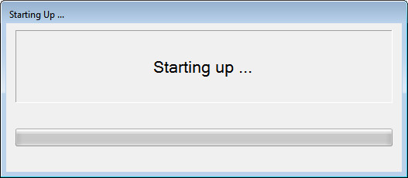
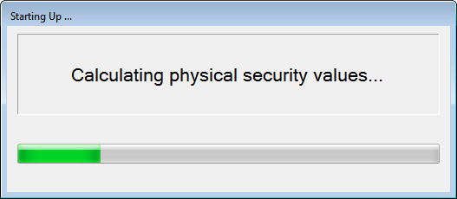
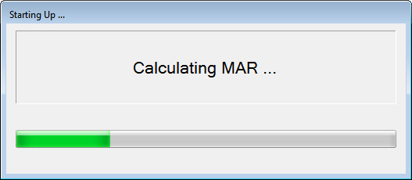
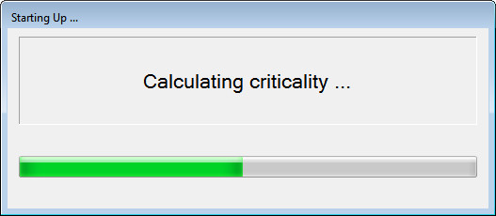

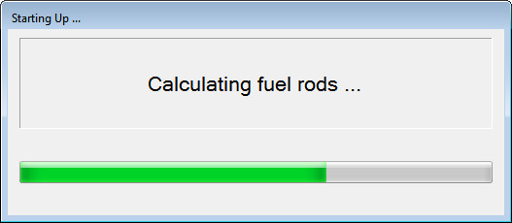

- Click each of the MAR Status, Physical Security Status and Criticality and Fuel Rod Status buttons to verify that values are displayed (we will verify that these values are correct later in the test).
- Each of these will require that an authorized user scans their badge in order to display the values. Scan an authorized user each time.

Sample output shown here.
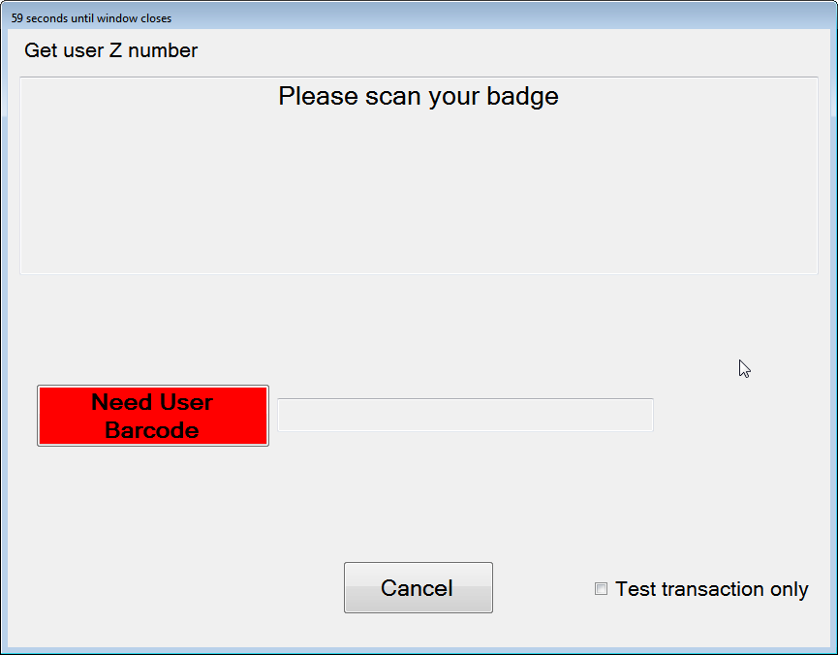
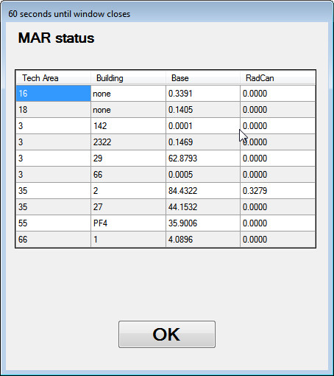

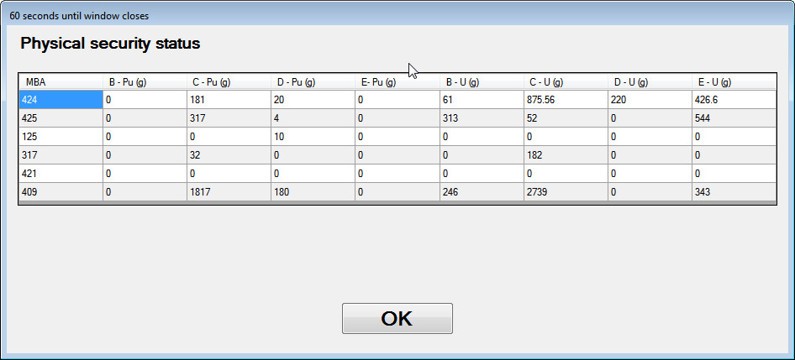
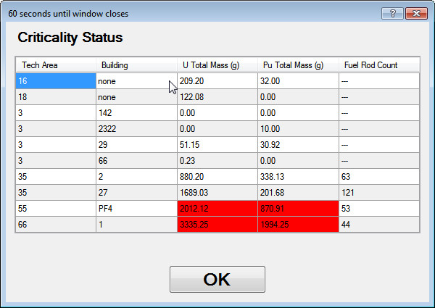

- Verify that Physical Security, MAR and Criticality and Fuel Rods values can be displayed.
- Verify that authorized user is required to display each of the status forms.
Table 4.1 Tests for Source Tracker Startup
Test Results
Date: |  | Name of Tester: Signature: |  | Test Status
Not tested Tested
In Process
Date: |  | Name of Acceptance Authority: Signature: |  | Test Status
 |  |  |  | Accepted Not Accepted
Acceptance
Notes:
 |  | Enter the version of software tested here:
 |  | Is this test being used for Regression Testing? Yes No
 |  | Is this a retest? Yes No
 |  | If a retest, comment or provide any documentation here of the version of software that failed, the items corrected before the retest and the new software version being tested:
Test #: | Expected Results: |  | PASS/FAIL
1 | Verify that Starting Up, Calculating Physical Security Limits, Calculating MAR, Calculating Criticality and Calculating Fuel Rod status messages are displayed in that order. |  | Pass Fail
2 | Verify that Physical Security, MAR and Criticality and Fuel Rods values can be displayed |  | Pass Fail
3 | Verify that authorized user is required to display each of the status forms. |  | Pass Fail
Comments

Functional Requirements

Determine Test Sources/ Confirm Default Settings [Demonstration Test]

Purpose
To determine which sources can be used for the various tests and to also make sure the computers are set with the proper defaults.

Input
You will need to scan a valid custodian barcode in some of these steps. You will also need access to the SourceTrackerTest database via login credentials to the trackerbeta.lanl.gov server. A system administrator should be involved for those steps. Make sure they are available before this test case is initiated.

Output
Some saved data from the database will be output to be used later in the test plan.

Process Steps
- Close the Source Tracker application by using the Custodian Operations and scanning a custodian Z number. The option to Exit the Program will be shown.
- Open the config file for the Source Tracker application (c:\Source Tracker\SourceTracker.exe.config in the application’s main directory and verify that the following line exists in the connectionStrings section:
<add name="DBConnectionString" connectionString="Data Source=trackerbeta;Initial Catalog=&quot;SourceTrackerTest&quot;;Integrated Security=True" providerName="System.Data.SqlClient" />
- Save the config file.
- Choose your testing location by clicking Custodian Operations and then entering a valid Custodian barcode.
- Choose Edit Program Settings.
- Choose the test location of “SNM Safe” using the dropdown menu.
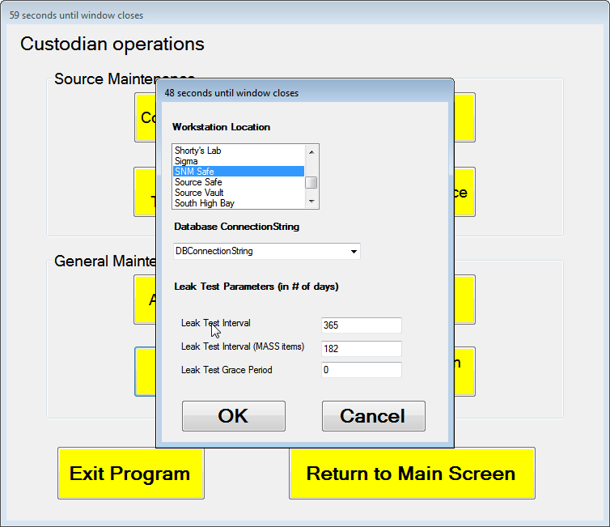
- Verify that the numbers in the Leak Test Parameters section are as shown above.
- Verify that the selected database is the test database you entered in the first step of this procedure.
- Exit the Program Parameters form by pressing the OK button.
- Exit the Custodian Menu by selecting Return to Main Screen.
- Get a sheet of barcodes from a System Administrator for testing.
- Browsing the sources in the Source table using the Browse Sources function and a normal user Z Number, pick 5 sources whose storage location is the SNM Safe. Source #1 will be an Exempt MASS Source, Source #2 will be a Non MASS source, Source #3 will have a CAT IV PU Attractiveness of C, Source #4 will be a non-exempt MASS Source, Source #5 will be a source with an expired leak test date, Source #6 will be a non-MASS RSSDMS source (choose a non-MASS item with a non-blank “RSSDMS” field) and Source #7 is a source that doesn’t exist in the database.. Make sure the current location of the sources is also the SNM Safe and that they are not checked out (znum field will be 0). Verify that you have access to the source barcode at the testing location or that the system administrators have given you a sheet with barcodes for these sources.
Note those Sources here:
#1
#2
#3
#4
#5
#6
#7
- Using the query stored in SelectAllMASSLocs.sql, record and save a copy of authorized MASS locations and their MBA’s in the database for later use.
- Using the query stored in SelectAllPermanentLocs.sql, record and save a copy of permanent storage locations.
- Close the SQL Server Database
- Click Return to Main Screen on the Source Tracker Custodian Form

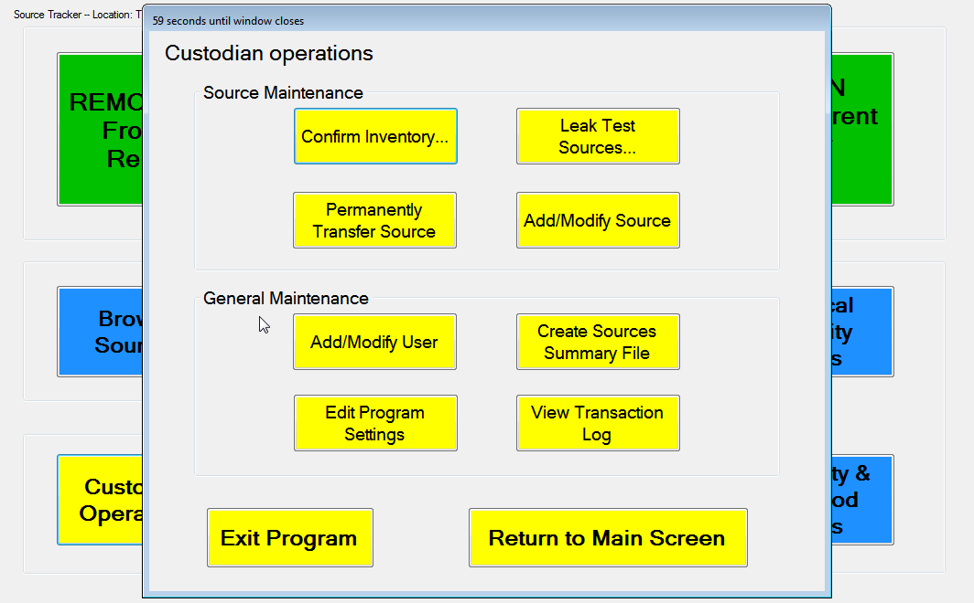

- Click the Exit Program button.
- Press No when asked to confirm.
- Verify that the program does not exit and that Source Tracker returns you to the Custodian Menu.
- Click the Exit Program button again.
- Select Yes when asked to confirm.
- Verify that the program exits.

Table 5.1 Tests for Determine Test Sources and Confirm Default Settings
Test Results
Date: | Name of Tester: Signature: | Test Status
Not tested Tested
In Process
Date: | Name of Acceptance Authority: Signature: | Test Status
 |  | Accepted Not Accepted
Acceptance
Notes:
 | Enter the version of software tested here:
 | Is this test being used for Regression Testing? Yes No
 | Is this a retest? Yes No
 | If a retest, comment or provide any documentation here of the version of software that failed, the items corrected before the retest and the new software version being tested:
Test #: | Expected Results: |  | PASS/FAIL
4 | Verify that the numbers in the Leak Test Parameters section are as shown. |  | Pass Fail
5 | Verify that the selected database is the test database you entered in the first step of this procedure. |  | Pass Fail
6 | Verify that the program does not exit and that Source Tracker returns you to the Custodian Menu |  | Pass Fail
7 | Verify that the program exits. |  | Pass Fail
Comments

Remove Source from Home Repository [Demonstration/Validation/Communication Test]

Purpose
Verify that the user can move a source from one MBA to another MBA. Verify that if the source is a MASS source a message is displayed requiring a MASS authorized user is present for the transfer.

Input
The user Z number and source id are required input. Logging of certain steps is noted in order to verify transaction logs and alert emails later.

Output
The database is updated to show the transfer data. Transactions are logged to database. Alert emails are generated and sent.

Process Steps
- Start the Source Tracker executable.
- Select REMOVE Source From Home Repository.
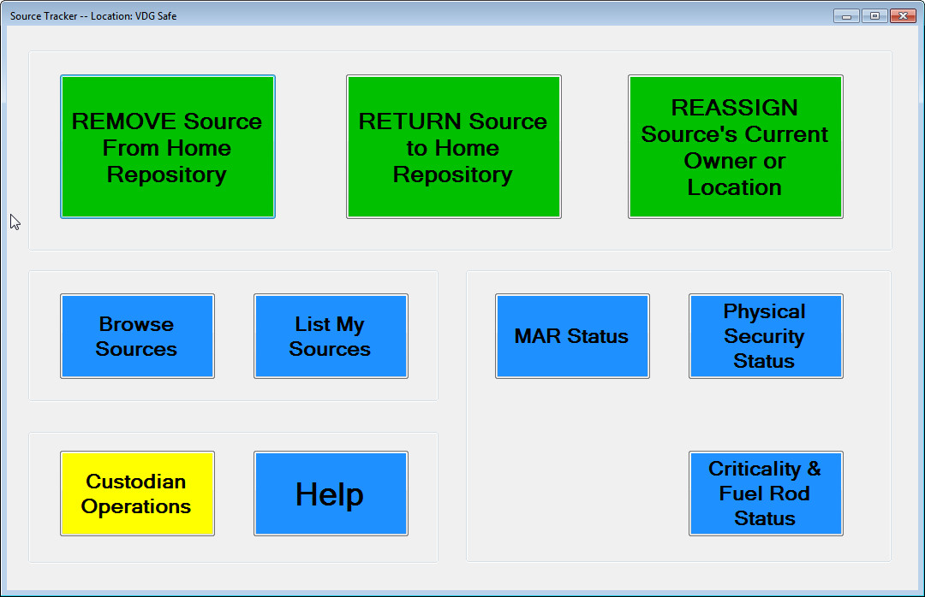
- Enter Source #1 barcode and normal user Z# by scanning/entering the barcode on the source and user badge.
- Verify that a Z Number is required, and that the checking out a MASS source message is displayed after entering the source barcode.
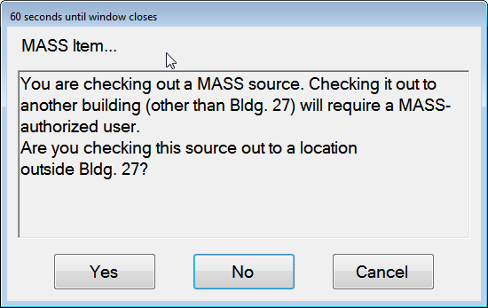
- Select No.
- Click OK to proceed to next step.
- Verify that the list of only those MASS locations located in the same MBA are displayed. Note: you were asked to store a list of MASS locations and MBA’s earlier in the test plan.
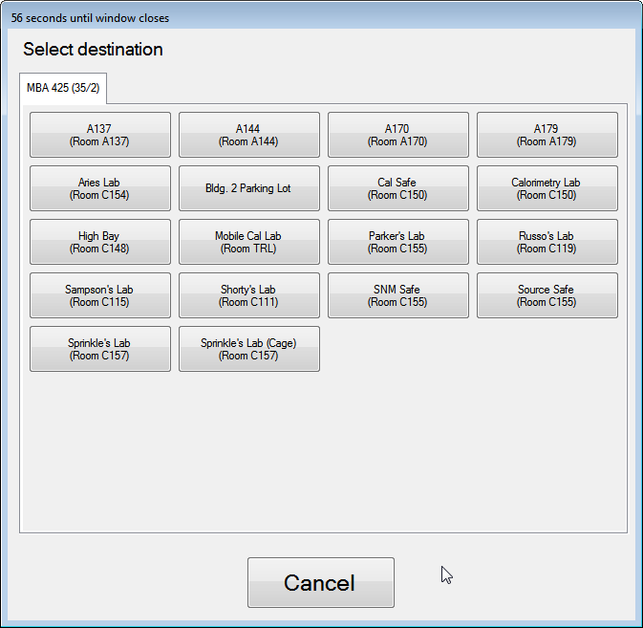
- Pick a MASS location that is the same as the SNM Safe as a destination.
- Verify that the source removal window is displayed with the correct information.
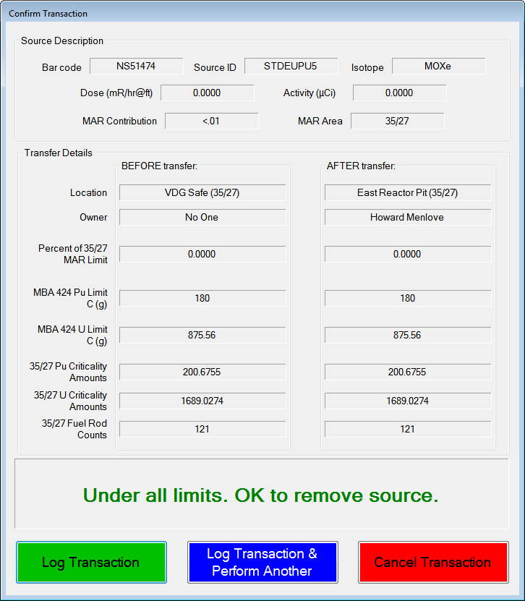
- Click on the Cancel Transaction button.
- Verify that the program returns to the main window.
- Use the Browse Sources to look at the source in the database.
- Verify that the source was not checked out (location is still SNMSafe and Current Owner is 0).
- Select REMOVE Source From Home Repository button.
- Enter Source #1 and the normal user.
- Select No at the checking out a source to a different MBA message.
- Select the Cal Safe as the destination location.
- Select Log Transaction at the source removal window. Note this transaction in the Transaction Log.
- Verify that the warning is displayed that you are moving the source across a MASS boundary.
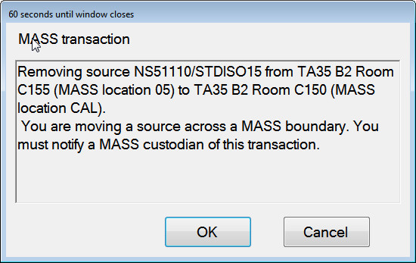
- Select Browse Sources button.
- Verify that the source transferred above is listed in the list of sources and that its current location is the one as shown above as the destination location. (Using the Browse Sources option of the main menu).
- Select OK.
- Select the REMOVE Source From Home Repository button.
- Select Source #3 and the normal user Z number.
- Verify that the following message is displayed.
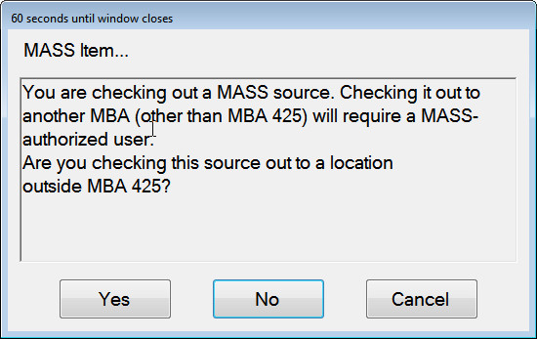
- Select Yes.
- Verify that the following message is displayed.
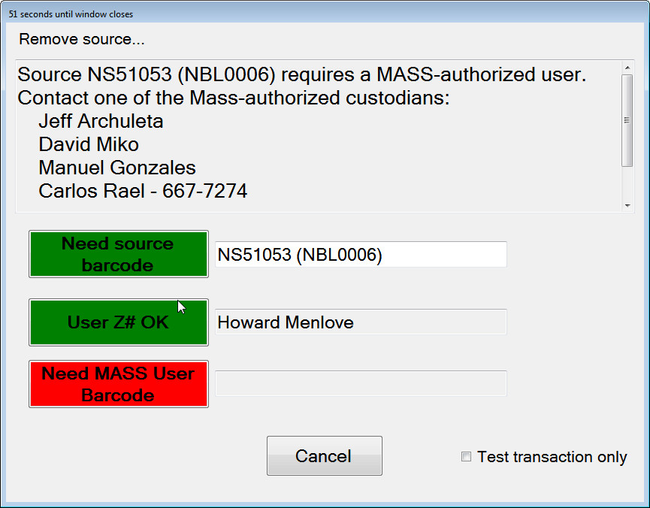
Select the Cancel button.
- Verify that the program returns to the main Source Tracker window.
- Select the REMOVE Source From Home Repository button.
- Select Source #3 and normal user Z number.
- Select No choosing to move the source within the MBA.
- Verify that the Remove Source window is displayed and the information is correct.
- Select a room in a different MASS Location and click on the Log Transaction & Perform Another button. Log this transaction on your Transaction Log.
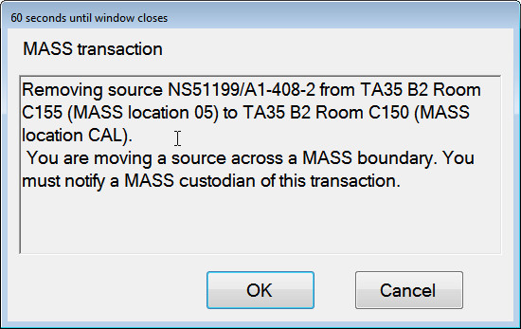
- Verify that the MASS boundary warning is shown.
- Verify that the software returns to the checkout source form as shown below.
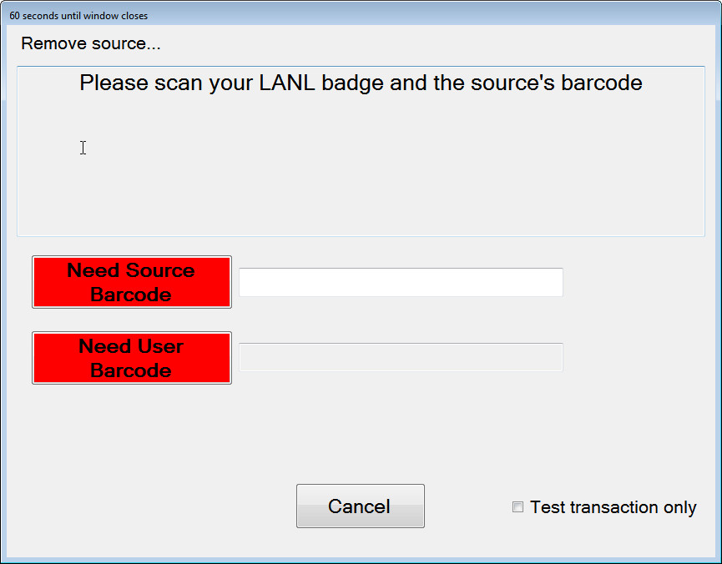
- Enter Source #4 and the normal user Z number.
- Select Yes on the message asking if it is being transferred to another MBA
- Verify that a MASS Custodian id is required.
Enter a MASS custodian id.
- Verify that all MASS locations in all MBA’s are listed. Note: the first case of the test plan had you save a listing of all MASS locations and MBA’s.
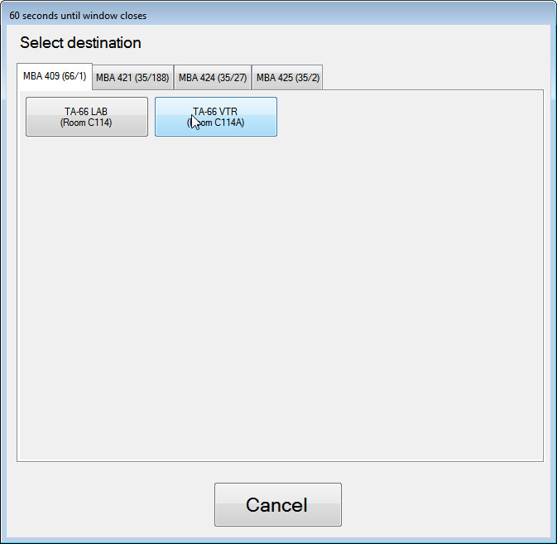
- Select a building and room that is in another MBA area (e.g. West Reactor Pit).
- Click on the Cancel Transaction button.
- Verify that the Main Menu is displayed.
Use the Custodian Operations button and enter a Custodian Z number.
Choose the View Transaction Log option to retrieve a log of source movements in the database.
- Verify that Sources # 1 and #4 were transferred and logged and that Source #3 has not been transferred to the selected location but remains at its storage location. Also check that appropriate email warnings for MASS movements are generated and sent.

Table 5.2 Tests for Remove Source from Home Repository
Test Results
Date: |  | Name of Tester: Signature: |  | Test Status
Not tested Tested
In Process
Date: |  | Name of Acceptance Authority: Signature: |  | Test Status
 |  |  |  | Accepted Not Accepted
Acceptance
Notes:
 |  | Enter the version of software tested here:
 |  | Is this test being used for Regression Testing? Yes No
 |  | Is this a retest? Yes No
 |  | If a retest, comment or provide any documentation here of the version of software that failed, the items corrected before the retest and the new software version being tested:
Transaction Log
Date/Time: | Description of transaction |  | Type:
 |  |  | Email Log
 |  |  | Email Log
 |  |  | Email Log
 |  |  | Email Log
 |  |  | Email Log
 |  |  | Email Log
 |  |  | Email Log
 |  |  | Email Log
 |  |  | Email Log
 |  |  | Email Log
 |  |  | Email Log
 |  |  | Email Log
 |  |  | Email Log
 |  |  | Email Log
 |  |  | Email Log
 |  |  | Email Log
 |  |  | Email Log
 |  |  | Email Log
 |  |  | Email Log
 |  |  | Email Log
 |  |  | Email Log
 |  |  | Email Log
 |  |  | Email Log
Test #: | Expected Results: |  | PASS/FAIL
8 | Verify that a Z Number is required, and that the checking out a MASS source message is displayed after entering the source barcode. |  | Pass Fail
9 | Verify that the list of only those MASS locations located in the same MBA are displayed. |  | Pass Fail
10 | Verify that the source removal window is displayed with the correct information. |  | Pass Fail
11 | Verify that the program returns to the main window. |  | Pass Fail
12 | Verify that the source was not checked out (location is still SNM Safe and Current Owner is 0). |  | Pass Fail
13 | Verify that the successful checkout message is displayed |  | Pass Fail
14 | Verify that the source transferred is listed in the list of sources and that its current location is the one as chosen as the destination location. |  | Pass Fail
15 | Verify that the MASS Item warning form is displayed |  | Pass Fail
16 | Verify that MASS user is required for checkout. |  | Pass Fail
17 | Verify program returns to Main Form. |  | Pass Fail
18 | Verify that the source removal window is displayed with the correct information. |  | Pass Fail
19 | Verify that the MASS boundary warning is shown |  | Pass Fail
20 | Verify that the software returns to the checkout source form. |  | Pass Fail
21 | Verify that a MASS Custodian is required. |  | Pass Fail
22 | Verify that all MASS locations in all MBA’s are listed. |  | Pass Fail
23 | Verify that the Main Menu is displayed. |  | Pass Fail
24 | Verify that Sources # 1 and #4 were transferred and logged and that Source #3 has not been transferred to the selected location but remains at its storage location. Also check that appropriate email warnings for MASS movements are generated and sent. |  | Pass Fail
Comments

Return Source to Home Repository [Demonstration/Validation/Communication Test]

Purpose
Verify that a source that has been removed from its designated storage location is returned to this location. The source needs to be returned to the location designated as its storage location. The computer system where the source’s storage location is must be used to return it. If the user tries to return a source to its storage location from another computer system, an error will occur. Verification of MASS item email notifications and the View Transaction Log option of Source Tracker are also tested in this process.

Input
The source id of the source to be returned is required.

Output
The database table is updated indicating the location of the source. Transaction logs are updated in the database. Alert emails are generated and sent when applicable.

Process Steps
- Select the RETURN Source to Home Repository button.
- Select Source #1.
- When warned about moving the source across a MASS boundary, select OK.
- Verify that a success message with the source id and location is displayed.
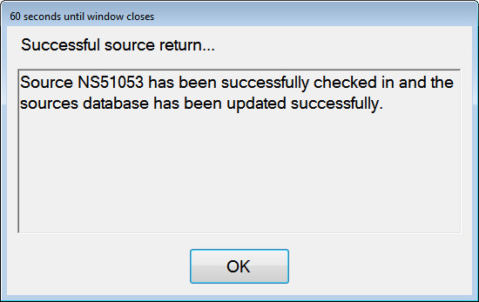
- Click OK and log this in your Transaction Log.
- Select the Browse Sources button.
- Enter the normal user Z number.
- Verify that Source #1 has been returned to its storage location.
- Select OK.
- Select the Custodian Operations option.
- Enter a Custodian Z number.
- Select the Edit Program Settings option
- Reset the location of this computer’s to something different from “SNM Safe”.
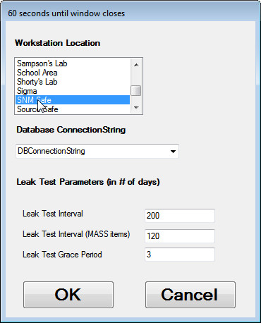
- Click OK.
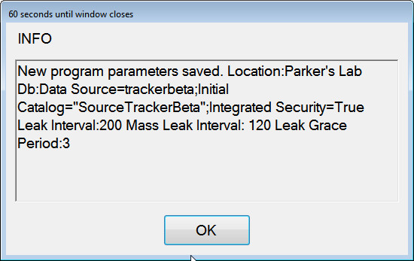
- Select Return to Main Screen.
- Select the RETURN Source to Home Repository button.
- Scan Source #4.
- Verify that the error message indicating that this is not the source’s storage location is displayed.
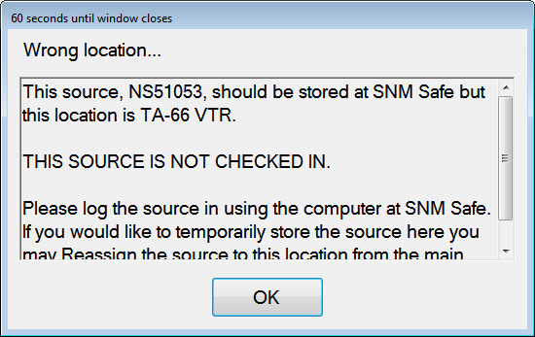
- Click on the OK button on the “check in source” message.
- Select the Custodian Operations option.
- Select a Custodian Z#.
- Select the Edit Program Settings option
- Reset the location of this source to its storage location.
- Click OK.
- Select RETURN Source to Home Repository.
- Select Source #4.
- Verify that the message that the source is being returned is displayed.
- Select OK and log this in your Transaction Log.
- Select the Browse Sources button.
- Enter the user Z number.
- Locate the source id in the table.
- Verify that the source has been returned to its home repository.
- Try to check in the same source again using the RETURN Source to Home Repository button and scanning/entering the source id.
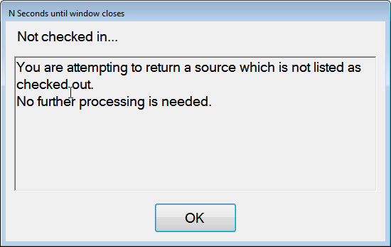
- Verify that a message is displayed that the source being checked in is not currently checked out.
- Verify that 4 emails are sent to the Custodian, Checkout emails for Source #1 and #4 and return emails for the same sources.
- Select Custodian Operations from the main menu.
- Enter Custodian Z number.
- Select View Transaction Log.
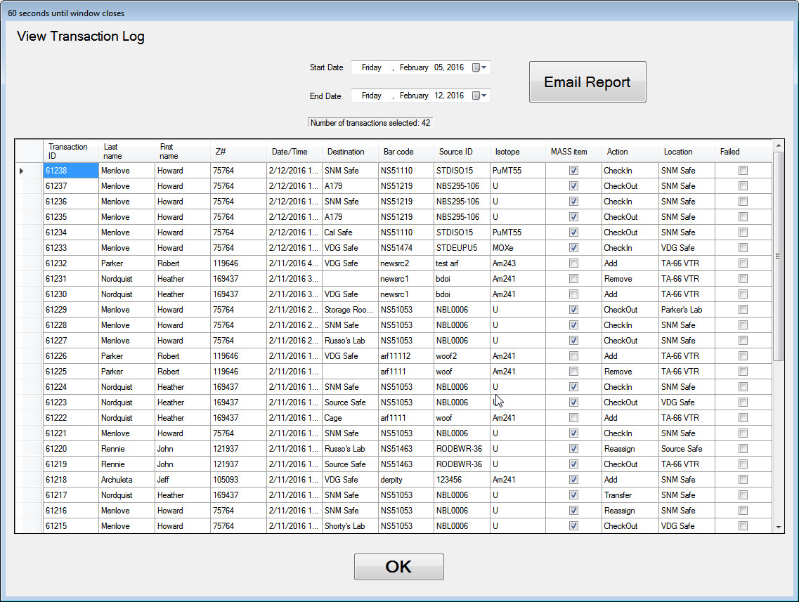
- Verify that the Transaction Log Window is displayed.
- Filter the view using the date selectors to only show today’s log entries.
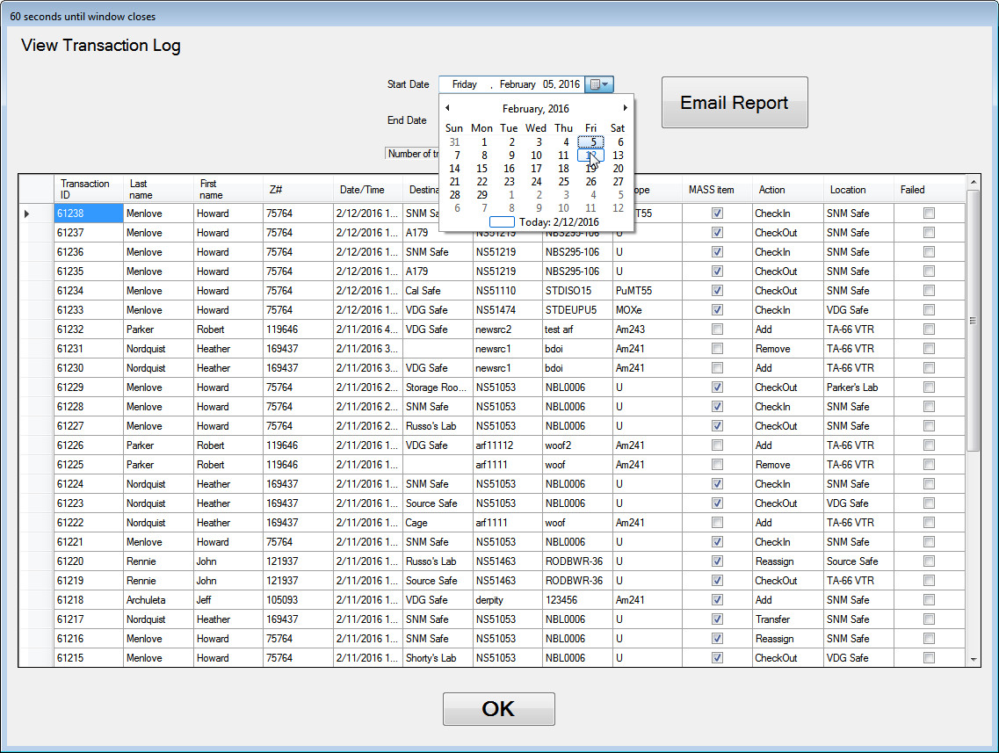

- Verify that the transactions are filtered and that only the date you selected is shown on the log.
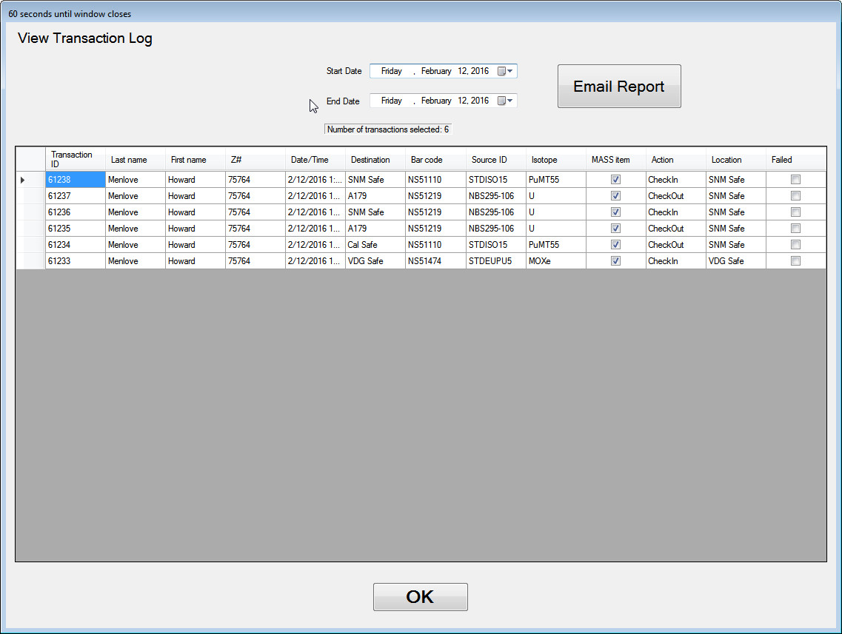
- Verify that the log has the two checkout and checkin transactions you completed in this procedure listed in the log.
- Press the Email Report button.
- Verify that the email confirmation form is displayed (example shown below), email is sent to the custodian you entered at the beginning of the procedure and that the contents of the email matches the contents of the Transaction Log view.
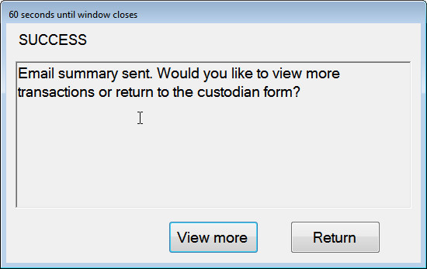
- Select Return to return to the Custodian Menu.
- Select Return to Main Screen to return to the Main Menu.
Table 5.3 Tests for Return Source to Home Repository
Test Results
Date: |  |  | Name of Tester: Signature: |  |  | Test Status
Not tested Tested
In Process
Date: |  |  | Name of Acceptance Authority: Signature: |  |  | Test Status
 |  |  |  |  |  | Accepted Not Accepted
Acceptance
Notes:
 |  |  | Enter the version of software tested here:
 |  |  | Is this test being used for Regression Testing? Yes No
 |  |  | Is this a retest? Yes No
 |  |  | If a retest, comment or provide any documentation here of the version of software that failed, the items corrected before the retest and the new software version being tested:
Transaction Log
Date/Time: |  | Description of transaction |  |  | Type:
 |  |  |  |  | Email Log
 |  |  |  |  | Email Log
 |  |  |  |  | Email Log
 |  |  |  |  | Email Log
 |  |  |  |  | Email Log
 |  |  |  |  | Email Log
 |  |  |  |  | Email Log
 |  |  |  |  | Email Log
 |  |  |  |  | Email Log
 |  |  |  |  | Email Log
 |  |  |  |  | Email Log
 |  |  |  |  | Email Log
 |  |  |  |  | Email Log
 |  |  |  |  | Email Log
 |  |  |  |  | Email Log
 |  |  |  |  | Email Log
 |  |  |  |  | Email Log
 |  |  |  |  | Email Log
 |  |  |  |  | Email Log
 |  |  |  |  | Email Log
 |  |  |  |  | Email Log
 |  |  |  |  | Email Log
Test #: | Expected Results: |  |  | PASS/FAIL
25 | Verify that a message with the source id and location is displayed. |  |  | Pass Fail
26 | Verify that the source to be returned is returned to its storage location. |  |  | Pass Fail
27 | Verify that the error message indicating that this is not the source’s storage location is displayed. |  |  | Pass Fail
28 | Verify that the message that the source is being returned is displayed |  |  | Pass Fail
29 | Verify that the source has been returned to its home repository. |  |  | Pass Fail
30 | Verify that a message is displayed that the source being checked in is not currently checked out. |  |  | Pass Fail
31 | Verify that 4 emails are sent to the Custodian, Checkout emails for Source #1 and #3 and return emails for the same sources. |  |  | Pass Fail
32 | Verify that the Transaction Log Window is displayed. |  |  | Pass Fail
33 | Verify that the transactions are filtered and that only the date you selected is shown on the log. |  |  | Pass Fail
34 | Verify that the log has the two checkout and checkin transactions you completed in this procedure listed in the log |  |  | Pass Fail
35 | Verify that the confirmation that the email is sent is display, email is sent to the custodian you entered at the beginning of the procedure and that the contents of the email matches the contents of the Transaction Log view. |  |  | Pass Fail
Comments

Re-Assign Source’s Current Owner or Location [Demonstration/Validation/Communication Test]

Purpose
Verify that a source can be stored in a temporary location other than its “home” location (storage location). Verify that the source can be assigned to another user without being checked back in.

Input
The user Z number and source barcode are required. Additionally if the source is a MASS source, the source custodian Z number will be required.

Output
The database table will be updated. Transactions will be logged in the database. Certain email alerts will be generated and sent to custodians.

Process Steps
- Select the RE-ASSIGN Source’s Current Owner or Location button.
- Enter the user Z number and source #5.
- Verify that the Leak Test Expired message is displayed. Log this to verify that an email is sent to the custodian in later steps.
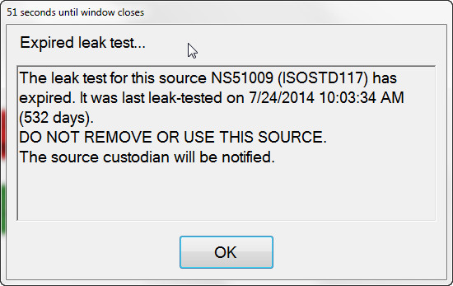
- Click OK.
- Enter Source #1 id.
- Verify that the “Not reassigned” window is displayed as shown below.
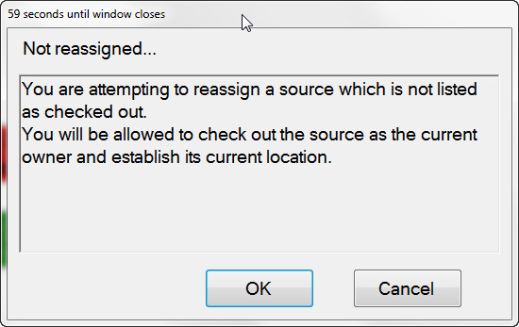
- Select OK.
- You will receive a warning that this is a MASS source. Select No to indicate you will not reassign the source outside the MBA.
- Verify that the Location Selection form is displayed showing MASS areas in the current MBA.
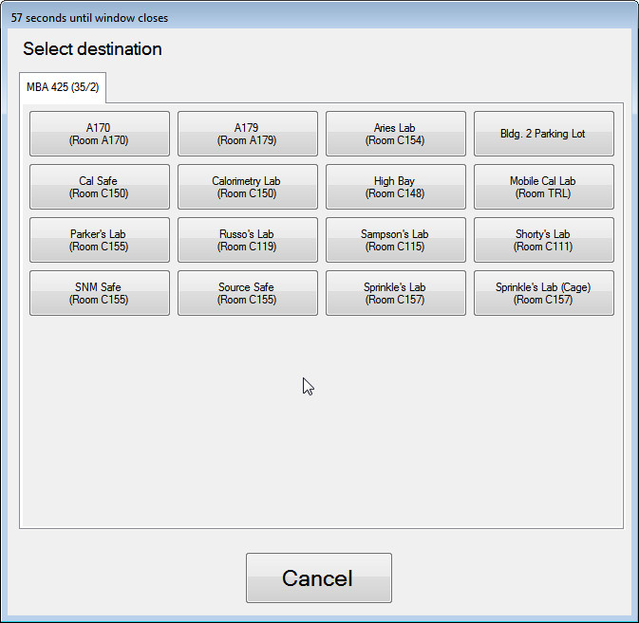
- Select the Cancel button.
- Verify that the main menu is displayed and the operation is cancelled.
- Use the Browse Sources option to verify that Source #1 was not checked out and is still in its storage location (SNM Safe)
- Verify that Source #1 is not reassigned.
- Select the RE-ASSIGN Source’s Current Owner or Location button.
- Enter the user Z number and source #1.
- Verify that the “Not reassigned” message is shown.
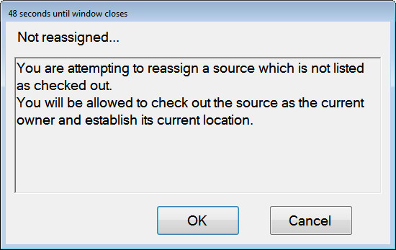
- Click OK.
- Select the No when the application asks if you will check the source out to a location outside the MBA.
- Verify that only MASS locations in the same MBA are displayed.
- Select one of the areas displayed.
- The source transfer details window is displayed. If you chose a location outside the MASS area, a warning will also be displayed. Select OK to continue.
- Verify that source description and transfer details are provided and are accurate.
- Select Log Transaction and note this reassign on your Transaction Log for later confirmation.
- Verify that the re-assignment is complete by selecting the Browse Sources button, selecting user Z #, and find the source. The Current Owner should be the user you selected for the transaction and the Current Location should be the one you selected above.
- Select the RE-ASSIGN Source’s Current Owner or Location button.
- Enter the user Z# and source #1.
- Select the Yes button on the MASS item warning message.
- Select a MASS Authorized user Z#
- Verify that all MBA areas are displayed.
- Select an area to reassign the source to. You may also get a warning about crossing a MASS boundary. Press OK to continue. Click the LogTransaction button.
- Select Log Source Removal and enter this transaction in the Transaction Log.
- Verify that the re-assignment is complete by selecting the Browse Sources button. Check that the location has been changed and the user performing the operation is the Current User.
- Verify that emails were sent to the Custodian for the leak test warning and MASS transactions and verify that the Log Transaction matches your entries on the handwritten Transaction Log.

Table 5.4 Tests for Reassign Source’s Current Owner or Location
Test Results
Date: |  | Name of Tester: Signature: |  | Test Status
Not tested Tested
In Process
Date: |  | Name of Acceptance Authority: Signature: |  | Test Status
 |  |  |  | Accepted Not Accepted
Acceptance
Notes:
 |  | Enter the version of software tested here:
 |  | Is this test being used for Regression Testing? Yes No
 |  | Is this a retest? Yes No
 |  | If a retest, comment or provide any documentation here of the version of software that failed, the items corrected before the retest and the new software version being tested:
Transaction Log
Date/Time: | Description of transaction |  | Type:
 |  |  | Email Log
 |  |  | Email Log
 |  |  | Email Log
 |  |  | Email Log
 |  |  | Email Log
 |  |  | Email Log
 |  |  | Email Log
 |  |  | Email Log
 |  |  | Email Log
 |  |  | Email Log
 |  |  | Email Log
 |  |  | Email Log
 |  |  | Email Log
 |  |  | Email Log
 |  |  | Email Log
 |  |  | Email Log
 |  |  | Email Log
 |  |  | Email Log
 |  |  | Email Log
 |  |  | Email Log
 |  |  | Email Log
 |  |  | Email Log
 |  |  | Email Log
Test #: |  | Expected Results: |  | PASS/FAIL
36 |  | Verify that the Leak Test Expired message is displayed. |  | Pass Fail
37 |  | Verify that the Not reassigned window is displayed. |  | Pass Fail
38 |  | Verify that the Location Selection form is displayed showing MASS areas in the current MBA |  | Pass Fail
39 |  | Verify that the main menu is displayed and the operation is cancelled |  | Pass Fail
40 |  | Verify that Source #1 is not reassigned |  | Pass Fail
41 |  | Verify that the Not reassigned window is displayed. |  | Pass Fail
42 |  | Verify that only MASS locations in the same MBA are displayed. |  | Pass Fail
43 |  | Verify that source description and transfer details are provided and are accurate. |  | Pass Fail
44 |  | Verify that the re-assignment is complete. |  | Pass Fail
45 |  | Verify that all MBA areas are displayed. |  | Pass Fail
46 |  | Verify that the re-assignment is complete. |  | Pass Fail
47 |  | Verify that emails were sent to the Custodian for the leak test warning and MASS transactions and verify that the Log Transaction matches your entries on the handwritten Transaction Log. |  | Pass Fail
Comments

Display List of Sources [Demonstration/Validation/ /Sampling/Boundary Condition Test]

Purpose
Verify that the list of sources is displayed with the source bar code, id, isotope, activity, the current owner, location, and mass value. Verify that the list can be filtered and ordered by bar code, source type, isotopes, locations, owners and exemption status for sources.

Input
An authorized user Z number is required. Some of these steps require a system administrator. SQL queries used to verify program output will be provided for validation that the program returns data that is consistent with database contents.

Output
A visual representation of the source list is shown to the user on a data grid. No other output is given for a normal user. A custodian may email the content of the source listing to him/herself using a custodian function. In that case, the output is a *.csv file emailed to the custodian.

Process Steps
- Select the Browse Sources button.
- Enter the inactive user Z number as recorded in Section 5.1
- Verify that the Inactive Account warning is displayed. Log this in your Transaction Log to verify later that an email is sent.
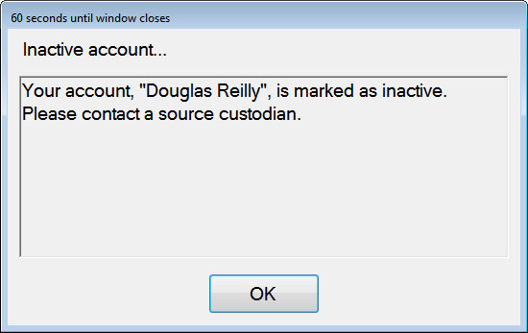
- Click OK.
- Select the Browse Sources button.
- Enter a Z number that does not exist (e.g. 777777). Log this in your Transaction Log to verify later that an email is sent.

- Verify that the Unrecognized Entry warning is displayed.
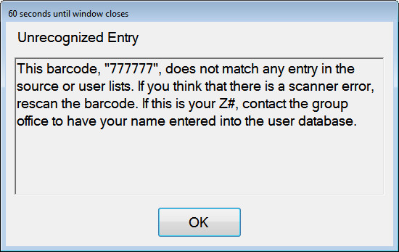
- Click OK.
- Select the Browse Sources button.
- Enter the normal user Z number as recorded in Section 5.1.
- Verify that the list of sources is displayed. Verify that the information displayed for the highlighted source includes the bar code number, source ID, isotope type, activity level, current owner, location, and MASS value.
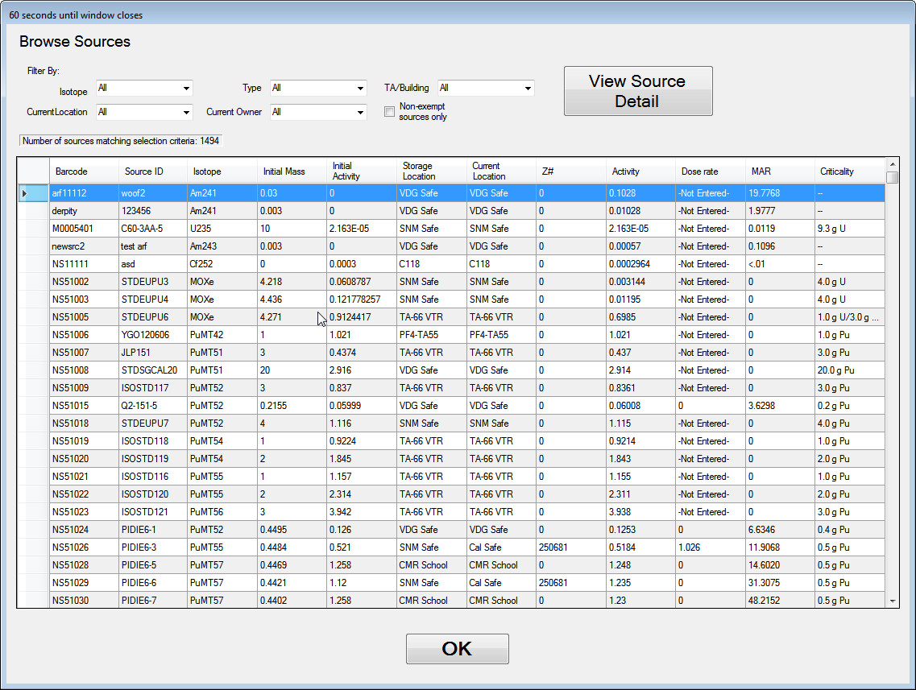
- Let the window time out.
- Verify that the program returns to the main menu.
- Select the Browse Sources button.
- Enter the normal user Z number.
- Select one of the sources in the list by highlighting it as shown.
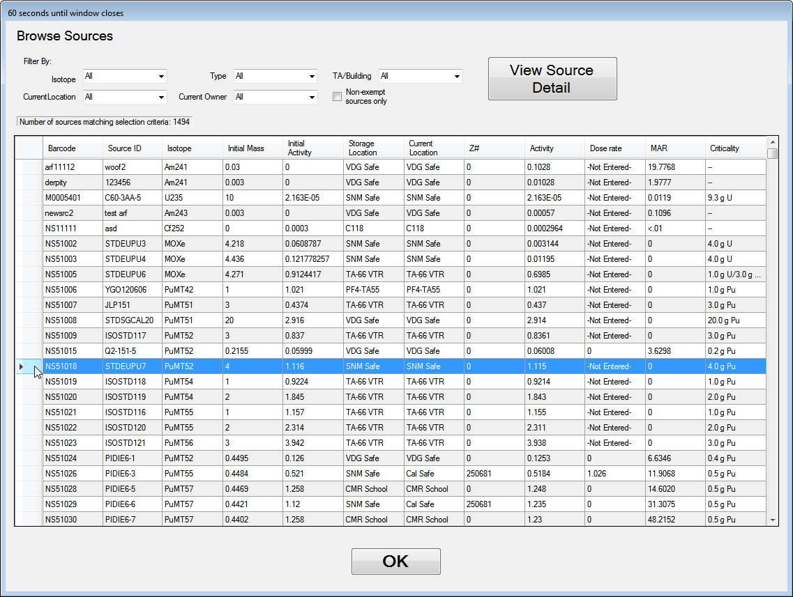
- Select the Source Details…button.

- Verify that the details for the source highlighted are displayed and that the data fields are read only (greyed out and do not respond to mouse clicks).
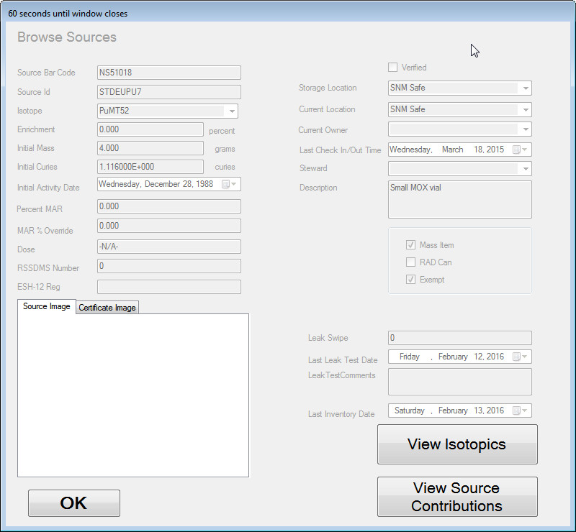
- Click Ok.
- Verify that the program returns you to the Browse Sources listing.
- Double click on one of the sources in the listing (a different one from the one selected before).
- Verify that the details for the source that was double-clicked are displayed and that the data fields are read only.
- Select the View Isotopics button.
- Click OK.

- Verify that the source isotopics are displayed and that the data fields are read only.
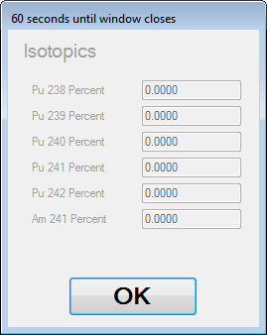
- Select the View Source Contributions button.
- Verify that the source contributions are displayed and that the data fields are read only.
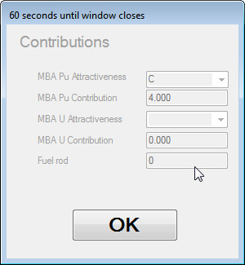
- Click OK.
- Click OK again to return to the Browse Sources listing.
- Clicking on each of the column headers in the data grid, sort the grid by each field as shown.
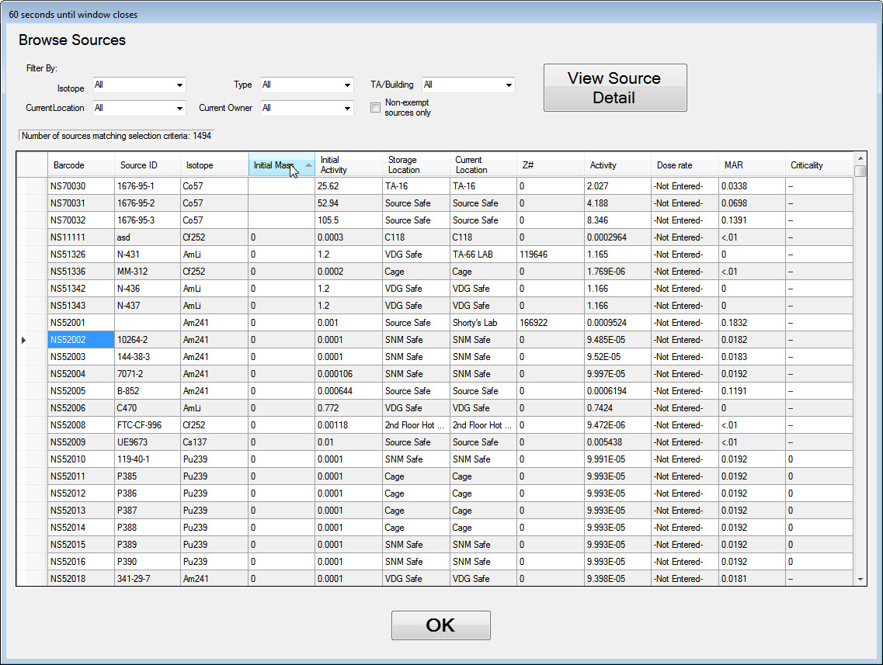
- Verify visually that the list of sources is sorted by the each column in ascending order.
- Select a column and verify that you see an arrow pointing upward and showing the list of items in that column alphabetically or numerically ascending. Press again to see that this arrow changes direction and the items are sorted in a descending order.
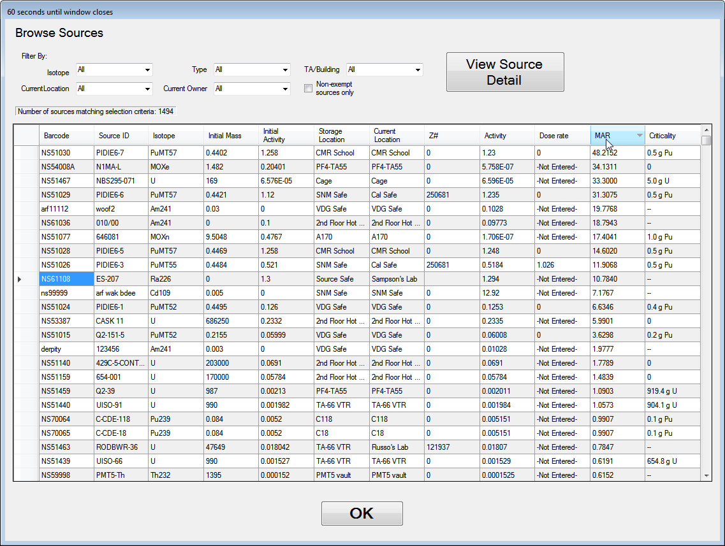
- Verify that the sources list is displayed in descending order by the selected columns.
- Note the number of sources displayed under the Current Location drop-down here.
______________________________________________
- Choose a random combination of selection criteria using the drop down menus and check box to select Isotope, Current Location, Current Owner, and Non-exempt sources only controls. Be sure to choose a set of selection criteria that displays more than one result. Note your selections here:
Isotope:
Current Location:
Current Owner:
Non-exempt sources only:
- Note the number of sources matching selection criteria for those selections here:
______________________________________________
- Choose a second random combination of selection criteria using the drop down menus and check box to select Isotope, Current Location, Current Owner, and Non-exempt sources only controls. Be sure to choose a set of selection criteria that displays more than one result. Note your selections here:
Isotope:
Current Location:
Current Owner:
Non-exempt sources only:
Note the number of sources matching selection criteria for those selections here:
______________________________________________
- Choose a TA/Building using the dropdown list. Make sure that all the other search criteria are set to “All” and the exempt checkbox unchecked. Be sure to choose a building that displays more than one result. Note your selection here:
TA/Building:
- Note the number of sources matching selection criteria for those selections here:
______________________________________________
- Choose a Source Type using the dropdown list. Make sure that all the other search criteria are set to “All” and the exempt checkbox unchecked. Be sure to choose a building that displays more than one result. Note your selection here:
Source Type:
Note the number of sources matching selection criteria for those selections here:
______________________________________________

- Click OK to exit the Browse Sources screen.
- Using remote desktop, login to the trackerbeta.lanl.gov server. Have a system admin help you with the next few steps.
- Open the SourceTrackerTest database and replicate the Browse Sources functionality by performing the following steps:
- To query for all sources in the database, use the provided SQL query in the file named SelectAllSources.sql.
- Note the number of records returned by the query _______________
- Next, repeat your 1st random query executing the SQL statement in the file SelectByCriteria.sql and replacing all the instances of REPLACE THIS with your selections noted above.
- Record the number of records returned here:
______________________________________________________
- Repeat the SQL query using your 2nd set of random selections and record the number of records returned here:
______________________________________________________
- To replicate the TA/Building query, execute the SQL query in SelectSourceByBuilding.sql, substituting the TA/Building combination you chose above.
- Record the number of records returned here:
______________________________________________________
- To replicate the Source Type query, execute the SQL query in SelectSourceByType.sql, substituting the Source Type combination you chose above.
- Record the number of records returned here:
______________________________________________________
- Click on the OK button.
- Verify that the program returns to the main menu.
- Click on the Browse Sources button.
- Select two users at random and use the drop down menu to filter the sources by those users. Note: you should choose users who have one or more sources assigned to them.
- Note those users here as well as the # of records shown for each in the Browse Sources Form:
__________________________________
__________________________________
- Exit the Browse Sources form. Press the Browse My Sources option, use one of the Z numbers noted above. Note the number of sources shown in the Browse My Sources form here:
_________________________________
- For each user, execute the following SQL query in SelectSourcesByUser.sql, replacing the fields with your randomly selected users.
- Verify each of your search criteria cases against the results shown in the Browse Sources and Browse My Sources form.
- From the Main Menu, select Custodian Operations.
- Enter a Custodian Z number.
- Select the Create Sources Summary File button.
- Use one of your search criteria above to filter the results. Note the number of records returned here:
_________________________________________________________
- Press the Email button. Log this in your transaction log. You will also need to note the Custodian you entered to get to this function. That is where the email report will be sent.
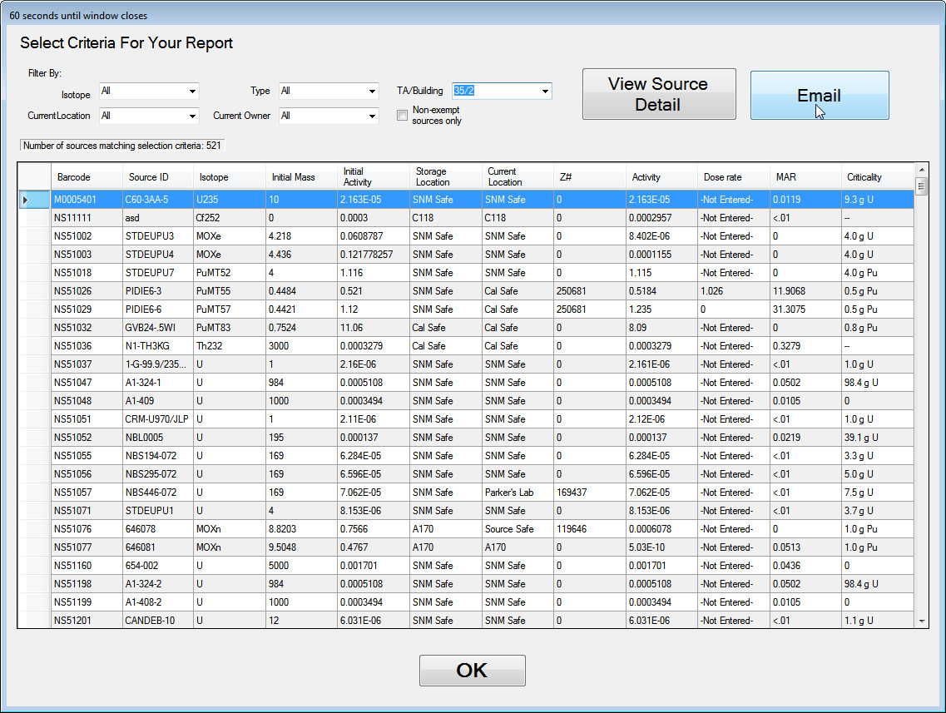
- Verify that the Email Sent form is shown to the screen.
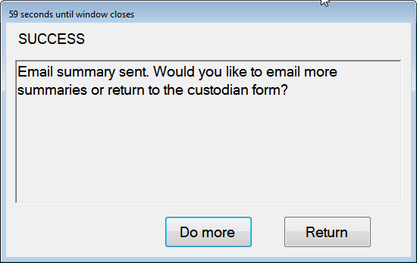
- Press Return.
- Verify that the program returns you to the Custodian Menu.
- Press OK to return to the Main Menu.
- Verify that an email is sent to the custodian and contains the same number of records noted above.
- Verify that the email warnings for unauthorized users logged at the beginning of this test case generated.

Table 5.5 Tests for Displaying a List of Sources
Test Results
Date: |  |  | Name of Tester: Signature: | Test Status
Not tested Tested
In Process
Date: |  |  | Name of Acceptance Authority: Signature: | Test Status
Accepted
Not Accepted
Acceptance
Notes:
 |  |  | Enter the version of software tested here:
 |  |  | Is this test being used for Regression Testing? Yes No
 |  |  | Is this a retest? Yes No
 |  |  | If a retest, comment or provide any documentation here of the version of software that failed, the items corrected before the retest and the new software version being tested:
Transaction Log
Date/Time: |  | Description of transaction |  | Type:
 |  |  |  | Email Log
 |  |  |  | Email Log
 |  |  |  | Email Log
 |  |  |  | Email Log
 |  |  |  | Email Log
 |  |  |  | Email Log
 |  |  |  | Email Log
 |  |  |  | Email Log
 |  |  |  | Email Log
 |  |  |  | Email Log
 |  |  |  | Email Log
 |  |  |  | Email Log
 |  |  |  | Email Log
 |  |  |  | Email Log
 |  |  |  | Email Log
 |  |  |  | Email Log
 |  |  |  | Email Log
 |  |  |  | Email Log
 |  |  |  | Email Log
 |  |  |  | Email Log
Test #: | Expected Results: |  |  | PASS/FAIL
48 | Verify that the Inactive Account warning is displayed. Log this in your Transaction Log to verify later that an email is sent. |  |  | Pass Fail
49 | Verify that the Unrecognized Entry warning is displayed. |  |  | Pass Fail
50 | Verify that the list of sources is displayed. Verify that the information displayed for the highlighted source includes the bar code number, source ID, isotope type, activity level, current owner, location, and MASS value. |  |  | Pass Fail
51 | Verify that the program returns to the main menu. |  |  | Pass Fail
52 | Verify that the details for the source highlighted are displayed and that the data fields are read only (greyed out and do not respond to mouse clicks). |  |  | Pass Fail
53 | Verify that the program returns you to the Browse Sources listing. |  |  | Pass Fail
54 | Verify that the details for the source that was double-clicked are displayed and that the data fields are read only. |  |  | Pass Fail
55 | Verify that the source isotopics are displayed and that the data fields are read only. |  |  | Pass Fail
56 | Verify that the source contributions are displayed and that the data fields are read only. |  |  | Pass Fail
57 | Verify visually that the list of sources is sorted by the each column in ascending order. |  |  | Pass Fail
58 | Verify that the sources list is displayed in descending order by the selected columns. |  |  | Pass Fail
59 | Verify that the program returns to the main menu. |  |  | Pass Fail
60 | Verify each of your search criteria cases against the results shown in the Browse Sources and Browse My Sources form. |  |  | Pass Fail
61 | Verify that the Email Sent form is shown to the screen. |  |  | Pass Fail
62 | Verify that the program returns you to the Custodian Menu. |  |  | Pass Fail
63 | Verify that an email is sent to the custodian and contains the same number of records noted above. |  |  | Pass Fail
64 | Verify that the email warnings for unauthorized users logged at the beginning of this test case generated. |  |  | Pass Fail
Comments

Confirm Inventory [Demonstration/Communication Test]

Purpose
Verify that the source locations identified in the database are the actual location of the source and that the designated owner is valid. Verify that the inventory is completed with the six month period required by the Department of Energy.

Input
The custodian Z number is required as input to this option, as well as scanned barcodes of the items being inventoried.

Output
A summary list of the sources that have been confirmed will be emailed to the custodian. A flag in the database table, “Sources” is set for each source that has been confirmed and an inventory date (current date) is written to the inventory date field.

Process Steps
- Select the Custodian Operations option from the main menu.
- Enter the Custodian Z number.
- Select Confirm Inventory… option.
- Select the Checked Out Only radio button.
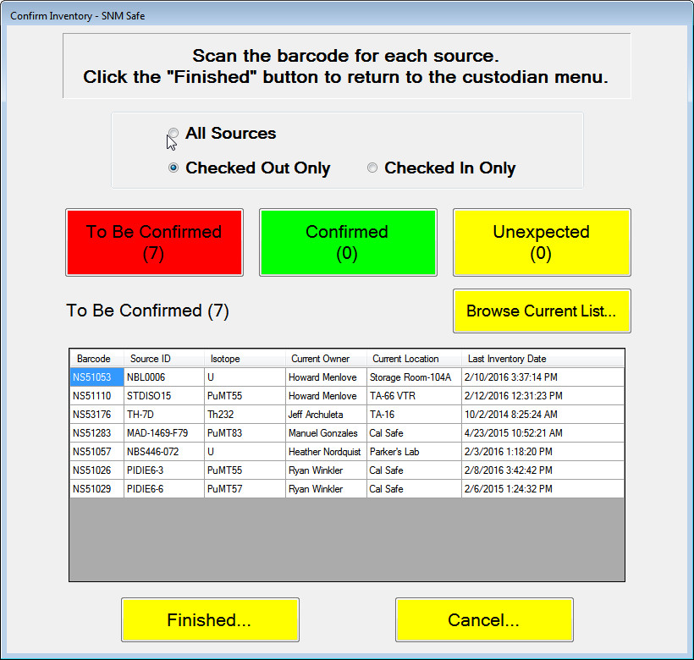
- Scan the bar code of two of the sources listed.

- Verify that the sources that have been scanned for confirmation are removed from the list displayed and that the number to be confirmed is reduced.
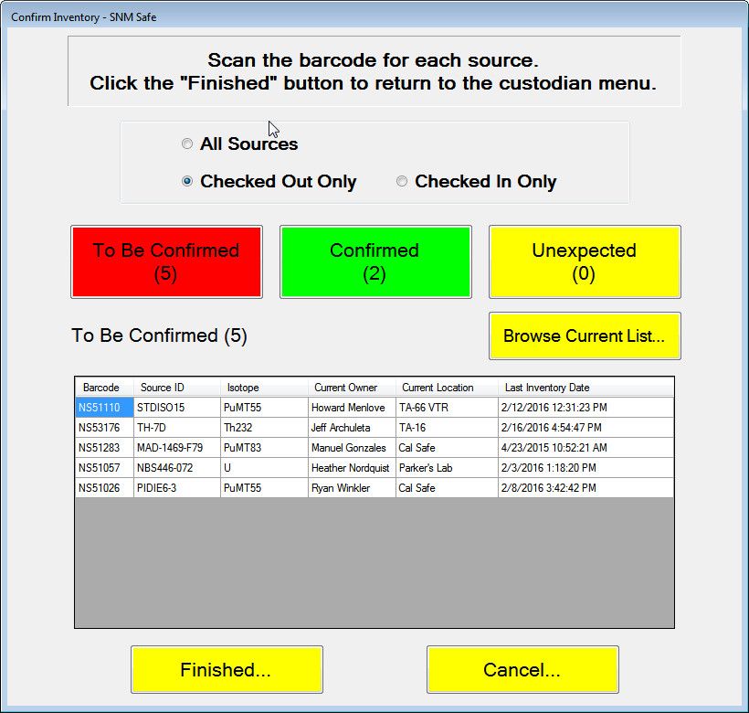
- Select the Cancel button.
- Verify that the following message occurs. The number shown could be different.
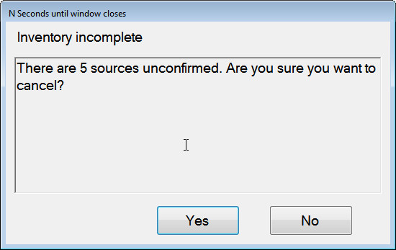
- Select the No button.
- Verify that the Confirm Inventory screen remains displayed.
- Select the Cancel button again.
- Select the Yes button.
- Verify that a notification message is displayed.
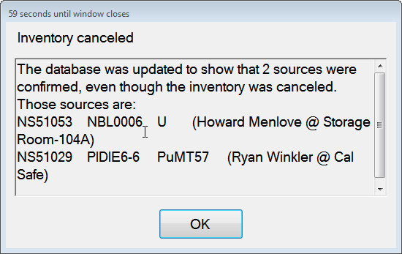
- Select OK.
- Verify that the program returns to the Custodian Operations screen.
- Select the Confirm Inventory button.
- Scan two barcodes of sources.
- Select a source that is “past due” on its leak test. (it may be necessary to make a change in the database).
- Verify that a warning is displayed (below) indicating that the leak test for the “past due” source has expired.
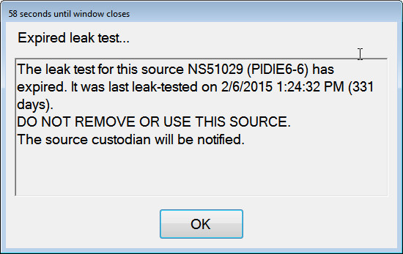
- Select OK.
- Verify that the sources are removed from the displayed list.
- Select the Finished button, logging this in your transaction log.
- Press Yes when you are warned that not all sources have been inventoried.
- Verify that the program returns to the Custodian Operations screen.
- Select the Confirm Inventory button.
- Select the Browse Current List… button.
- Verify that the detailed list for each of the sources is displayed.
- Select the OK button.
- Select the Finished… button, logging this in your transaction log.
- Verify that a notification window is displayed warning that not all sources have been inventoried.
- Select Yes.
- Select the Confirm Inventory button.
- Select the Checked Out Only button.
- Verify that the sources you inventoried have an updated inventory date.
- Select the Checked In Only button.
- Scan two barcodes of sources.
- Verify that the display lists as Current Owner “No One”
- Select the Finished… button, logging this transaction in your transaction log for email notification only.
- Select Yes.
- Select the Confirm Inventory button.
- Confirm that the source inventory date is updated.
- Scan two barcodes of sources, making sure to scan a source that is not at that location.
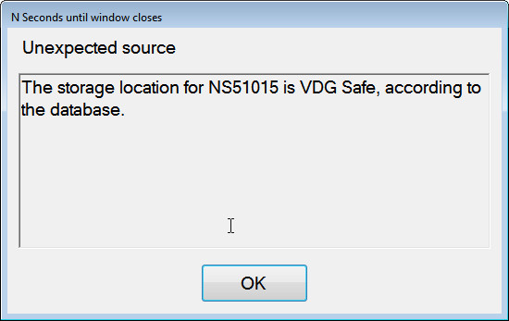
- Confirm that a display window (above) appears and that the “Unexpected” count increases by one.
Click OK.
- Click Finished… logging is transaction in your transaction log for email notification only.
- Click Yes when warned that the inventory is not complete.
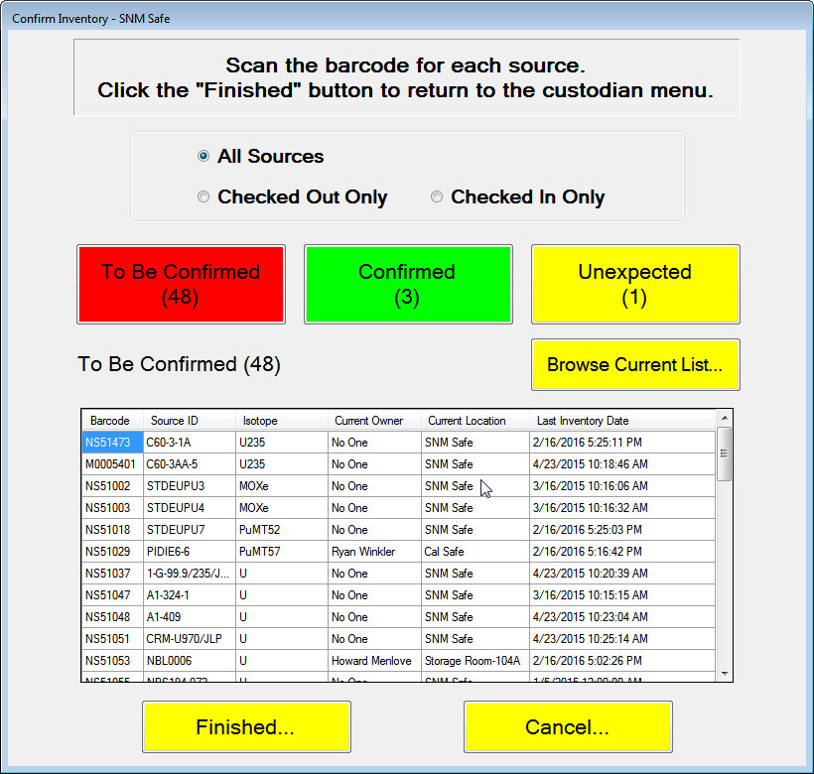
- Confirm that the emails sent in this section include information showing that a list of sources are confirmed and, if a source is unexpected, it should be included in the summarized list.
Note: The inventory process generates email but does not get entered in the transaction log.
- Click Return to Main Screen.

Table 5.6 Tests for Confirm Inventory
Test Results
Date: |  |  | Name of Tester: Signature: |  |  | Test Status
Not tested Tested
In Process
Date: |  |  | Name of Acceptance Authority: Signature: |  |  | Test Status
 |  |  |  |  |  | Accepted Not Accepted
Acceptance
Notes:
 |  |  | Enter the version of software tested here:
 |  |  | Is this test being used for Regression Testing? Yes No
 |  |  | Is this a retest? Yes No
 |  |  | If a retest, comment or provide any documentation here of the version of software that failed, the items corrected before the retest and the new software version being tested:
Transaction Log
Date/Time: |  | Description of transaction |  |  | Type:
 |  |  |  |  | Email Log
 |  |  |  |  | Email Log
 |  |  |  |  | Email Log
 |  |  |  |  | Email Log
 |  |  |  |  | Email Log
 |  |  |  |  | Email Log
 |  |  |  |  | Email Log
 |  |  |  |  | Email Log
 |  |  |  |  | Email Log
 |  |  |  |  | Email Log
 |  |  |  |  | Email Log
 |  |  |  |  | Email Log
 |  |  |  |  | Email Log
 |  |  |  |  | Email Log
 |  |  |  |  | Email Log
 |  |  |  |  | Email Log
 |  |  |  |  | Email Log
 |  |  |  |  | Email Log
 |  |  |  |  | Email Log
 |  |  |  |  | Email Log
 |  |  |  |  | Email Log
Test #: | Expected Results: |  |  | PASS/FAIL
65 | Verify that the sources that have been scanned for confirmation are removed from the list displayed and that the number to be confirmed is reduced. |  |  | Pass Fail
66 | Verify that the following message occurs. The number shown could be different. |  |  | Pass Fail
67 | Verify that the Confirm Inventory screen remains displayed. |  |  | Pass Fail
68 | Verify that a notification message is displayed. |  |  | Pass Fail
69 | Verify that the program returns to the Custodian Operations screen. |  |  | Pass Fail
70 | Verify that a warning is displayed (below) indicating that the leak test for the “past due” source has expired. |  |  | Pass Fail
71 | Verify that the sources are removed from the displayed list. |  |  | Pass Fail
72 | Verify that the program returns to the Custodian Operations screen. |  |  | Pass Fail
73 | Verify that the detailed list for each of the sources is displayed. |  |  | Pass Fail
74 | Verify that the sources you inventoried have an updated inventory date. |  |  | Pass Fail
75 | Verify that the display lists as Current Owner “No One” |  |  | Pass Fail
76 | Confirm that the source inventory date is updated. |  |  | Pass Fail
77 | Confirm that a display window (above) appears and that the “Unexpected” count increases by one. |  |  | Pass Fail
78 | Confirm that the emails sent in this section include information showing that a list of sources are confirmed and, if a source is unexpected, it should be included in the summarized list. |  |  | Pass Fail
Comments

Transfer a Source Permanently from one Location to Another [Demonstration/Communication Test]

Purpose
Verify that the custodian can permanently transfer a source to another location.

Input
The custodian Z number and the source id are entered.

Output
If the transfer is completed, the new location of the source is entered into the database.

Process Steps
Select the Custodian Operations… button.
Enter the custodian Z number.
Select the Permanently Transfer Source… option.
Select Source #1.
- Verify that a MASS notice message is displayed.
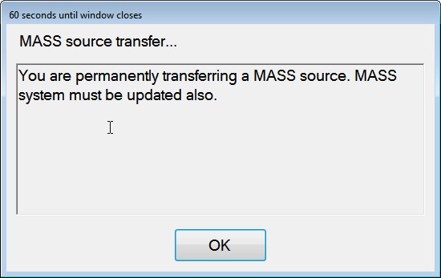
Click OK.

- Verify that the MASS locations are displayed.
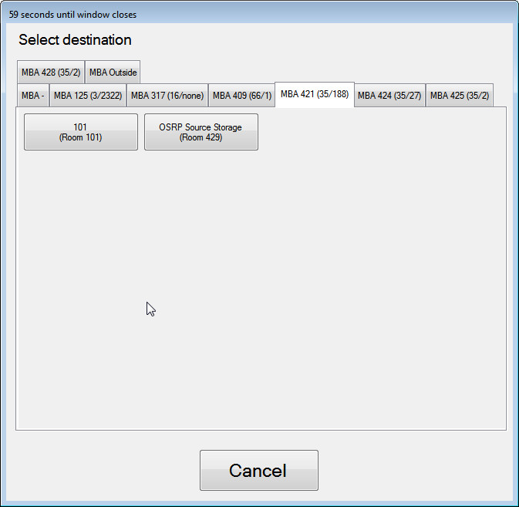
Click on the Cancel button.
Using the Create Sources Summary File option and browse for Source #1.
- Verify that the source was not moved from your currently location (SNM Safe)
Press OK.
- Verify that the program returns to the Custodian Operations screen.
Select the Permanently Transfer Source… option.
Select Source #1.
Select OK.
Select a room from those displayed.
- Verify that the Confirm Source Transfer window is displayed and the new location for the source is identified in the window.
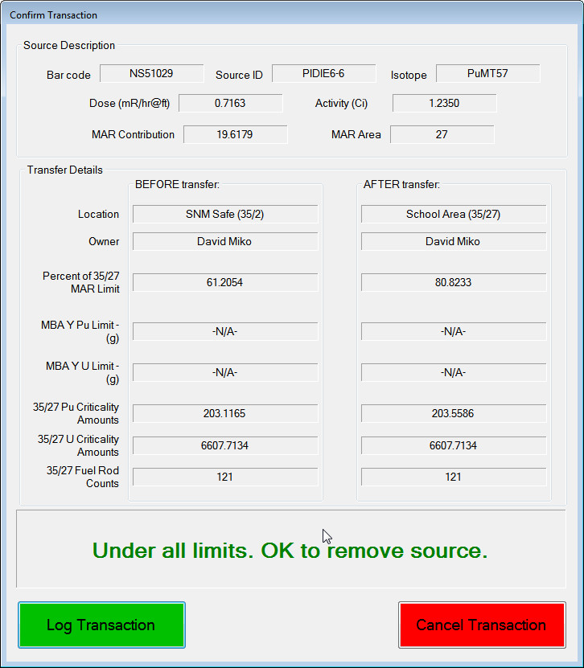
Select Cancel Transaction
Using the Create Sources Summary File option and browse for Source #1.
- Verify that the source was not moved from your currently location (SNM Safe)
Click OK
Select Source #1.
Select a room to transfer the source to.
Select the Log Transaction button and note this on your Transaction Log.
Using the Create Sources Summary File option and browse for Source #1.
- Verify that the source was moved from your currently location (SNM Safe) to the selected location and that the new location was set as the storage location.
Click OK
Click Return to Main Screen option.
- Verify that the MASS emails were sent to the custodian as shown in your handwritten log.

Table 5.7 Tests for Transfer of a Source Permanently
Test Results
Date: |  |  | Name of Tester: Signature: | Test Status
Not tested Tested
In Process
Date: |  |  | Name of Acceptance Authority: Signature: | Test Status
Accepted
Not Accepted
Acceptance
Notes:
 |  |  | Enter the version of software tested here:
 |  |  | Is this test being used for Regression Testing? Yes No
 |  |  | Is this a retest? Yes No
 |  |  | If a retest, comment or provide any documentation here of the version of software that failed, the items corrected before the retest and the new software version being tested:
Transaction Log
Date/Time: |  | Description of transaction |  | Type:
 |  |  |  | Email Log
 |  |  |  | Email Log
 |  |  |  | Email Log
 |  |  |  | Email Log
 |  |  |  | Email Log
 |  |  |  | Email Log
Test #: | Expected Results: |  |  |  | PASS/FAIL
79 | Verify that a MASS notice message is displayed. |  |  |  | Pass Fail
80 | Verify that the MASS locations are displayed. |  |  |  | Pass Fail
81 | Verify that the source was not moved from your currently location (SNM Safe) |  |  |  | Pass Fail
82 | Verify that the program returns to the Custodian Operations screen. |  |  |  | Pass Fail
83 | Verify that the Confirm Source Transfer window is displayed and the new location for the source is identified in the window. |  |  |  | Pass Fail
84 | Verify that the source was not moved from your currently location (SNM Safe) |  |  |  | Pass Fail
85 | Verify that the source was moved from your currently location (SNM Safe) to the selected location and that the new location was set as the storage location. |  |  |  | Pass Fail
86 | Verify that the MASS emails were sent to the custodian as shown in your handwritten log. |  |  |  | Pass Fail
Comments

Edit Program Parameters [Demonstration/Failure Mode Test]

Purpose
Verify that when values are entered into the dialog window that they are recorded in the registry in order to be used in the program. Test the Bar Code Scanner to ensure that it works as required.

Input
The custodian Z number and barcode Scanner input are required for this option.

Output
Certain values set by the custodian are written to the application’s *.config file (location, database). Others are stored in the central database (leak test parameters).

Process Steps
Select Custodian Operations from the Main Menu.
Enter a Custodian Z number.
Select Edit Program Settings from the Custodian Menu.
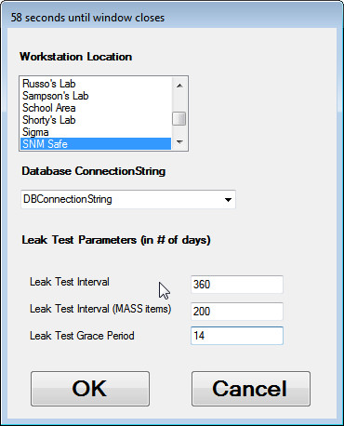
Set MASS, non-MASS and Grace Period parameters to values different than are shown. Note those here:
MASS interval:
Non-MASS interval:
Grace Period:
Press OK.
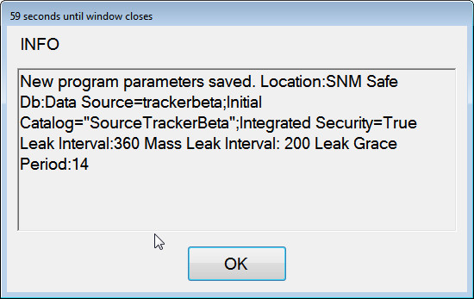
- Verify that a summary of parameter changes is displayed.
Using remote desktop and the file CheckLeakTestParms.sql, retrieve the current leak test parameters from the database.
- Verify that the leak test parameters were successfully written to the database.
Exit Source Tracker
Replace the config file provided by the System Administrator in the Source Tracker installation folder.
Restart Source Tracker
Select Custodian Operations
Enter a Custodian Z Number
Select Edit Program Settings
Select the database called “Bogus” in the drop-down list under the label Database Connection String. Note: The timeout operation for connecting to a non-existent database is quite slow. Be patient.
Press OK.
- Verify that a message is displayed that the main database could not be opened.
Press OK.
- Verify the error warning that the application will reconnect to the previous database.
Press OK.
Select Edit Program Settings
Select the database called “Alternate” in the drop-down list under the label Database Connection String.
- Verify that confirmation the database was switched is displayed to the screen.
Press OK.
Select Return to Main Screen.
Click OK.
Exit the application and restart it.

Table 5.8 Tests for Edit Program Parameters
Test Results
Date: |  | Name of Tester: Signature: |  | Test Status
Not tested Tested
In Process
Date: |  | Name of Acceptance Authority: Signature: |  | Test Status
 |  |  |  | Accepted Not Accepted
Acceptance
Notes:
 |  | Enter the version of software tested here:
 |  | Is this test being used for Regression Testing? Yes No
 |  | Is this a retest? Yes No
 |  | If a retest, comment or provide any documentation here of the version of software that failed, the items corrected before the retest and the new software version being tested:
Test #: | Expected Results: |  | PASS/FAIL
87 | Verify that a summary of parameter changes is displayed. |  | Pass Fail
88 | Verify that the leak test parameters were successfully written to the database. |  | Pass Fail
89 | Verify that a message is displayed that the main database could not be opened. |  | Pass Fail
90 | Verify the error warning that the application will reconnect to the previous database. |  | Pass Fail
91 | Verify that confirmation the database was switched is displayed to the screen. |  | Pass Fail
Comments

Leak Test Selected Sources [Demonstration/Communication Test]

Purpose
Verify that the user is able to perform leak testing on a few selected sources and that an email message of only those sources leak tested and/or selected will be sent to the custodian.

Input
This option requires a user with custodian privileges to perform the task.

Output
The Source Tracker database is updated. An email is sent to the custodian indicating which sources need to be leak tested.

Process Steps
Select Custodian Operations
- Verify that the user is prompted for the Custodian z number.
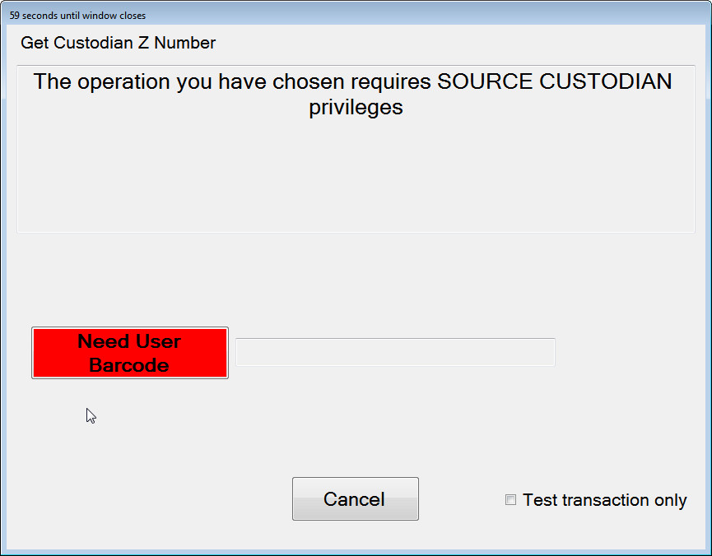
Let the time elapse.
- Verify that the program returns to the main screen.
Select the Custodian Operations button again and enter a custodian Z number.
- Verify that Custodian Operations window is displayed.
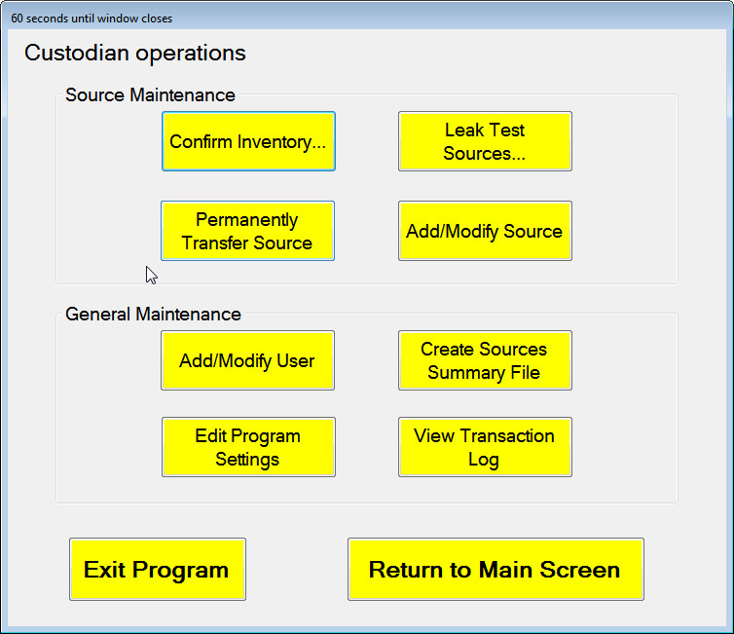
Select Leak Test Sources
The Confirm Inventory Check Box should be unselected
Scan barcodes for three of the source ids listed in the window.
- Verify that the “To Be Leak Tested” and “Leak Tested” numbers are changed by three.
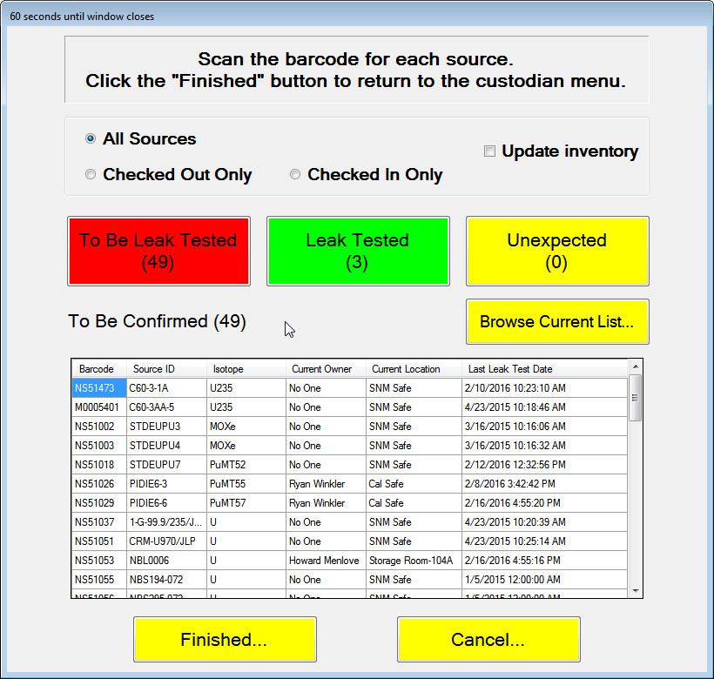
Click on the Finished… button and enter this transaction in your Transaction Log.
- Verify that the warning that all sources weren’t leak tested is displayed.
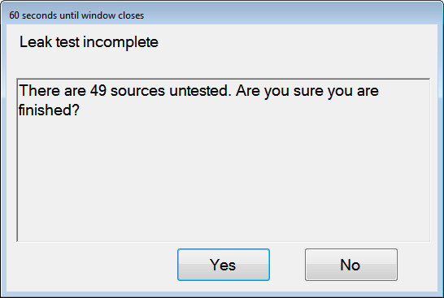
Click Yes to proceed.
- Verify that the custodian is sent an email listing the sources that were tested.
- Using the Create Source Summary File option, browse and verify that the source leak test dates have been updated for the three sources.
Enter the Custodian Operations options again and select the Leak Test Sources option.
The Confirm Inventory Check Box should be unselected
Scan three new sources to be leak tested.
Click on the Cancel… button.
- Verify that the following message occurs.
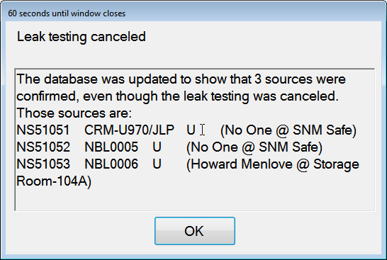
Select No.
- Verify that the Leak Test Sources window remains.
Select the Cancel button again and select Yes on the message window. Enter in the Transaction Log noting that an email SHOULD NOT be sent.
- Verify that the custodian does not receive a message and the figure above appears.
Select the Leak Test Sources… option again.
The Confirm Inventory check box should be selected.
Scan two sources for leak test and confirmation.
Select Finished and enter this in your Transaction Log.
Select OK.
- Verify that the sources are also marked as inventoried by browsing the listing in the Create Sources Summary File option and in the contents of the email.
Select Return to Main Menu
- Verify that emails arrived as logged in your Transaction Log.

Table 5.9 Tests for Leak Test Selected Sources
Test Results
Date: |  |  | Name of Tester: Signature: |  |  | Test Status
Not tested Tested
In Process
Date: |  |  | Name of Acceptance Authority: Signature: |  |  | Test Status
 |  |  |  |  |  | Accepted Not Accepted
Acceptance
Notes:
 |  |  | Enter the version of software tested here:
 |  |  | Is this test being used for Regression Testing? Yes No
 |  |  | Is this a retest? Yes No
 |  |  | If a retest, comment or provide any documentation here of the version of software that failed, the items corrected before the retest and the new software version being tested:
Transaction Log
Date/Time: |  | Description of transaction |  |  | Type:
 |  |  |  |  | Email Log
 |  |  |  |  | Email Log
Test #: | Expected Results: |  |  | PASS/FAIL
92 | Verify that the user is prompted for the Custodian z number. |  |  | Pass Fail
93 | Verify that the program returns to the main screen. |  |  | Pass Fail
94 | Verify that Custodian Operations window is displayed. |  |  | Pass Fail
95 | Verify that the “To Be Leak Tested” and “Leak Tested” numbers are changed by three. |  |  | Pass Fail
96 | Verify that the warning that all sources weren’t leak tested is displayed. |  |  | Pass Fail
97 | Verify that the custodian is sent an email listing the sources that were tested. |  |  | Pass Fail
98 | Using the Create Source Summary File option, browse and verify that the source leak test dates have been updated for the three sources. |  |  | Pass Fail
99 | Verify that the following message occurs. |  |  | Pass Fail
100 | Verify that the Leak Test Sources window remains. |  |  | Pass Fail
101 | Verify that the custodian does not receive a message and the figure above appears. |  |  | Pass Fail
102 | Verify that the sources are also marked as inventoried by browsing the listing in the Create Sources Summary File option and in the contents of the email. |  |  | Pass Fail
103 | Verify that emails arrived as logged in your Transaction Log. |  |  | Pass Fail
Comments

Add/Remove/Modify Source [Demonstration/Validation/Communication/Boundary Condition Test]

Purpose
Verify that Custodians may enter new sources in the Source Tracker database using the program interface. Verify that newly entered sources are “unverified” until other custodians are notified and verify the source entry. Verify that Custodians can make changes to existing sources in the database. Verify that custodians can add source and certificate photos to the database and that those pictures are accessible to normal users when viewing source details.

Input
This input will be done via keyboard/mouse at a Custodian PC and not at a Source Tracker workstation. All source information for new sources should be input. At least two custodian z numbers will be required to complete the verification process. Source and certificate photos should be added to the database, and users should be able to view these photos in the source details of the Browse Sources form. For testing purposes, any two image files may be used.

Output
New source records are added to the database or existing records are updated. Photos are added to the database and can be viewed in the Browse Sources form.

Process Steps
Select Custodian Operations and enter a custodian Z number.
Select Add/Modify Source
Enter a new source not in the database (the system admin can provide a barcode of a source not present in the database for testing).
Fill in some basic information about the source. Required fields are marked on the form. Leave both the Initial Activity and Initial Mass fields blank.
Click Save.
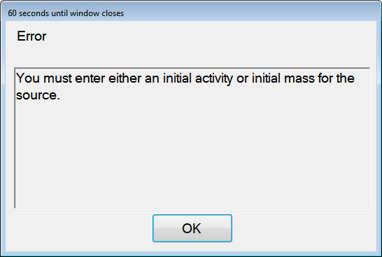
- Verify that a message is displayed that you must specify either the initial mass or initial activity.
Click OK.
Fill in the Initial Activity or Initial Mass field but remove the isotope. Click Save.
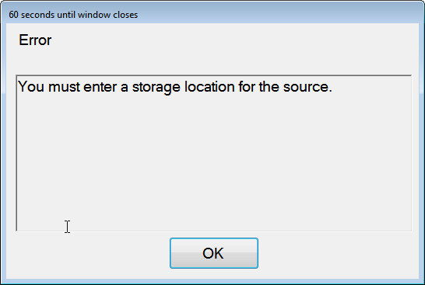
- Verify that a message is displayed that you must specify a storage location.
Click OK. Fill in the isotope field but remove the isotope. Click Save.
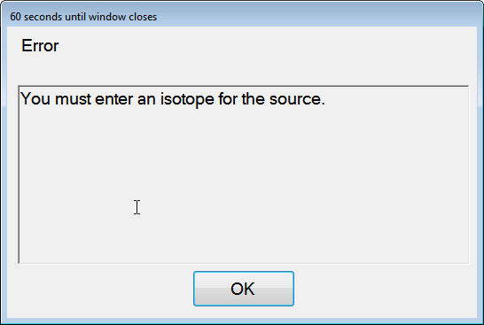

- Verify that a message is displayed that you must specify an isotope.
Click OK. Fill in the source id, but leave the location blank. Click Save.
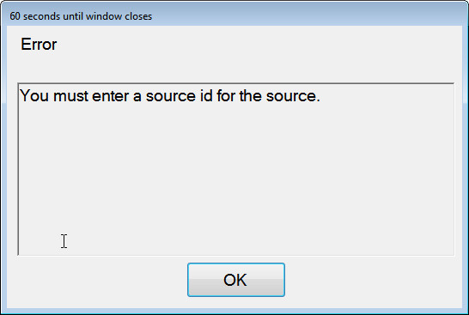
- Verify that a message is displayed that you must specify a source id.
Click OK. Select a valid location from the list.
Note your entries here:
Barcode:
Source ID:
Initial Activity/Mass:
Isotope
Location
Click Save. Note this in your Transaction Log to verify that an email is sent later in the procedure.
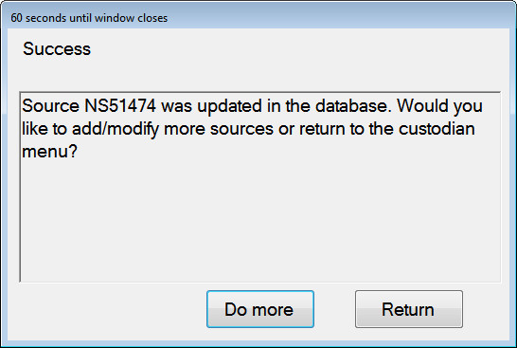
- Verify that a message is displayed indicating the source was added to the database.
Click Return to return to the Custodian Menu.
Use the Create Sources Summary File to browse sources and view the newly added source. Double-click the line in the display or select it and hit Source Detail to view the source detail for the newly added source.
- Verify that the source is in the list, that the values you entered are displayed and that the status in the upper right-hand corner shows the source is NOT verified.
Click OK to exit the Source Detail screen, then OK again to exit the Create Sources Summary File form.
Click Add/Modify Source. Enter the same custodian Z number that was used to add the source.
Scan the newly added source barcode.
- Verify that the “Verified” checkbox is disabled.
Click Cancel and then Return to Main Screen to return to the Main Menu.
Select Custodian Operations, this time logging in with a DIFFERENT Z number than was used to add the source.
Check the “Verified” checkbox and press Save.
- Verify that a message is displayed that the changes were saved.
Select Do More to return to Add/Modify Source form.
Scan the barcode of the source you just verified.
Select the View/Change Isotopics button
- Verify that the Isotopics for the source are shown.
Enter Pu isotopic values whose sum < 100. Press OK.
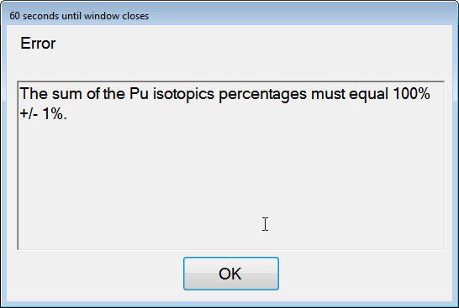
- Verify that a warning that the values must sum to 100 is displayed.
Press OK. Enter Pu isotopic values whose sum > 100. Press OK.
- Verify that a message is displayed that the isotopic values must add up to 100.
Press OK. Change the Pu isotopic values again so that they add up to 100.
Note those values here:
Pu238:
Pu239:
Pu240:
Pu241:
Pu242:
Am241:
Click OK.
Verify that the program returns you to the Source Info form.
Press Cancel
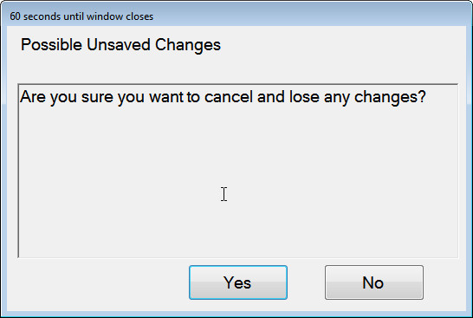
- Verify that a warning that unsaved changes will be lost is displayed.
Press No
- Verify that the program returns you to the Source add/modify page.
Press Save.
When prompted, select Do More to return to the source add/modify page.
Scan the barcode of your added source again.
Press the View/Change Source Contributions button.
Select a Pu and U Contribution and Attractiveness and set some number of fuel rods in the fuel rods field.
Note those values here:
Pu Attractiveness:
Pu Contribution
U Attractiveness:
U Contribution:
Fuel Rods:
Press OK.
Press Save.
When prompted, select Return to return to the Custodian Menu.
Select Add/Modify Source and enter a custodian Z number.
Scan the same source we have been modifying.
Click on the Source Image screen.
- Verify that a file browser is shown to allow you to choose an image for the source.
Choose one and press Open.
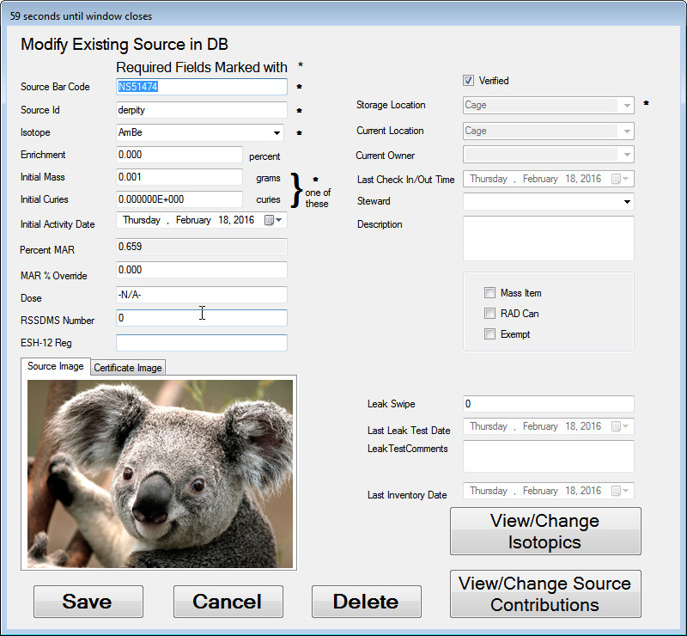
- Verify that the photo is added to the Source Image Tab.
Click on the Certificate Image tab and choose a photo for it.
Press Save, then press Return, then press Return to Main Screen.
Click Browse Sources and enter a normal user’s Z Number.
Find your added source in the listing and double-click to view the source detail.
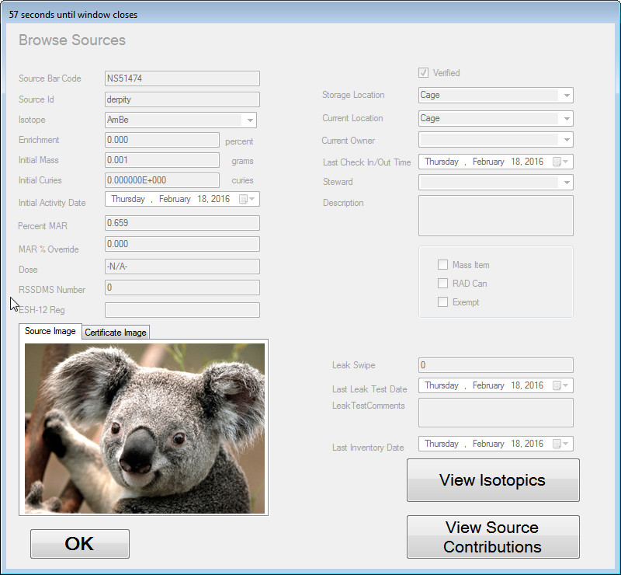
- Verify that the information displayed matches the information you entered, and that the images you added are visible in this view.
Click OK to return to the Main Menu
Choose Custodian Operations and enter a custodian Z number
Select Add/Modify Source
Scan the same barcode added earlier.
Press Delete.
- Verify that the source is deleted by looking in the Source Summary …..
Choose Add/Modify Source and enter Custodian Z Number.
Scan the barcode you just deleted.
Add details, recording your entries here on the next page, being sure to select a MASS location from the “Storage Location” list.
Select the “MASS Item” checkbox.
- Verify that Storage Location is reset and that a list of only MASS locations is displayed.
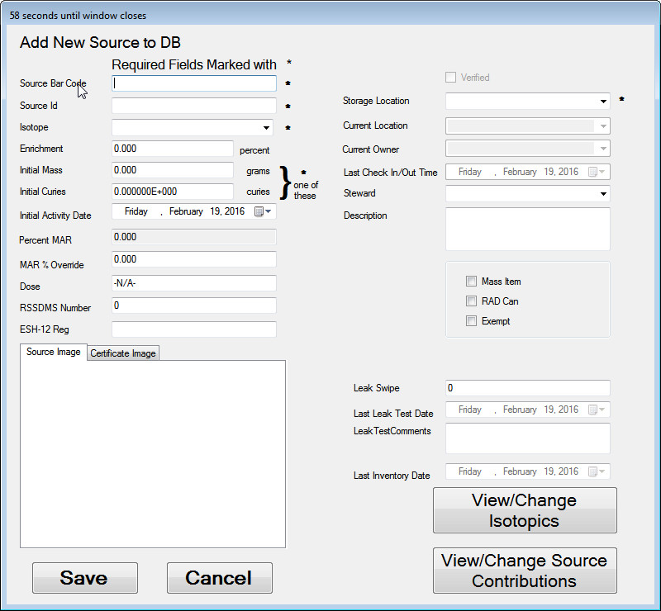
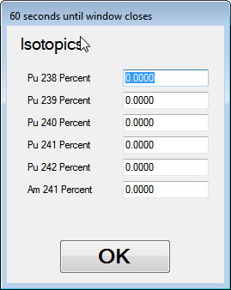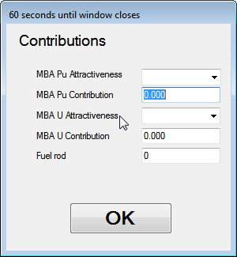

- SELECT A MASS LOCATION
Select a valid MASS location. Click Save. Note this in your Transaction Log to verify that an email is sent for verification.
Using the Choose Create Sources Summary option, find the newly added source, double-click to view details.
- Verify the data entered matches source detail.
Return to the in Menu.
Try to check out the source.
- Verify that the transaction is not allowed.
Try to re-assign the source
- Verify that the transaction is not allowed.
Try to permanently transfer the source.
- Verify that the transaction is not allowed.
- Verify that verification emails were sent as recorded in the handwritten Transaction Log.

Table 5.10 Tests for Add/Modify Source
Test Results
Date: |  |  | Name of Tester: Signature: |  |  | Test Status
Not tested Tested
In Process
Date: |  |  | Name of Acceptance Authority: Signature: |  |  | Test Status
 |  |  |  |  |  | Accepted Not Accepted
Acceptance
Notes:
 |  |  | Enter the version of software tested here:
 |  |  | Is this test being used for Regression Testing? Yes No
 |  |  | Is this a retest? Yes No
 |  |  | If a retest, comment or provide any documentation here of the version of software that failed, the items corrected before the retest and the new software version being tested:
Transaction Log
Date/Time: |  | Description of transaction |  |  | Type:
 |  |  |  |  | Email Log
 |  |  |  |  | Email Log
 |  |  |  |  | Email Log
 |  |  |  |  | Email Log
 |  |  |  |  | Email Log
 |  |  |  |  | Email Log
 |  |  |  |  | Email Log
 |  |  |  |  | Email Log
 |  |  |  |  | Email Log
 |  |  |  |  | Email Log
 |  |  |  |  | Email Log
Test #: | Expected Results: |  |  | PASS/FAIL
104 | Verify that a message is displayed that you must specify either the initial mass or initial activity. |  |  | Pass Fail
105 | Verify that a message is displayed that you must specify a storage location. |  |  | Pass Fail
106 | Verify that a message is displayed that you must specify an isotope. |  |  | Pass Fail
107 | Verify that a message is displayed that you must specify a source id. |  |  | Pass Fail
108 | Verify that a message is displayed indicating the source was added to the database. |  |  | Pass Fail
109 | Verify that the source is in the list, that the values you entered are displayed and that the status in the upper right-hand corner shows the source is NOT verified. |  |  | Pass Fail
110 | Verify that the “Verified” checkbox is disabled. |  |  | Pass Fail
111 | Verify that a message is displayed that the changes were saved. |  |  | Pass Fail
112 | Verify that the Isotopics for the source are shown. |  |  | Pass Fail
113 | Verify that a warning that the values must sum to 100 is displayed. |  |  | Pass Fail
114 | Verify that a message is displayed that the isotopic values must add up to 100. |  |  | Pass Fail
115 | Verify that a warning that unsaved changes will be lost is displayed. |  |  | Pass Fail
116 | Verify that the program returns you to the Source add/modify page. |  |  | Pass Fail
117 | Verify that a file browser is shown to allow you to choose an image for the source. |  |  | Pass Fail
118 | Verify that the photo is added to the Source Image Tab. |  |  | Pass Fail
119 | Verify that the information displayed matches the information you entered, and that the images you added are visible in this view. |  |  | Pass Fail
120 | Verify that the source is deleted by looking in the Source Summary ….. |  |  | Pass Fail
121 | Verify that Storage Location is reset and that a list of only MASS locations is displayed. |  |  | Pass Fail
122 | SELECT A MASS LOCATION |  |  | Pass Fail
123 | Verify the data entered matches source detail. |  |  | Pass Fail
124 | Verify that the transaction is not allowed. |  |  | Pass Fail
125 | Verify that the transaction is not allowed. |  |  | Pass Fail
126 | Verify that the transaction is not allowed. |  |  | Pass Fail
127 | Verify that verification emails were sent as recorded in the handwritten Transaction Log. |  |  | Pass Fail
Comments

Add/Remove/Modify User [Demonstration/Validation Test]

Purpose
Verify that the custodians can add/modify and delete authorized users in the Source Tracker program.

Input
The user id barcode is required.

Output
Authorized user records are added/deleted/updated in the Source Tracker central database.

Process Steps
Select Remove Source from Home Repository.
Scan the deactivated user on your barcode sheet. Note this on your Transaction Log to verify that a notification is sent to the custodians about an unauthorized user.
- Verify that an error is displayed showing the user is inactive.
Press OK, then press Cancel to return to the Main Menu.
Select Custodian Operations and enter a custodian Z number.
Select Add/Modify User
Scan the barcode for the deactivated user.
Select the checkbox marked “Active”
Select Save/Update.
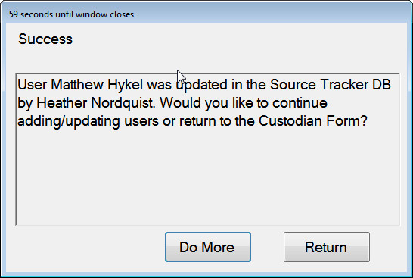
- Verify that a message showing the user record was updated is shown.
Select Return to get to the Custodian Menu, then Return to Main Screen to return to the Main Menu.
Try checking out a non-MASS source from the Main Menu by selecting Remove Source From Home Repository. Scan the user you just modified to be active.
- Verify that the user is now able to see destination locations for the source.
Select Cancel.
Try checking out a non-MASS RSSDMS source from the Main Menu by selecting Remove Source From Home Repository. Scan the user you just modified to be active and the RSSDMS source noted in Section 5.1.
Complete the checkout transaction, noting it in your Transaction Log to verify that a notification of the transfer of an RSSDMS source is emailed to custodians.
Try checking out a MASS source from the Main Menu by selecting Remove Source From Home Repository. Scan the user you just modified to be active.
When the barcode and user have been scanned. When the MASS source warning is shown, select OK to continue.
When prompted whether you l move outside the MBA, choose to move outside the MBA.
- Verify that you are prompted to enter a MASS user.
Scan the same user again.
Verify that the MASS user field is not filled with this user’s Z number.
Press Cancel to return to the Main Menu.
Select Custodian Operations and enter a custodian Z number.
Select Add/Modify User and scan the same user again.
Select the “MASS Authorize” checkbox and enter an email that you will have access to. Press Save/Update.
Select Return to return to the Custodian Menu, then Return to Main Menu to return to the Main Menu.
Repeat the steps to try to check out a MASS source outside the MBA.
Complete the MASS source checkout, entering this on the Transaction Log. Note, since this user is now a MASS user and not a custodian, he will not receive the email, but custodians will.
- Verify that the user is now a MASS user because he is allowed to check out a MASS source.
Check the source back in, logging the transaction in the transaction log. Again, custodians should receive an email for this, but not this user.
Select Custodian Operations and enter a custodian Z number.
Select Add/Modify User and scan the same user again.
Now, select the Custodian checkbox and change the email to something you can check, but an email not already entered as a custodian in the database.
Press Save/Update and return to the main menu.
Checkout the MASS source again, logging this transaction for an email to email address you just entered for the custodian.
- Verify that emails were sent as described.
Select Custodian Operations and enter a custodian Z number.
Select Add/Modify User.
Scan the barcode for the non-existent user that is not a LANS employee.
- Verify that the system does not recognize the user.
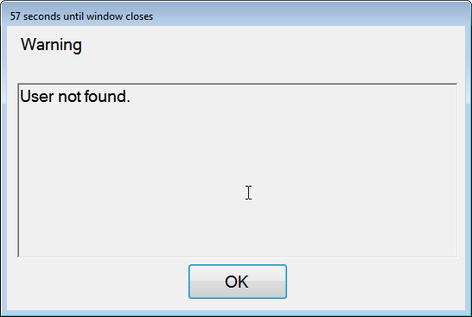
Cancel the operation and enter the Add/Modify User screen again. Scan the barcode for the non-existent user that IS a LANS employee.
- Verify that the system recognizes the user as a new user and that the user data fields are filled.
Cancel the operation and enter the Add/Modify User screen again.
Return to the Main Menu.
Attempt to check out a source with both users that we have verified to NOT be in the Source Tracker database. Note these for email confirmation in your Transaction Log.
- Verify that the checkout is not allowed for either account.
- Verify that emails were sent for unauthorized login attempts and for MASS transactions.

Table 5.11 Tests for Add/Modify User
Test Results
Date: |  |  | Name of Tester: Signature: |  |  | Test Status
Not tested Tested
In Process
Date: |  |  | Name of Acceptance Authority: Signature: |  |  | Test Status
 |  |  |  |  |  | Accepted Not Accepted
Acceptance
Notes:
 |  |  | Enter the version of software tested here:
 |  |  | Is this test being used for Regression Testing? Yes No
 |  |  | Is this a retest? Yes No
 |  |  | If a retest, comment or provide any documentation here of the version of software that failed, the items corrected before the retest and the new software version being tested:
Transaction Log
Date/Time: |  | Description of transaction |  |  | Type:
 |  |  |  |  | Email Log
 |  |  |  |  | Email Log
 |  |  |  |  | Email Log
 |  |  |  |  | Email Log
 |  |  |  |  | Email Log
 |  |  |  |  | Email Log
Test #: | Expected Results: |  |  | PASS/FAIL
128 | Verify that an error is displayed showing the user is inactive. |  |  | Pass Fail
129 | Verify that a message showing the user record was updated is shown. |  |  | Pass Fail
130 | Verify that the user is now able to see destination locations for the source. |  |  | Pass Fail
131 | Verify that you are prompted to enter a MASS user. |  |  | Pass Fail
132 | Verify that the user is now a MASS user because he is allowed to check out a MASS source. |  |  | Pass Fail
133 | Verify that emails were sent as described. |  |  | Pass Fail
134 | Verify that the system does not recognize the user. |  |  | Pass Fail
135 | Verify that the system recognizes the user as a new user and that the user data fields are filled. |  |  | Pass Fail
136 | Verify that the checkout is not allowed for either account. |  |  | Pass Fail
137 | Verify that emails were sent for unauthorized login attempts and for MASS transactions. |  |  | Pass Fail
Comments

Time Out Timers [Demonstration/Code Verification Test]

Purpose
Verify that all forms except the program’s Main Form and lockout screen time out.

Input
Opening randomly selected forms.

Output
Return to the Main Screen.

Process Steps
- Perform some Source Tracker function. At some point, allow a form to countdown to zero.
- Verify that the form closes and returns you to the main menu.
- To assure that all the forms in Source Tracker behave the same way, a base class was written called TimedForm. Except for the Main Menu and the Black Screen that locks the desktop, all forms and message boxes in Source Tracker inherit from this class.
- Verify by a code walkthrough that all forms except the ones noted derive from TimedForm, as shown in the example below:
public partial class SomeForm:Timed Form {
Table 5.12 Tests for Time Out Timers
Test Results
Date: |  | Name of Tester: Signature: |  | Test Status
Not tested Tested
In Process
Date: |  | Name of Acceptance Authority: Signature: |  | Test Status
 |  |  |  | Accepted Not Accepted
Acceptance
Notes:
 |  | Enter the version of software tested here:
 |  | Is this test being used for Regression Testing? Yes No
 |  | Is this a retest? Yes No
 |  | If a retest, comment or provide any documentation here of the version of software that failed, the items corrected before the retest and the new software version being tested:
Test #: | Expected Results: |  | PASS/FAIL
138 | Verify that the form closes and returns you to the main menu. |  | Pass Fail
139 | Verify by a code walkthrough that all forms except the ones noted derive from TimedForm, as shown in the example below: |  | Pass Fail
Comments

System Security Features [Demonstration/Security Test]

Purpose
Verify that the Source Tracker application does not allow users to access any functions of the workstations except the Source Track executable.

Input
Touchscreen, keyboard and mouse input.

Output
None.

Process Steps
- While the Source Tracker application is running, use the touchscreen to attempt to close the application.
- In attempting to shut down the application, you may login with a normal user barcode, but may not use a custodian barcode.
- Verify that you cannot close the Source Tracker application.
- Plug in a keyboard and mouse and retry the previous test. Be sure to use the special Windows startup button, ALT-CTRL-DEL, Alt-Tab, Alt-Esc.
- Verify that you cannot close the Source Tracker application.
- Reboot the machine.
- Verify that the Source Tracker application automatically starts up in less than 5 minutes.
- Close the application by using Custodian Operations | Exit Program.
- Verify that the program restarts in less than 5 minutes.
- Shut down the workstation
- Turn on the workstation
- Verify that the program restarts in less than 5 minutes.
Table 5.13 Tests for System Security Features
Test Results
Date: |  | Name of Tester: Signature: |  | Test Status
Not tested Tested
In Process
Date: |  | Name of Acceptance Authority: Signature: |  | Test Status
 |  |  |  | Accepted Not Accepted
Acceptance
Notes:
 |  | Enter the version of software tested here:
 |  | Is this test being used for Regression Testing? Yes No
 |  | Is this a retest? Yes No
 |  | If a retest, comment or provide any documentation here of the version of software that failed, the items corrected before the retest and the new software version being tested:
Test #: | Expected Results: |  | PASS/FAIL
140 | Verify that you cannot close the Source Tracker application. |  | Pass Fail
141 | Verify that you cannot close the Source Tracker application. |  | Pass Fail
142 | Verify that the Source Tracker application automatically starts up in less than 5 minutes. |  | Pass Fail
143 | Verify that the program restarts in less than 5 minutes. |  | Pass Fail
144 | Verify that the program restarts in less than 5 minutes. |  | Pass Fail
Comments

Automatic Database Backups [Demonstration/Validation/Failure Mode Test]

Purpose
Verify that the database is backed up daily so that recovery can be made in case of failure. If the backup fails, verify that an email is sent to one or more system administrators for further action. See also Testing Document for Backup and Recovery of AIX/Oracle Environments Using Tivoli Storage Manager, 3/30/2004, LANL Office of the CIO, BC/DR (CIO-ST-TIVOLI).

Input
The database administrator for the central database server must log into the Tivoli backup manager and print a log of database backups. If the backup has failed, the administrator should show an email notifying of the failure. If the backup has not failed, the administrator should cause a failure to show that a notification is sent.

Output
Printed log reports of backups and notification emails.

Process Steps
- Have the Source Tracker database administrator log in to the Tivoli storage manager website.
- Verify that Tivoli is backing up the database daily.
- Look for any backup failures in the log. If a failure exists, verify with administrator that they received an email and print this for the test record.
- Determine whether failure has happened.
- If a failure does not exist in the log, physically disconnect the server from the network prior to the next scheduled backup.
- Verify that the Tivoli backup manager logs a failure and generates an email to the database administrator.
- Be sure to reconnect the server once test is complete.

Table 5.14 Tests for Automatic Database Backups
Test Results
Date: |  |  | Name of Tester: Signature: |  |  | Test Status
Not tested Tested
In Process
Date: |  |  | Name of Acceptance Authority: Signature: |  |  | Test Status
 |  |  |  |  |  | Accepted Not Accepted
Acceptance
Notes:
 |  |  | Enter the version of software tested here:
 |  |  | Is this test being used for Regression Testing? Yes No
 |  |  | Is this a retest? Yes No
 |  |  | If a retest, comment or provide any documentation here of the version of software that failed, the items corrected before the retest and the new software version being tested:
Transaction Log
Date/Time: |  | Description of transaction |  |  | Type:
 |  |  |  |  | Email Log
 |  |  |  |  | Email Log
Test #: | Expected Results: |  |  | PASS/FAIL
145 | Verify that Tivoli is backing up the database daily. |  |  | Pass Fail
146 | Determine whether failure has happened. |  |  | Pass Fail
147 | Verify that the Tivoli backup manager logs a failure and generates an email to the database administrator. |  |  | Pass Fail
Comments

Email Notifications [Communication Test]

Purpose
Verify that automatically generated emails are created/sent according to specification.

Input
None.

Output
Check custodian and admin emails to verify that emails are sent and compare to database records.

Process Steps
- At the end of a business day, run the SQL query stored in SourcesNotPermStorage.sql to retrieve a list of sources not in permanent storage locations.
- Save the list of sources stored in non-permanent locations at the end of the day.
- Check the custodian email the following day.
- Verify that the the custodian is emailed the same list of sources as you stored the evening before.

Table 5.15 Tests for Email Notifications
Test Results
Date: |  |  | Name of Tester: Signature: |  |  | Test Status
Not tested Tested
In Process
Date: |  |  | Name of Acceptance Authority: Signature: |  |  | Test Status
 |  |  |  |  |  | Accepted Not Accepted
Acceptance
Notes:
 |  |  | Enter the version of software tested here:
 |  |  | Is this test being used for Regression Testing? Yes No
 |  |  | Is this a retest? Yes No
 |  |  | If a retest, comment or provide any documentation here of the version of software that failed, the items corrected before the retest and the new software version being tested:
Transaction Log
Date/Time: |  | Description of transaction |  |  | Type:
 |  |  |  |  | Email Log
 |  |  |  |  | Email Log
Test #: | Expected Results: |  |  | PASS/FAIL
148 | Save the list of sources stored in non-permanent locations at the end of the day. |  |  | Pass Fail
149 | Verify that the the custodian is emailed the same list of sources as you stored the evening before. |  |  | Pass Fail
Comments

MAR Calculation Validation [Demonstration/Validation Test]

Purpose
Verify that the calculations for MAR are correct and that movements are properly allowed or disallowed based on the calculations.
These tests verify that MAR values are calculated and handled properly for sources under the following circumstances:
- Removal
- Return
- Reassignment
- Permanent transfer
- Addition
- Modification
- Deletion
This section also verifies that a MAR override value may be set and will be treated the same as calculated MAR.

Input
- User Z numbers and representative source barcodes
- A list of sources ordered by MAR will be useful for selecting sources for the different operations; this list may be obtained by using the Create Sources Summary File operation on the Custodian form to list the non-exempt sources, sort by MAR by clicking on the column header, and then emailing the resulting list to yourself.
- MAR values for the buildings used in the test. This may be obtained by selecting the MAR status from the main menu and either writing the values down or doing a screen capture and printing the result.

Output
A filled-in form reflecting the results of the operations performed.

Process Steps

Setup
      - Fill in the table provided in Appendix A as described in the steps that follow. Rows already filled in are to serve as examples.
      - Fill the Source column with a set of sources that
        - will alter the destination MAR value with each move,
        - some of which will cause the move to be disallowed because the resultant destination MAR value would be over the allowed limit.
        - at least one of which will just put one of the building MAR values over 80%.
      - Select a few exempt sources to show that MAR is not counted.
      - Fill in the From column with each source’s current room and building.
      - Fill in the To column with a location in another building.
      - Fill in the Source MAR value (%) column with the MAR value for each source. This can be found by browsing the sources and noting the value in the MAR column. The MAR column may be sorted by clicking the column header.
      - Fill in the Building MAR before columns with the initial MAR value for the buildings that will be used in the tests.

Removing and returning sources
This section verifies that when sources are removed and returned that the MAR values are taken into account before the transactions are allowed and the values are updated accordingly.
- Remove the first source on the list to the location specified in column To (refer Section 5.2).
- If the move was allowed, fill in the Building MAR after columns by selecting the MAR Status button on the main menu for the source building and take the value from the confirmation screen for the destination building. Put a “Y” in the Move allowed? column. Select the MAR Status button on the main menu and verify that the values shown for the source and destination buildings accurately reflect the transaction.
- If the move was not allowed fill in the cell from the value determined in the Confirm Transaction screen. Note that in this case only one MAR value can be verified. Put a “N” in the Move allowed? column.
- If the move was allowed and the destination building’s MAR value is over 80%, verify that an email was sent to custodians warning them of this fact.
- If the move was allowed, return the source to its original location (refer to Section 5.3).
- Select the MAR Status button on the main menu. Put in a “Y” in the RETURN Value and condition correct? column if the MAR values are the same as before step 1.
- Initial the Source Tracker meets criteria column if the values in the Building MAR before and Building MAR after columns are equal to or within + 1% error.
- Repeat steps 1 – 8 with the selected sources.
- All operations completed as expected.

Returning sources that cause MAR to be exceeded
This section verifies that when a return is performed that the MAR values are taken into account and returns that would violate MAR are not allowed. Select one or more sets of sources such that you can remove source 1 from building A to another building, then move source 2 into building A, and when you try to return source 1 to building A the MAR will be exceeded.
Use the Appendix A sheet similarly as in the previous section, either filling it ahead of time or while the test is progressing. Log the returns in the same manner as checkouts, i.e., use the current location as the From location and the home location as the To location. This will make the data consistent and allow proper logging of results.
- Note the building MAR values.
- Remove source 1 which has a moderate MAR value from building A to building B.
- Remove source 2 from some other building to building A. Source 2’s MAR value should be such that it makes the total MAR for building A close to 100%.
- Try to return source 1 to building A. If source 1’s MAR is large enough then the move should be disallowed and an error message will be displayed.
- Click OK
- Return source 2 to its original location.
- Return source 1 to its original location. This time the return should be allowed.
- Verify that the building MAR values are as they were before the test was executed.
- All operations completed as expected.

Reassigning sources
This section verifies that when sources are reassigned to another building that the MAR values are calculated correctly and that reassignments that would cause MAR to exceed 100% are not allowed.
As before, log the reassignments in the same manner as removals and returns to allow tracking of success and building MAR values.
- Identify a large-MAR value source and check it out to a location in the same building.
- Use the Reassign button on the main menu to reassign the sources location to another building where the source’s MAR value added to the building’s MAR value would exceed 100%.
- Verify that the transaction is not allowed because the MAR value for the destination building would be exceeded. Verify that the calculation of (exceeded) MAR for the destination building is correct.
- Return the source to its original location.
- Repeat with other sources and buildings as needed.
- All operations completed as expected.

Permanently transferring sources
This section verifies that when sources are permanently transferred to another building that the MAR values are calculated correctly and that permanent transfers that would cause MAR to exceed 100% are not allowed.
As before, log the reassignments in the same manner as removals and returns to allow tracking of success and building MAR values.
- Access the Custodian Operation menu.
- Identify a large-MAR value source and use the Permanently Transfer Source button to attempt to transfer it to a building whose MAR values is such that 100% would be exceeded were the transfer to take place.
- Verify that the transfer is not allowed and that the excessive MAR value calculation for the destination building is correct.
- Repeat with other sources and buildings as needed.
- All operations completed as expected.

Adding a source
This section verifies that when sources are added to a building that the MAR values are calculated correctly and that additions that would cause MAR to exceed 100% are not allowed. Note: The source(s) added in this section will be modified in the next.
For Add/Modify/Delete tests, continue to use the log sheet, but in this case only enter values in the From columns to track source and building MAR values for added, modified, and deleted sources.
- Access the Custodian Operation menu.
- Click the Add/Modify Source button to bring up the Add/Modify Source screen.
- Enter a made-up value in the Source Bar Code field and press Enter. The screen name should change to “Add New Source to DB”.
- Enter a Source Id and select a Storage Location that is in a building for which the MAR is known.
- Select Isotope and Initial Mass values such that the Percent MAR value, when added to the building MAR value, will be over 100%. Note that to cause the Percent MAR field to be updated you must click on a field outside the Initial Mass field.
- Click on the Save button and verify that the addition is not allowed and that the sum of the displayed Percent MAR field and the known building MAR value is correct.
- Change the Initial Mass so that the sum of the Percent MAR field and the building MAR value is less than 100% and click Save. Verify that the source is added to the database.
- Return to the main menu and use the MAR Status button to verify the new building MAR value.
- Repeat with other sources and buildings as needed.
- All operations completed as expected.

Modify a source
This section verifies that when sources are modified that the MAR values are calculated correctly and that additions that would cause MAR to exceed 100% are not allowed. Note: The source(s) used in this section were added in the previous.
- Access the Custodian Operation menu (if required).
- Select the Add/Modify Source button to bring up the Add/Modify Source screen.
- Enter a barcode for a source that was added in the previous test section and press Enter. The screen name should change to “Modify Existing Source in DB” and the previously-entered source’s values should be displayed.
- Modify the Initial Mass such that the new Percent MAR will cause the building’s MAR limit to be exceeded and click on Save.
- Verify that the modification is not allowed and that the calculation of the new Percent MAR and the building MAR values is correct. Click OK and change the Initial mass to a value that decreases the Percent MAR value enough to reduce the building MAR to below 100%. Click Save and verify that the modifications are saved.
- Return to the main menu and use the MAR Status button to verify the new building MAR value.
- Repeat as needed with other sources and buildings.
- All operations completed as expected.

Delete a source
This section verifies that when a source is deleted that the building MAR values are recalculated properly. Note: The source(s) deleted in this section were added and modified in the previous sections.
- Access the Custodian Operation menu (if required).
- Select the Add/Modify Source button to bring up the Add/Modify Source screen.
- Enter a barcode for a source that was added previously. The screen name should change to “Modify Existing Source in DB” and the previously-entered source’s values should be displayed.
- Click the Delete button to delete the source from the database and enter dummy responses to the next screen. Click OK when asked if you really want to delete the source.
- Return to the main screen and use the MAR Status button to display the building MAR values. Verify that the building MAR accurately reflects the new value with the source deleted.
- Repeat as needed with other sources and buildings.
- All operations completed as expected.

Verify MAR override setting
This section verifies that the calculated MAR value for a source may be overridden and that the overridden value will thereafter be used for the source’s MAR value.
- Access the Custodian Operation menu (if required).
- Select the Add/Modify Source button to bring up the Add/Modify Source screen.
- Enter a barcode for a non-exempt source that does not have a MAR override value entered.
- Note the value that appears in the Percent MAR field.
- Enter a value into the MAR % Override field and verify that the new value appears in the Percent MAR field when you exit the MAR % Override field.
- Exit the custodian menu and perform a transaction (Remove, Reassign, etc.) and verify that the percent MAR used for the source is the one entered as the override value.
- Access the Custodian Operation menu again.
- Select the Add/Modify Source button to bring up the Add/Modify Source screen.
- Enter the barcode for the source used previously in this section.
- Enter a 0 into the MAR % Override field and verify that the value that appears in the Percent MAR field when you exit the MAR % Override field is the one that was initially in that field.
- Exit the custodian menu and perform a transaction (Remove, Reassign, etc.) and verify that the percent MAR used for the source is the calculated (initial) value.
- All operations completed as expected.

Table 5.16 MAR Calculation Validation Test
Test Results
Date: |  |  | Name of Tester: Signature: | Test Status
Not tested Tested
In Process
Date: |  |  | Name of Acceptance Authority: Signature: | Test Status
Accepted
Not Accepted
Acceptance
Notes:
 |  |  | Enter the version of software tested here:
 |  |  | Is this test being used for Regression Testing? Yes No
 |  |  | Is this a retest? Yes No
 |  |  | If a retest, comment or provide any documentation here of the version of software that failed, the items corrected before the retest and the new software version being tested:
Transaction Log
Date/Time: |  | Description of transaction |  | Type:
 |  |  |  | Email Log
 |  |  |  | Email Log
Test #: | Expected Results: |  |  |  | PASS/FAIL
150 | All operations completed as expected. |  |  |  | Pass Fail
151 | All operations completed as expected. |  |  |  | Pass Fail
152 | All operations completed as expected. |  |  |  | Pass Fail
153 | All operations completed as expected. |  |  |  | Pass Fail
154 | All operations completed as expected. |  |  |  | Pass Fail
155 | All operations completed as expected. |  |  |  | Pass Fail
156 | All operations completed as expected. |  |  |  | Pass Fail
157 | All operations completed as expected. |  |  |  | Pass Fail

Comments

Criticality Calculation Validation [Demonstration/Validation Test]

Purpose
Verify that criticality calculations are correct and that transactions are not permitted if limits are exceeded.
These tests verify that criticality is checked and handled properly for sources under the following circumstances:
- Removal
- Return
- Reassignment
- Permanent transfer
- Addition
- Modification
- Deletion

Input
- User Z numbers and representative source barcodes
- A list of sources ordered by criticality will be useful for selecting sources for the different operations; this list may be obtained by using the Create Sources Summary File operation on the Custodian form to list the non-exempt sources, sorting by criticality by clicking on the column header, and then emailing the resulting list to yourself.
- Criticality values for the buildings used in the test. This may be obtained by selecting the Criticality and Fuel Rod Status button from the main menu and either writing the values down or doing a screen capture and printing the result.
- The criticality limits from the Crit_Limits table of the database.

Output
A filled-in form reflecting the results of the operations performed.

Process Steps

Setup
- Fill in the table provided in Appendix A2 as described in the steps that follow. Rows already filled in are to serve as examples.
- Fill the Source column with a set of sources that
        - will alter the destination criticality values with each move,
        - some of which will cause the move to be disallowed because the resultant destination criticality values would be over the allowed limit.
- Select a few fuel rods whose criticality will be 0 because the To or From building has fuel rod limits.
- Fill in the From column with each source’s current room and building.
- Fill in the To column with a location in another building.
- Fill in the Criticality column with the values for each source.
- Fill in the Building Crit before columns with the initial criticality values for the buildings that will be used in the tests.

Removing and returning sources
This section verifies that when sources are removed and returned that the criticality values are taken into account before the transactions are allowed and the values are updated accordingly.
- Remove the first source on the list to the location specified in column To (refer Section 5.2).
- If the move was allowed, fill in the Building crit after columns using the value from the confirmation screen for the destination building and selecting the Criticality and Fuel Rod Status button on the main menu for the source building and. Put a “Y” in the Move allowed? column.
- If the move was not allowed fill in the cell from the value determined in the Confirm Transaction screen. Note that in this case only one criticality value can be verified. Put a “N” in the Move allowed? column.
- If the move was allowed, return the source to its original location (refer to Section 5.3).
- Select the Criticality and Fuel Rod Status button on the main menu. Put in a “Y” in the RETURN Value and condition correct? column if the criticality values are the same as before step 1.
- Initial the Source Tracker meets criteria column if the values in the Building crit before and Building crit after columns are equal to or within + 1% error.
- Repeat steps 1 – 6 with the selected sources.
- All operations completed as expected.

Returning sources that cause criticality limit to be exceeded
This section verifies that when a return is performed that the criticality values are taken into account and returns that would violate criticality limits are not allowed. Select one or more sets of sources such that you can remove source 1 from building A to another building, then move source 2 into building A, and when you try to return source 1 to building A the criticality limit for the building will be exceeded.
Use the Appendix A2 sheet as in the previous section, either filling it ahead of time or while the test is progressing. Log the returns in the same manner as checkouts, i.e., use the current location as the From location and the home location as the To location. This will make the data consistent and allow proper logging of results.
- Note the building criticality values.
- Remove source 1 which has moderate criticality values from building A to building B.
- Remove source 2 from some other building to building A. Source 2’s criticality values should be such that it makes the total crit for building A close to the limit.
- Try to return source 1 to building A. If source 1’s criticality values are large enough then the move should be disallowed and a warning message should be displayed.
- Click OK.
- Return source 2 to its original location.
- Return source 1 to its original location. This time the return should be allowed.
- Verify that the building criticality values are as they were before the test was executed.
- All operations completed as expected.

Reassigning sources
This section verifies that when sources are reassigned to another building that the criticality values are calculated correctly and that reassignments that would cause criticality limits to be exceeded are not allowed.
As before, log the reassignments in the same manner as removals and returns to allow tracking of success and building criticality values.
- Identify a large-crit source and check it out to a location in the same building.
- Use the Reassign button on the main menu to reassign the source’s location to another building where the source’s criticality values added to the building’s criticality values would be exceeded.
- Verify that the transaction is not allowed because the criticality values for the destination building would be exceeded. Verify that the calculation of (exceeded) criticality values for the destination building is correct.
- Return the source to its original location.
- Repeat with other sources and buildings as needed.
- All operations completed as expected.

Permanently transferring sources
This section verifies that when sources are permanently transferred to another building that the criticality values are calculated correctly and that permanent transfers that would cause criticality values to be exceeded are not allowed.
As before, log the transfers in the same manner as removals and returns to allow tracking of success and building criticality values.
- Access the Custodian Operation menu.
- Identify a large-crit source and use the Permanently Transfer Source button to attempt to transfer it to a building whose criticality values are such that the building limits would be exceeded were the transfer to take place.
- Verify that the transfer is not allowed and that the (excessive) criticality values calculated for the destination building are correct.
- Repeat with other sources and buildings as needed.
- All operations completed as expected.

Adding sources
This section verifies that when sources are added to a building that the criticality values are calculated correctly and that additions that would cause criticality limits to be exceeded are not allowed. Note: The source(s) added in this section will be modified in the next.
For Add/Modify/Delete tests, continue to use the log sheet, but in this case only enter values in the From columns to track source and building criticality values for added, modified, and deleted sources.
- Access the Custodian Operation menu.
- Click the Add/Modify Source button to bring up the Add/Modify Source screen.
- Enter a made-up value in the Source Bar Code field and press Enter. The screen name should change to “Add New Source to DB”.
- Enter a Source Id and select a Storage Location that is in a building for which the criticality values are known.
- Select Isotope and Contributions values such that the criticality values, when added to the building criticality values, will exceed the building limits.
- Click on the Save button and verify that the addition is not allowed and that the sum of the source’s criticality values and the known building criticality values is correct.
- Change the Contributions so that the sum of the source and building criticality values is less than the building limits and click Save. Verify that the source is added to the database.
- Return to the main menu and use the Criticality and Fuel Rod Status button to verify the new building criticality value.
- Repeat with other sources and buildings as needed.
- All operations completed as expected.

Modify a source
This section verifies that when sources are modified that the criticality values are calculated correctly and that modifications that would cause building limits to be exceeded are not allowed. Note: The source(s) used in this section were added in the previous.
- Access the Custodian Operation menu (if required).
- Select the Add/Modify Source button to bring up the Add/Modify Source screen.
- Enter a barcode for a source that was added in the previous test section and press Enter. The screen name should change to “Modify Existing Source in DB” and the previously-entered source’s values should be displayed.
- Modify the contributions such that the new criticality values will cause the building’s criticality limit to be exceeded and click on Save.
- Verify that the modification is not allowed and that the sum of the source and building criticality values is correct. Click OK and change the Contributions to values that decrease the criticality values enough to reduce the sum to below the limits. Click Save and verify that the modifications are saved.
- Return to the main menu and use the Criticality and Fuel Rod Status button to verify the new building criticality values.
- Repeat as needed with other sources and buildings.
- All operations completed as expected.

Delete a source
This section verifies that when a source is deleted that the building criticality values are recalculated properly. Note: The source(s) deleted in this section were added and modified in the previous sections.
- Access the Custodian Operation menu (if required).
- Select the Add/Modify Source button to bring up the Add/Modify Source screen.
- Enter a barcode for a source that was added previously. The screen name should change to “Modify Existing Source in DB” and the previously-entered source’s values should be displayed.
- Click the Delete button to delete the source from the database and enter dummy responses to the next screen. Click OK when asked if you really want to delete the source.
- Return to the main screen and use the Criticality and Fuel Rod Status button to display the building criticality values. Verify that the building criticality values accurately reflect the new values with the source deleted.
- Repeat as needed with other sources and buildings.
- All operations completed as expected.

Table 5.17 Criticality Calculation Validation Test
Test Results
Date: |  | Name of Tester: Signature: | Test Status
Not tested Tested
In Process
Date: |  | Name of Acceptance Authority: Signature: | Test Status
Accepted
Not Accepted
Acceptance
Notes:
 |  | Enter the version of software tested here:
 |  | Is this test being used for Regression Testing? Yes No
 |  | Is this a retest? Yes No
 |  | If a retest, comment or provide any documentation here of the version of software that failed, the items corrected before the retest and the new software version being tested:
Test #: | Expected Results: |  |  | PASS/FAIL
158 | All operations completed as expected.Error! Reference source not found. |  |  | Pass Fail
159 | All operations completed as expected. |  |  | Pass Fail
160 | All operations completed as expected. |  |  | Pass Fail
161 | All operations completed as expected. |  |  | Pass Fail
162 | All operations completed as expected. |  |  | Pass Fail
163 | All operations completed as expected. |  |  | Pass Fail
164 | All operations completed as expected. |  |  | Pass Fail

Comments

CAT IV Physical Security Calculation Validation [Demonstration/Validation Test]

Purpose
Verify that physical security calculations are correct and that transactions are not permitted if limits are exceeded.
These tests verify that criticality is checked and handled properly for sources under the following circumstances:
- Removal
- Return
- Reassignment
- Permanent transfer
- Addition
- Modification
- Deletion

Input
- User Z numbers and representative source barcodes
- A set of sources for which the attractiveness levels and contributions are known. This list may be compiled by using the Browse Sources button on the main menu and the viewing the source details for various sources or by directly querying the database.
- Physical security values for the MBAs used in the test. This may be obtained by selecting the Physical Security Status button from the main menu and either writing the values down or doing a screen capture and printing the result.
- The limits from the MBA_Limits table of the database.

Output
A filled-in form reflecting the results of the operations performed.

Process Steps

Setup
- Fill in the table provided in Appendix A3 as described in the steps that follow. Rows already filled in are to serve as examples.
- Fill the Source column with a set of sources that
- contain all the attractiveness values, B – E, at least twice each, for both U and Pu,
- will alter the destination attractiveness values with each move,
- some of which will be disallowed due to putting an MBA over its limit,
- some of which are 0
- Fill in the From column with each source’s current room and MBA.
- Fill in the To column with a location in another MBA.
- Fill in the Attractiveness Level column with the attractiveness level for Pu or U or a combination of the two.
- Fill in the SNM column with the value(s) for each source.
- Fill in the MBA Total BEFORE Move column with the initial physical security values for the destination MBA that will be used in the tests.
- Fill in the Move valid? column with Y if the move should be allowed and N if not.

Removing and returning sources
This section verifies that when sources are removed and returned that the physical security values are taken into account before the transactions are allowed and the values are updated accordingly.
- Remove the first source on the list to the location specified in column To (refer Section 5.2).
- Fill in the Move allowed? column and then examine the physical security status and fill in the Totals as expected…? column.
- If the move was allowed, return the source to its original location (refer to Section 5.3). Verify that the final physical security values for the MBA are identical to the initial values and fill in the final column.
- Initial the Source Tracker meets criteria column if the values in the before and after columns are equal to or within + 1% error.
- Repeat steps 1 – 4 with the selected sources.
- All operations completed as expected.

Returning sources that cause limits to be exceeded
This section verifies that when a return is performed that the physical security values are taken into account and returns that would violate limits are not allowed. Select one or more sets of sources such that you can remove source 1 from MBA A to another MBA, then move source 2 into MBA A, and when you try to return source 1 to MBA A the limit for the MBA will be exceeded.
Use the Appendix A3 sheet as in the previous section, either filling it in ahead of time or while the test is progressing. Log the returns in the same manner as checkouts, i.e., use the current location as the From location and the home location as the To location. This will make the data consistent and allow proper logging of results.
- Note the MBA physical security values.
- Remove source 1 which has moderate contributions from MBA A to MBA B.
- Remove source 2 from some other MBA to MBA A. Source 2’s contributions should be such that it makes the total for MBA A close to the limit.
- Try to return source 1 to building A. If source 1’s contribution is large enough then the return should be disallowed and a warning message should be displayed.
- Click OK.
- Return source 2 to its original location.
- Return source 1 to its original location. This time the return should be allowed.
- Verify that the MBA’s physical security values are as they were before the test was executed.
- All operations completed as expected.

Reassigning sources
This section verifies that when sources are reassigned to another MBA that the physical security values are calculated correctly and that reassignments that would cause physical security limits to be exceeded are not allowed.
As before, log the reassignments in the same manner as removals and returns to allow tracking of success and MBA physical security values.
- Identify a large-contribution source and check it out to a location in the same MBA.
- Use the Reassign button on the main menu to reassign the source’s location to another MBA where the source’s contribution added to the destination MBA’s physical security values would exceed the MBA’s limit.
- Verify that the transaction is not allowed because the physical security values for the destination MBA would be exceeded. Verify that the calculation of the (exceeded) physical security value for the destination MBA is correct.
- Return the source to its original location.
- Repeat with other sources and MBAs as needed.
- All operations completed as expected.

Permanently transferring sources
This section verifies that when sources are permanently transferred to another MBA that the physical security values are calculated correctly and that permanent transfers that would cause physical security values to be exceeded are not allowed.
As before, log the transfers in the same manner as removals and returns to allow tracking of success and MBA physical security values.
- Access the Custodian Operation menu.
- Identify a large-contribution source and use the Permanently Transfer Source button to attempt to transfer it to an MBA whose physical security values are such that the MBA limit would be exceeded were the transfer to take place.
- Verify that the transfer is not allowed and that the (excessive) physical security value calculated for the destination MBA is correct.
- Repeat with other sources and MBAs as needed.
- All operations completed as expected.

Adding sources
This section verifies that when sources are added to an MBA that the physical security values are calculated correctly and that additions that would cause physical security limits to be exceeded are not allowed. Note: The source(s) added in this section will be modified in the next.
For Add/Modify/Delete tests, continue to use the log sheet, but in this case only enter values in the From columns to track source and MBA physical security values for added, modified, and deleted sources.
- Access the Custodian Operation menu.
- Click the Add/Modify Source button to bring up the Add/Modify Source screen.
- Enter a made-up value in the Source Bar Code field and press Enter. The screen name should change to “Add New Source to DB”.
- Enter a Source Id and select a Storage Location that is in an MBA for which the physical security values are known.
- Select Contributions values such that the contributions, when added to the MBA physical security values, will exceed the MBA limits.
- Click on the Save button and verify that the addition is not allowed and that the sum of the source’s contributions and the known MBA physical security values is correct.
- Change the Contributions so that the sum of the source and MBA physical security values is less than the MBA limits and click Save. Verify that the source is added to the database.
- Return to the main menu and use the Physical Security Status button to verify the new MBA physical security values.
- Repeat with other sources and MBAs as needed.
- All operations completed as expected.

Modify a source
This section verifies that when sources are modified that the physical security values are calculated correctly and that modifications that would cause MBA limits to be exceeded are not allowed. Note: The source(s) used in this section were added in the previous.
- Access the Custodian Operation menu (if required).
- Select the Add/Modify Source button to bring up the Add/Modify Source screen.
- Enter a barcode for a source that was added in the previous test section and press Enter. The screen name should change to “Modify Existing Source in DB” and the previously-entered source’s values should be displayed.
- Modify the contributions such that the new contribution value(s) will cause the MBA’s physical security limit(s) to be exceeded and click on Save.
- Verify that the modification is not allowed and that the source and MBA values are correct. Click OK and change the contributions to values that decrease the physical security values enough to reduce the sum to below the limits. Click Save and verify that the modifications are saved.
- Return to the main menu and use the Physical Security Status button to verify the new MBA values.
- Repeat as needed with other sources and MBAs.
- All operations completed as expected.

Delete a source
This section verifies that when a source is deleted that the building criticality values are recalculated properly. Note: The source(s) deleted in this section were added and modified in the previous sections.
- Access the Custodian Operation menu (if required).
- Select the Add/Modify Source button to bring up the Add/Modify Source screen.
- Enter a barcode for a source that was added previously. The screen name should change to “Modify Existing Source in DB” and the previously-entered source’s values should be displayed.
- Click the Delete button to delete the source from the database and enter dummy responses to the next screen. Click OK when asked if you really want to delete the source.
- Return to the main screen and use the Physical Security Status button to display the MBA values. Verify that the MBA physical security values accurately reflect the new values with the source deleted.
- Repeat as needed with other sources and MBAs.
- All operations completed as expected.

Table 5.18 CAT IV Acceptance Approval
 | Test Results
 | Date: |  |  | Name of Tester: Signature: | Test Status
Not tested Tested
In Process
 | Date: |  |  | Name of Acceptance Authority: Signature: | Test Status
Accepted
Not Accepted
Acceptance
Notes:
 |  |  |  | Enter the version of software tested here:
 |  |  |  | Is this test being used for Regression Testing? Yes No
 |  |  |  | Is this a retest? Yes No
 |  |  |  | If a retest, comment or provide any documentation here of the version of software that failed, the items corrected before the retest and the new software version being tested:
 | Transaction Log
 | Date/Time: |  | Description of transaction |  | Type:
 |  |  |  |  | Email Log
 |  |  |  |  | Email Log
Test #: |  | Expected Results: |  |  |  | PASS/FAIL
165 |  | All operations completed as expected. |  |  |  | Pass Fail
166 |  | All operations completed as expected. |  |  |  | Pass Fail
167 |  | All operations completed as expected. |  |  |  | Pass Fail
168 |  | All operations completed as expected. |  |  |  | Pass Fail
169 |  | All operations completed as expected. |  |  |  | Pass Fail
170 |  | All operations completed as expected. |  |  |  | Pass Fail
171 |  | All operations completed as expected. |  |  |  | Pass Fail
Comments

Fuel Rod Calculations Validation [Demonstration/Validation Test]

Purpose
Verify that fuel rod calculations are correct and that transactions are not permitted if limits are exceeded.
These tests verify that the fuel rod count is checked and handled properly for sources under the following circumstances:
- Removal
- Return
- Reassignment
- Permanent transfer
- Addition
- Modification
- Deletion

Input
- User Z numbers
- A list of sources showing the fuel rod counts for the sources and their barcodes and locations. This may be obtained from the database table by running a query.
- A few sources whose fuel rod count is 0.
- One or more sources which have been “made up” to contain a number of rods for testing. These sources will have names like “testrod8,” which indicates that it is a bundle of eight fuel rods.
- Fuel rod counts for the buildings used in the test. This may be obtained by selecting the Criticality and Fuel Rod Status button from the main menu and either writing the values down or doing a screen capture and printing the result.
- Fuel rod limits from the Crit_Limits table of the database. Note that only buildings 35/2, 35/27, and 66/1 have fuel rod limits; totals for any other buildings will not be checked since there are no defined limits for them.

Output
A filled-in form reflecting the results of the operations performed.

Process Steps

Setup
- Fill in the table provided in Appendix A4 as described in the steps that follow. Rows already filled in are to serve as examples.
- Fill the Source column with a set of sources that
  - will alter the destination fuel rod counts with each move,
  - some of which will cause the move to be disallowed because the resultant destination criticality values would be over the allowed limit.
- Select a few sources whose fuel rod count is 0.
- Fill in the From column with each source’s current room and building.
- Fill in the To column with a location in another building.
- Fill in the Fuel Rod Count column with the rod counts for each source.
- Fill in the Fuel rod totals before move column with the initial fuel rod count for the buildings that will be used in the tests.
- Fill in the Fuel rod totals after move column with the expected fuel rod count for the buildings after the test.
- Fill in the Move valid? column with the Y if the move should be allowed and N if it should not.

Removing and returning sources
This section verifies that when sources are removed and returned that the fuel rod counts are taken into account before the transactions are allowed and are updated accordingly.
- Remove the first source on the list to the location specified in column To (refer Section 5.2).
- If the move was allowed, put a Y in the Move allowed? column. Select the Criticality and Fuel Rod Status button on the main menu and verify that the values shown for the source and destination buildings accurately reflect the transaction.
- If the move was not allowed, put a N in the Move allowed? column. Select the Criticality and Fuel Rod Status button on the main menu and verify that the values shown for the source and destination buildings have not changed.
- If the move was allowed, return the source to its original location (refer to Section 5.3).
- Select the Criticality and Fuel Rod Status button on the main menu. Put in a “Y” in the Initial values the same after item returned? column if the criticality values are the same as before step 1, otherwise put in a N.
- Initial the Source Tracker meets criteria column if the before and after counts are the same.
- Repeat steps 1 – 6 with the selected sources.
- All operations completed as expected.

Returning sources that cause limit to be exceeded
This section verifies that when a return is performed that the fuel rod counts are taken into account and returns that would violate limits are not allowed. Select one or more sets of sources such that you can remove source 1 from building A to another building, then move source 2 into building A, and when you try to return source 1 to building A the limit for the building will be exceeded.
Use the Appendix A4 sheet as in the previous section, either filling it in ahead of time or while the test is progressing. Log the returns in the same manner as checkouts, i.e., use the current location as the From location and the home location as the To location. This will make the data consistent and allow proper logging of results.
- Note the building fuel rod counts.
- Remove source 1 from building A to building B. Select source 1 so that after you remove it you can successfully move another source into building A and when you return source 1 the fuel rod count for the building will be exceeded.
- Remove source 2 from some other building to building A. Source 2’s fuel rod count should be such that it makes the total count for building A close to the limit.
- Try to return source 1 to building A. If source 1’s fuel rod count is large enough then the move should be disallowed and a warning message should be displayed.
- Click OK.
- Return source 2 to its original location.
- Return source 1 to its original location. This time the return should be allowed.
- Verify that the building fuel rod counts are as they were before the test was executed.
- All operations completed as expected.

Reassigning sources
This section verifies that when sources are reassigned to another building that the fuel rod counts are calculated correctly and that reassignments that would cause the limits to be exceeded are not allowed.
As before, log the reassignments in the same manner as removals and returns to allow tracking of success and building fuel rod counts.
- Identify a source with a large fuel rod count and check it out to a location in the same building.
- Use the Reassign button on the main menu to reassign the source’s location to another building where the source’s fuel rod count added to the building’s count would exceed the building limit.
- Verify that the transaction is not allowed because the fuel rod limit for the destination building would be exceeded. Verify that the calculation of the (exceeded) fuel rod count for the destination building is correct.
- Return the source to its original location.
- Repeat with other sources and buildings as needed.
- All operations completed as expected.

Permanently transferring sources
This section verifies that when sources are permanently transferred to another building that the fuel rod counts are calculated correctly and that permanent transfers that would cause the limit to be exceeded are not allowed.
As before, log the transfers in the same manner as removals and returns to allow tracking of success and building fuel rod counts.
- Access the Custodian Operation menu.
- Identify a source with a large fuel rod count and use the Permanently Transfer Source button to attempt to transfer it to a building whose fuel rod count is such that the building limits would be exceeded were the transfer to take place.
- Verify that the transfer is not allowed and that the (excessive) fuel rod count calculated for the destination building are correct.
- Repeat with other sources and buildings as needed.
- All operations completed as expected.

Adding sources
This section verifies that when sources are added to a building that the fuel rod counts are calculated correctly and that additions that would cause limits to be exceeded are not allowed. Note: The source(s) added in this section will be modified in the next.
For Add/Modify/Delete tests, continue to use the log sheet, but in this case only enter values in the From columns to track source and building fuel rod counts for added, modified, and deleted sources.
- Access the Custodian Operation menu.
- Click the Add/Modify Source button to bring up the Add/Modify Source screen.
- Enter a made-up value in the Source Bar Code field and press Enter. The screen name should change to “Add New Source to DB”.
- Enter a Source Id and select a Storage Location that is in a building for which there are fuel rod limits.
- In the Contributions menu, set a fuel rod count that will cause the building’s limit to be exceeded.
- Click on the Save button and verify that the addition is not allowed and that the sum of the source’s fuel rod count and the known building count is correct.
- Change the fuel rod count so that the sum of the source and building counts is less than the building limits and click Save. Verify that the source is added to the database.
- Return to the main menu and use the Criticality and Fuel Rod Status button to verify the new building fuel rod count.
- Repeat with other sources and buildings as needed.
- All operations completed as expected.

Modify a source
This section verifies that when sources are modified that the fuel rod counts are calculated correctly and that modifications that would cause building limits to be exceeded are not allowed. Note: The source(s) used in this section were added in the previous.
- Access the Custodian Operation menu (if required).
- Select the Add/Modify Source button to bring up the Add/Modify Source screen.
- Enter a barcode for a source that was added in the previous test section and press Enter. The screen name should change to “Modify Existing Source in DB” and the previously-entered source’s values should be displayed.
- Modify the fuel rod count such that the new count will cause the building’s limit to be exceeded and click on Save.
- Verify that the modification is not allowed and that the sum of the source and building counts is correct. Click OK and change the count to a value small enough the sum falls below the building’s limit. Click Save and verify that the modifications are saved.
- Return to the main menu and use the Criticality and Fuel Rod Status button to verify the new building counts.
- Repeat as needed with other sources and buildings.
- All operations completed as expected.

Delete a source
This section verifies that when a source is deleted that the building fuel rod count is recalculated properly. Note: The source(s) deleted in this section were added and modified in the previous sections.
- Access the Custodian Operation menu (if required).
- Select the Add/Modify Source button to bring up the Add/Modify Source screen.
- Enter a barcode for a source that was added previously. The screen name should change to “Modify Existing Source in DB” and the previously-entered source’s values should be displayed.
- Click the Delete button to delete the source from the database and enter dummy responses to the next screen. Click OK when asked if you really want to delete the source.
- Return to the main screen and use the Criticality and Fuel Rod Status button to display the building fuel rod counts. Verify that the building count accurately reflects that the source was deleted.
- Repeat as needed with other sources and buildings.
- All operations completed as expected.

Table 5.19 Fuel Rod Calculation Validiation
 | Test Results
 | Date: |  |  | Name of Tester: Signature: | Test Status
Not tested Tested
In Process
 | Date: |  |  | Name of Acceptance Authority: Signature: | Test Status
Accepted
Not Accepted
Acceptance
Notes:
 |  |  |  | Enter the version of software tested here:
 |  |  |  | Is this test being used for Regression Testing? Yes No
 |  |  |  | Is this a retest? Yes No
 |  |  |  | If a retest, comment or provide any documentation here of the version of software that failed, the items corrected before the retest and the new software version being tested:
 | Transaction Log
 | Date/Time: |  | Description of transaction |  | Type:
 |  |  |  |  | Email Log
 |  |  |  |  | Email Log
Test #: |  | Expected Results: |  |  |  | PASS/FAIL
172 |  | All operations completed as expected. |  |  |  | Pass Fail
173 |  | All operations completed as expected. |  |  |  | Pass Fail
174 |  | All operations completed as expected. |  |  |  | Pass Fail
175 |  | All operations completed as expected. |  |  |  | Pass Fail
176 |  | All operations completed as expected. |  |  |  | Pass Fail
177 |  | All operations completed as expected. |  |  |  | Pass Fail
178 |  | All operations completed as expected. |  |  |  | Pass Fail

Comments

Verify SourceTracker Calculations [Demonstration Test]

Purpose
MAR percentage and criticality calculations are involved and the path through the code is dependent upon the nature of the source. (See the pathways for these calculations in sections Error! Reference source not found. and Error! Reference source not found..) Because of this, the calculations must be verified against a representative sample of sources that exercise the different pathways.
In addition, the summed values for MAR percentage, criticality, physical security, and fuel rods are displayed via buttons on the main screen.
This test verifies that the calculations performed by SourceTracker are correct and that the displayed building and MBA summaries are accurate..

Input
- User barcode to access SourceTracker functions
- List of hand-calculated values for MAR percentage and criticality
- Access to the trackerbeta server and utilities

Output
Completed Test Results table

MAR Calculation Verification
For each source in the hand-calculated MAR percentage table, locate the same source in the Browse Sources form and verify that the values are the same.
- SourceTracker and hand-calculated MAR values match.

Criticality Verification
For each source in the hand-calculated criticality table, locate the same source in the Browse Sources form and verify that the values are the same.
- SourceTracker and hand-calculated criticality values match.

MAR Building Totals Verification
      - Access the Custodian Menu.
      - Click on Create Sources Summary File to display the table of sources.
      - Select a building using the dropdown menu and then click Email to send the list of sources to your email client.
      - Import the .csv file that you receive into Excel and sum up the MAR column. Compare this value with the value obtained from the Display MAR Status button on the main menu. Retain this spreadsheet for the next section.
      - Repeat with other buildings as required.
- Values match.

Criticality Building Totals Verification
- Using the same spreadsheet that was used for MAR verification, highlight the column labeled “Criticality”. Click on Data in the Excel menu, and then click Text to Columns. Select Delimited and Next and then under Delimiters put a check mark in the Other: box and enter g next to Other:. Click Finish.
- Highlight all the values in the Criticality column and columns M and N and select Sort from the Excel menu. Under Sort by choose (Column M) and then click Add Level. In the Then by row, select Criticality and Z to A under Order. Click OK.
- For the most part the masses will remain in the Criticality column and the Isotope name (U or Pu) will be placed in column M, the next one to the right. Except where a source contains both U and Pu, the values for each isotope may now be summed and compared to the values obtained by selecting Display Criticality and Fuel Rod Status on the main menu. In the cases where a source contains both U and Pu, the U will be in the original column and the Pu in column M.
- Repeat with different buildings as required.
- Values match.

Physical Security Totals Verification
- Values for physical security must be pulled from the database directly, as there is no easy way to view them all in SourceTracker. Log into the trackerbeta server and start the SQL Server 2014 Management Studio.
- Click Connect when prompted.
- Click New Query and paste in the PhysicalSecurityTotalsByMBA.sql query. At the end of the third line, replace 425 with the number or name of the MBA under consideration and click Execute.
- Select the lower pane, containing the sources, type ctrl-A to Select All, right-click the mouse and select Copy with Headers, and then ctrl-C to Copy everything. Switch to an empty Excel spreadsheet, click in cell A1, and type ctrl-V to paste in the copied values.
- If the copied values do not separate into columns on their own, select the Data menu and click Text to Columns. Select Delimited and Next, click the box next to Comma, and click Finish.
- The data will be sorted by attractiveness, with Pu values in columns B and C and U values in columns D and E. For each attractiveness level, B – E, sum the values in the contributions column and compare them to the values for the chosen MBA obtained by selecting Physical Security Status from the main menu.
- Repeat with different MBAs as required.
- Values match.

Fuel Rod Counts Validation
- Values for fuel rods must be pulled from the database directly, as there is no easy way to view them all in SourceTracker. Log into the trackerbeta server and start the SQL Server 2014 Management Studio.
- Click Connect when prompted.
- Click New Query and paste in the FuelRodTotalsByBuilding.sql query. At the end of the third line, replace 35 and 27 with the tech area and building under consideration and click Execute.
- Select the lower pane, containing the sources, type ctrl-A to Select All, right-click the mouse and select Copy with Headers, and then ctrl-C to Copy everything. Switch to an empty Excel spreadsheet, click in cell A1, and type ctrl-V to paste in the copied values.
- If the copied values do not separate into columns on their own, select the Data menu and click Text to Columns. Select Delimited and Next, click the box next to Comma, and click Finish.
- Note that fuel rods with enrichment of <0.72 do not contribute to totals, so do not include them when you sum the values in the FuelRod column. Compare the sum to the value obtained by selecting Display Criticality and Fuel Rod Status from the main menu.
- Repeat as required with different buildings.
- Values match.

Table 5.20 Verify Source Tracker Calculations
 | Test Results
 | Date: |  |  | Name of Tester: Signature: | Test Status
Not tested Tested
In Process
 | Date: |  |  | Name of Acceptance Authority: Signature: | Test Status
Accepted
Not Accepted
Acceptance
Notes:
 |  |  |  | Enter the version of software tested here:
 |  |  |  | Is this test being used for Regression Testing? Yes No
 |  |  |  | Is this a retest? Yes No
 |  |  |  | If a retest, comment or provide any documentation here of the version of software that failed, the items corrected before the retest and the new software version being tested:
 | Transaction Log
 | Date/Time: |  | Description of transaction |  | Type:
 |  |  |  |  | Email Log
 |  |  |  |  | Email Log
Test #: |  | Expected Results: |  |  |  | PASS/FAIL
179 |  | SourceTracker and hand-calculated MAR values match. |  |  |  | Pass Fail
180 |  | SourceTracker and hand-calculated criticality values match. |  |  |  | Pass Fail
181 |  | Values match. |  |  |  | Pass Fail
182 |  | Values match. |  |  |  | Pass Fail
183 |  | Values match. |  |  |  | Pass Fail
184 |  | Values match. |  |  |  | Pass Fail

Comments

Integration Test [Integration Test]

Purpose
When running in production mode, all Source Tracker workstations will be simultaneously accessing/writing the central database. This test will verify that no race conditions exist that could cause an abnormal condition that might impact safety limit calculations and that leak test parameters are properly updated on each workstation when changes are made.

Input
Two separate workstations will be tested simultaneously to recreate the conditions under which race conditions may exist.

Output
Messages and other output to the Source Tracker GUI indicating that the race condition is handled correctly.

Process Steps
- This test is best accomplished by using two workstations in close proximity to one another and using two testers. We suggest you use the two machines in TA-35, Building 2, Room C155 (we don’t have to use these locations for our test, as any locations may be set).
- Set one of the machines to the SNM safe. Set the other to the C155 Source safe.
- Choose a source to move from the SNM safe to the VDG safe on the machine set as the SNM safe location.
- Using Remove Source From Home Repository, select the VDG safe as a destination location, but when you get to the transfer details page, stop.
- Have the person at the other machine move a source to the VDG safe, completing the transaction.
- Now, attempt to complete the first transaction by hitting the Log Transaction button.
- Verify that Source Tracker warns that the contents of the destination safe have changed and recalculates.
- Cancel the transaction.
- For the next test, leave one machine set as the SNM safe location and the other machine as the VDG Safe.
- Open the Custodian Operations/Edit Program Settings option on the machine that is set as the SNM safe.
- Set the leak test parameters to 120 days for MASS and non-MASS sources and grace period to 10 days.
- Using the Browse Sources option, find 1 source at the SNM safe and one source at the VDG safe whose leak test date is greater than 30 days old but newer than 120 days old.
- Attempt to check out the source at the SNM safe, stopping at the transfer detail page.
- Verify that you do not receive the leak test out of date warning and are allowed to continue.
- Cancel the transaction.
- Open the Custodian Operations/Edit Program Settings option on the machine set to be the SNM safe, set the leak test parameters to 30 days for MASS and non-MASS sources and grace period to 0 days.
- Save the settings.
- Now, at the machine set as the VDG safe location, attempt to check out the source you identified earlier.
- Verify that you do receive the leak test out of date warning and are not allowed to continue.
- Set the leak test parameters back to the original values of 120 days and 10 days grace period.
- Using the machine set to be the SNM safe, attempt to check out the source you identified for checkout from the VDG safe.
- Verify that you receive a warning that the source is not in its home repository but that you are allowed to continue the checkout.
- Cancel the transaction
- From the SNM safe, repeat the checkout procedure for the selected source at the SNM safe, but check the box labelled “Test Transaction Only”.
- Proceed with checkout until the verification screen is shown.
- Verify that ONLY the Cancel Transaction option is available and that the transaction cannot proceed to completion.

Table 5.21 Integration Test
Test Results
Date: |  |  | Name of Tester: Signature: |  |  | Test Status
Not tested Tested
In Process
Date: |  |  | Name of Acceptance Authority: Signature: |  |  | Test Status
 |  |  |  |  |  | Accepted Not Accepted
Acceptance
Notes:
 |  |  | Enter the version of software tested here:
 |  |  | Is this test being used for Regression Testing? Yes No
 |  |  | Is this a retest? Yes No
 |  |  | If a retest, comment or provide any documentation here of the version of software that failed, the items corrected before the retest and the new software version being tested:
Transaction Log
Date/Time: |  | Description of transaction |  |  | Type:
 |  |  |  |  | Email Log
 |  |  |  |  | Email Log
Test #: | Expected Results: |  |  | PASS/FAIL
185 | Verify that Source Tracker warns that the contents of the destination safe have changed and recalculates. |  |  | Pass Fail
186 | Verify that you do not receive the leak test out of date warning and are allowed to continue. |  |  | Pass Fail
187 | Verify that you do receive the leak test out of date warning and are not allowed to continue. |  |  | Pass Fail
188 | Verify that you receive a warning that the source is not in its home repository but that you are allowed to continue the checkout. |  |  | Pass Fail
189 | Verify that ONLY the Cancel Transaction option is available and that the transaction cannot proceed to completion. |  |  | Pass Fail

Comments

Network Outage and other Failure Modes [Demonstration/Failure Mode Test]

Purpose
Verify that Source Tracker appropriately handles the case where the central database is not available.

Input
Disconnecting network connections when instructed.

Output
Verification of response in Source Tracker GUI.

Process Steps
- Shut down Source Tracker using the Custodian Options/Exit Program option.
- Start Source Tracker.
- Verify that the program displays an error that the database cannot be connected, but that the Main Menu and black screen still lock the entire screen.
- Plug the network cable back in.
- Use Remove Source from Home Repository to check out a source to another location (any random source at your current location is ok).
- Verify that the source can be moved and that no database errors are displayed.
- Return the source using the Return Source to Home Repository.
- Repeat the steps to Remove Source from Home Repository, but when the transaction detail screen is displayed, stop.
- Disconnect the network cable.
- Press the Log Transaction button.
- Verify that an error is displayed to the screen showing the database is unavailable and warning that the transaction was not completed.
- Verify that the program returns to the Main Menu and the screen is still locked by the Source Tracker Main Menu and black screen.
- Reconnect the network cable.
- Verify that some other Source Tracker functions are available. (Maybe try to browse sources or Custodian options).

Table 5.22 Tests for Network Outage and other Failure Modes
Test Results
Date: |  |  | Name of Tester: Signature: |  |  | Test Status
Not tested Tested
In Process
Date: |  |  | Name of Acceptance Authority: Signature: |  |  | Test Status
 |  |  |  |  |  | Accepted Not Accepted
Acceptance
Notes:
 |  |  | Enter the version of software tested here:
 |  |  | Is this test being used for Regression Testing? Yes No
 |  |  | Is this a retest? Yes No
 |  |  | If a retest, comment or provide any documentation here of the version of software that failed, the items corrected before the retest and the new software version being tested:
Transaction Log
Date/Time: |  | Description of transaction |  |  | Type:
 |  |  |  |  | Email Log
 |  |  |  |  | Email Log
Test #: | Expected Results: |  |  | PASS/FAIL
190 | Verify that the program displays an error that the database cannot be connected, but that the Main Menu and black screen still lock the entire screen. |  |  | Pass Fail
191 | Verify that the source can be moved and that no database errors are displayed. |  |  | Pass Fail
192 | Verify that an error is displayed to the screen showing the database is unavailable and warning that the transaction was not completed |  |  | Pass Fail
193 | Verify that the program returns to the Main Menu and the screen is still locked by the Source Tracker Main Menu and black screen. |  |  | Pass Fail
194 | Verify that some other Source Tracker functions are available. (Maybe try to browse sources or Custodian options). |  |  | Pass Fail
Comments

Source Tracker Disaster Recovery Test

Disaster recovery
After a disaster, LANL must recover the status of all sources tracked by Source Tracker. Disasters include human error, unexpected hardware failure, a natural or man-made physical event, or intentional hacking and modification of software and data.
A recovered Source Tracker system contains the most recently available data state, where complete physical inventory restores knowledge from data gaps, coupled with a running Source Tracker software and hardware system. In other words, a recovered Source Tracker system contains data representing the current physical status of all tracked sources, and operates as intended.
The steps to recovery of a working Source Tracker system with the most recent source status comprise
- performing a complete physical inventory of all sources in affected area;
- acquiring from the best available backup archive the essential Source Tracker software, support software and most recent source database;
- acquiring sufficient hardware resources to install and deploy Source Tracker;
- installing and deploying a working Source Tracker software and hardware system using the results of steps 2 and 3;
- comparing and reconciling the most recent available validated Source Tracker database backup from step 2, with the inventory of step 1; and
- modifying the deployed Source Tracker database content such that the database content for each source is in agreement with the reconciliation of step 5.

System components required for complete system reconstruction
Per NEN1-PLAN-ST-SPP § 10.2, Configuration Methodology, all software configuration items, including the Source Tracker installation package, support (COTS) software installation packages, Source Tracker software source code, all source-code related assets used to construct the Source Tracker software, and all supporting documentation for Source Tracker, are stored in the LANL “yellow” network. Code and supporting COTS software are stored using the SVN source repository, while documentation is kept on a SharePoint server (NEN1-WWW).
The contents of the SVN repository are available at any time the central server is available.

Source data retention and recovery
The Source Tracker client and server machines operate on LANL’s “yellow” network. LANL’s lab-wide Tivoli Storage Manager (TSM) system backs up machines on the “yellow” network nightly. The TSM backup resides off-site from TA-35 and the NISC. Material moves first to disk in the TSM system, then to permanent tape-based storage.
LANL’s Office of the CIO tested TSM backups for assurance. See [CIO-ST-TIVOLI] and
[CIO-ST-REMOVABLE MEDIA].

Disaster Recovery Test [Failure Mode Test]

Purpose
Verify complete recovery from total loss of the Source Tracker software and hardware system and associated source data.
A completely recovered Source Tracker system contains the most recently available data state, where complete physical inventory restores knowledge from data gaps, coupled with operative Source Tracker hardware and software.

Input
Archived Source Tracker software system material, used for installation.
Archived Source Tracker database(s).

Output
A current Source Tracker database on all restored client and server machines.

Process Steps
Note: The test process may start with step 1 or 2 depending on the depth of the recovery procedure under test.

Software System Recovery

- From LANL Tivoli Storage Manager (TSM): Use TSM to recover the most recent complete Source Tracker central database server machine content: the latest backed up database (night before the test is run.
- From the SVN repository (restored in step #163) : Obtain access to the Source Tracker SVN project containing the Source Tracker source code and related content, and the pre-built Source Tracker application and final installation script and related content.
- If rebuilding the Source Tracker application and installation script, follow the build instructions accompanying the Source Tracker source code and development tools.

Hardware and Support Software System Recovery

- Acquire and prepare hardware following NEN1-ST-SRS § 3.9, Hardware Requirements.
- Acquire and prepare third-party support software not obtained from TSM, SVN or a Custodian (steps 1, 2 or 3). DCS can provide the windows/network machine for this. These products are listed in NEN1-ST-BL.
- Install Source Tracker, using the installation script content copied directly from the pre-built material retrieved in steps 1, 2, or 3, or newly built in step 4, by following NEN1-ST-UM Installation Instructions.

Recovering the most recent Source Tracker database.
- Perform a complete physical inventory of the all source tracker sources.
- Use the database restored in step #163 to compare to the physical inventory.

Table 6.1 Tests for Disaster Recovery
Test Results
Date: | Name of Tester: Signature:
 | Is this test being used for Regression Testing? Yes No
Date: |  | Name of Acceptance Authority: Signature: | Test Status
 |  |  | Accepted Not Accepted
Acceptance
Notes:
Test #: | Expected Results: |  | PASS/FAIL
195 | From LANL Tivoli Storage Manager (TSM): Use TSM to recover the most recent complete Source Tracker central database server machine content: the latest backed up database (night before the test is run. |  | Pass Fail
196 | From the SVN repository (restored in step #163) : Obtain access to the Source Tracker SVN project containing the Source Tracker source code and related content, and the pre-built Source Tracker application and final installation script and related content. |  | Pass Fail
197 | If rebuilding the Source Tracker application and installation script, follow the build instructions accompanying the Source Tracker source code and development tools. |  | Pass Fail
198 | Acquire and prepare hardware following NEN1-ST-SRS § 3.9, Hardware Requirements. |  | Pass Fail
199 | Acquire and prepare third-party support software not obtained from TSM, SVN or a Custodian (steps 1, 2 or 3). DCS can provide the windows/network machine for this. These products are listed in NEN1-ST-BL. |  | Pass Fail
200 | Install Source Tracker, using the installation script content copied directly from the pre-built material retrieved in steps 1, 2, or 3, or newly built in step 4, by following NEN1-ST-UM Installation Instructions |  | Pass Fail
201 | Perform a complete physical inventory of the all source tracker sources. |  | Pass Fail
202 | Use the database restored in step #163 to compare to the physical inventory. |  | Pass Fail
Comments

Appendix A
Verification of MAR calculations and handling during operations

Source | From |  | To |  | Source MAR value (%) | Building MAR before |  | Building MAR after |  | Move?  Y / N |  | RETURN  Value and conditions correct?  Y / N | Source Tracker meets criteria  (-001% to +1% error)  Initial
 | Room | Bldg | Room | Bldg |  | From | To | From | To` | Valid? | Allowed?
NS51030 | CMR School | 3/29 | Cal Safe | 2 | 48.2 | 62.9 | 66.8 | 62.9 | 66.8 | N
NS51029 | Cal Safe | 2 | VDG | 27 | 31.3 | 66.8 | 54.8 | 35.5 | 86.1 | Y

Appendix A2
Verification of criticality calculations and handling during operations

Source | From |  | To |  | Source crit  U / Pu | Building crit before  U / Pu |  | Building crit after  U / Pu |  | Move?  Y / N |  | RETURN  Value and conditions correct?  Y / N | Source Tracker meets criteria  (-001% to +1% error)  Initial
 | Room | Bldg | Room | Bldg |  | From | To | From | To` | Valid? | Allowed?
NS51047 | SNM Safe | 2 | VDG | 27 | 98.4 / 0 | 1056 / 247 | 1090 / 258 | 958 / 247 | 1188 / 258 | Y
 |  |  |  |  | / | / | / | / | /
 |  |  |  |  | / | / | / | / | /
 |  |  |  |  | / | / | / | / | /
 |  |  |  |  | / | / | / | / | /
 |  |  |  |  | / | / | / | / | /
 |  |  |  |  | / | / | / | / | /
 |  |  |  |  | / | / | / | / | /
 |  |  |  |  | / | / | / | / | /
 |  |  |  |  | / | / | / | / | /
 |  |  |  |  | / | / | / | / | /
 |  |  |  |  | / | / | / | / | /
 |  |  |  |  | / | / | / | / | /
 |  |  |  |  | / | / | / | / | /
 |  |  |  |  | / | / | / | / | /
 |  |  |  |  | / | / | / | / | /
 |  |  |  |  | / | / | / | / | /
 |  |  |  |  | / | / | / | / | /
 |  |  |  |  | / | / | / | / | /
 |  |  |  |  | / | / | / | / | /
 |  |  |  |  | / | / | / | / | /
 |  |  |  |  | / | / | / | / | /
 |  |  |  |  | / | / | / | / | /
 |  |  |  |  | / | / | / | / | /

Appendix A3
CAT IV Verification
Initial CAT IV Values with Test Values Set
MBA | B – PU (g) | C – PU (g) | D – PU (g) | B – U (g) | C – U (g) | D – U (g)
125
317
409
421
424
425

Initial CAT IV Values with Test Values Set to 0
MBA | B – PU (g) | C – PU (g) | D – PU (g) | B – U (g) | C – U (g) | D – U (g)
125
317
409
421
424
425

Appendix A4
CAT IV Test
SOURCE | From |  | To |  | SNM | Attractiveness Level | SOURCE  Mass in grams | Source Tracker Total Value BEFORE move |  | Source Tracker Total Value AFTER move |  |  | Hand Calc  Verified Total Value AFTER move |  |  | All other values the same?  Y / N |  | Move allowed?  Y / N |  | Source Tracker meets criteria  (0% to +1% error)  Initial |  |  | Initial values the same after item RETURNed?  Y/N
 | MBA | Room | MBA | Room

Appendix B

Pre- and Post Test Checklist
Date: ____________________________________________
Preconditions:
Name(s) of Testers and date of completion of required training:
__________________________________
__________________________________
__________________________________

Were all testers independent of the software design/development team? If not, explain why here.
_________________________________________________________________________________________________________________________________________________________________________________________________________________________________________________________________________________________________________________________________________________________________________________________________________________________________________________________________________________________________________________________________________________________________________________________________________________________________________________________________________________________

Were users informed of testing activity and given administrative procedures for source movements during the testing/fielding process? (Attach email or other method of notification as well as any official method of controlling the test/production environment during this process)
_________________________________________________________________________________________________________________________________________________________________________________________________________________________________________________________________________________________________________________________________________________________________________________________________________________________________________________________________________________________________________________________________________________________________________________________________________________________________________________________________________________________

Was the master Source Tracker database ported to SQL Server? Attach a copy of any scripts used to complete this task or any procedures used to verify the data ported.
_________________________________________________________________________________________________________________________________________________________________________________________________________________________________________________________________________________________________________________________________________________________________________________________________________________________________________________________________________________________________________________________________________________________________________________________________________________________________________________________________________________________

Has the Test Plan been reviewed and approved prior to testing? Attach approval documentation here as part of the test record.
_________________________________________________________________________________________________________________________________________________________________________________________________________________________________________________________________________________________________________________________________________________________________________________________________________________________________________________________________________________________________________________________________________________________________________________________________________________________________________________________________________________________

Have all testing and development personnel been advised of the test schedule to assure availability? Attach an email or other method of notification here to show that this has been done.
_________________________________________________________________________________________________________________________________________________________________________________________________________________________________________________________________________________________________________________________________________________________________________________________________________________________________________________________________________________________________________________________________________________________________________________________________________________________________________________________________________________________

Have all test personnel been assigned appropriate authorities to execute the test cases? Note these here to assure that any authorities assigned for testing purposes are removed when the software goes to production mode.
_________________________________________________________________________________________________________________________________________________________________________________________________________________________________________________________________________________________________________________________________________________________________________________________________________________________________________________________________________________________________________________________________________________________________________________________________________________________________________________________________________________________

Post conditions:

All Source Tracker workstations have been fielded and full inventories of sources at each location have been completed? Attach inventory reports here as part of the test record.
_________________________________________________________________________________________________________________________________________________________________________________________________________________________________________________________________________________________________________________________________________________________________________________________________________________________________________________________________________________________________________________________________________________________________________________________________________________________________________________________________________________________

